Sgoil an Rubha - Parental Update
Monday 9th December 2024

Energy Workshops
We were delighted to welcome Iain and Stewart from Point and Sandwick Energy Support Unit into the school to deliver workshops to some of our classes. The children enjoyed participating in the practical sessions about energy sources and conservation. The workshops were excellent in reinforcing the ongoing work around sustainability and pupils were very appreciative of the goodie bags. We are very grateful to Iain and Stewart for giving up their time to support the work of the school and we look forward to further collaboration with them. (UNCRC Article 29, SDGs)

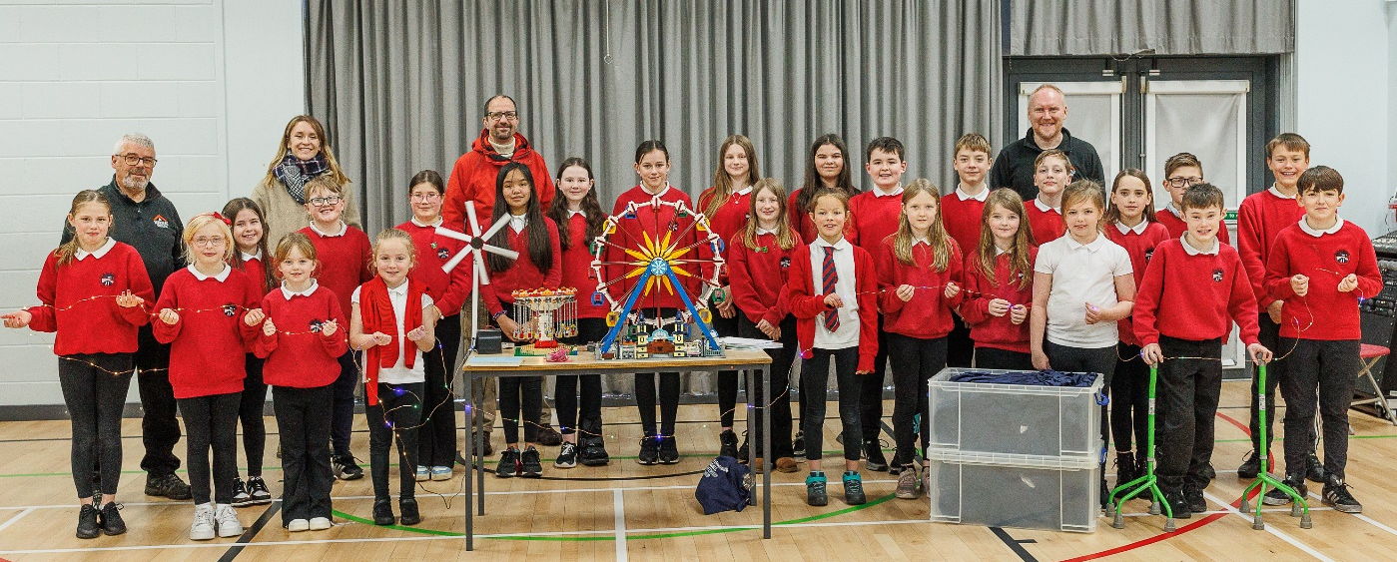

Stoiridh ‘s Spòrs
Our very youngest children were delighted to receive a special visit from ‘Bodach na Nollaig’ to bring this term’s play sessions to an end. Gifts were provided by Elaine Poke, Early Years Curriculum Teacher.
Stoiridh ‘s Spòrs sessions will resume in January and are open to all parents of children aged 0-3. The sessions will be delivered in Gaelic however parents do not need to be able to speak Gaelic to attend.

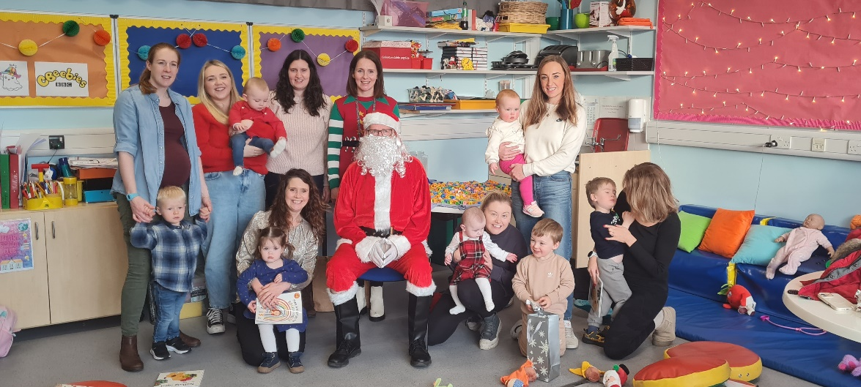

Transition Event
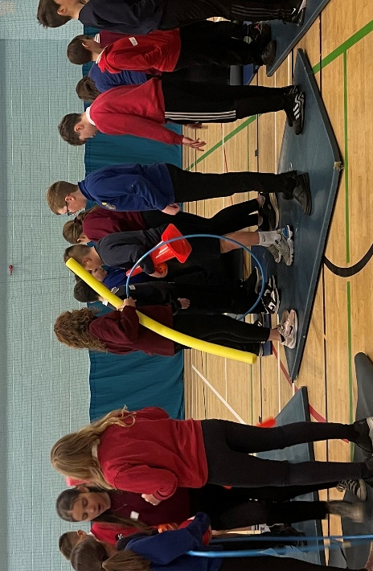
Last Wednesday, all P7 pupils travelled up to the Nicolson Institute to participate in the first of many planned transition activities. All P7 pupils from across Lewis attend the event and feedback from the children was extremely positive.

NYCOS
Well done to all our pupils who participated in the recent NYCOS concert at the Nicolson Institute. They performed extremely well. (UNCRC Article 31)

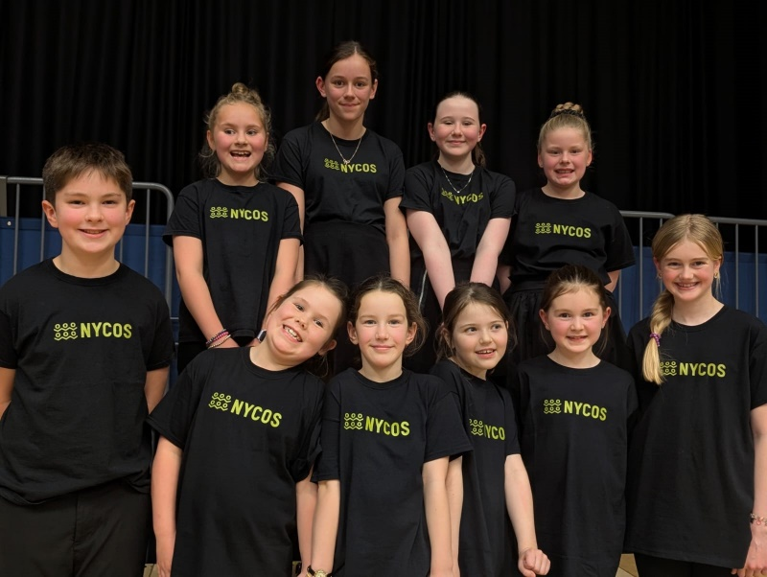

Fundraising
Congratulations to Nathan Peck who, during the month of November, completed the Swim 10K Challenge to raise money for Cancer Research UK. What a fantastic achievement for a very worthy cause. So far, he has raised an amazing £545! Well done, Nathan!

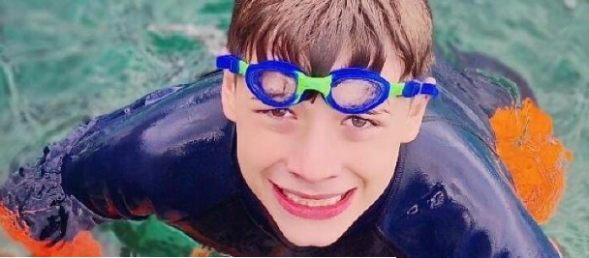

Christmas Performance
Pupils and staff have been busily preparing for our annual Christmas Performance which will take place on Thursday 12th December at 6:30pm. It is shaping up to be an amazing show, not to be missed!

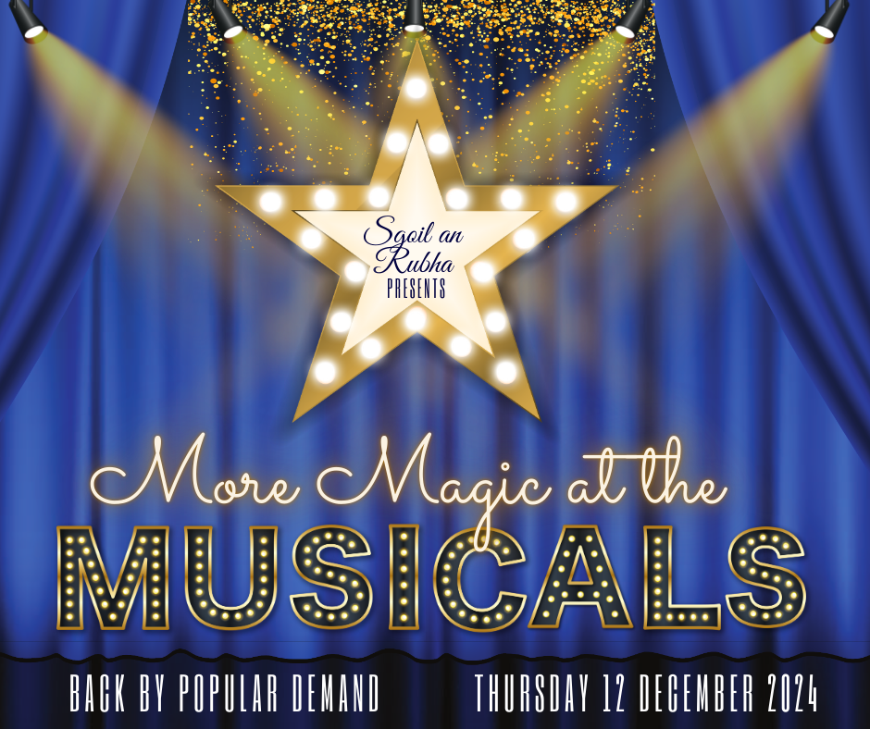

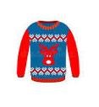
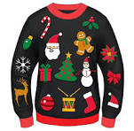
Christmas Jumper Day
All pupils are invited to wear Christmas jumpers/accessories on Friday 13th December. No donations are necessary.

House Captain Update
It was the Eagles who were the winning house this fortnight, earning themselves an early break time.
Well done Eagles!
The pupils below were awarded the house mascots by the captains/vice captains.

Eagles – Emma Flower
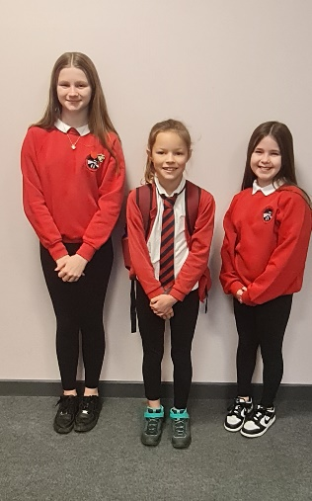
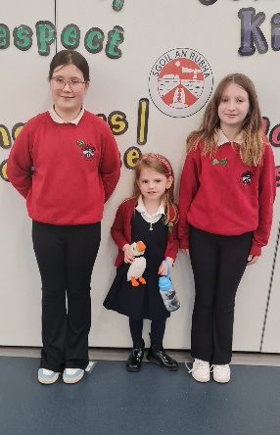
Herons – Ava Mae Woodman
Oystercatchers – Ella Beth Robins
Puffins – Maggie Macleod
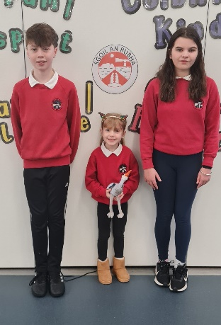
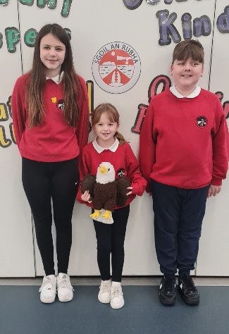

Dates for your diary
Thursday 12th December 6:30pm | Christmas Performance
Friday 13th December | Christmas Jumper Day
Tuesday 17th December | Canteen Christmas Lunch
Wednesday 18th December | Christmas Parties
Friday 20th December 11:15am | Christmas Service
Friday 20th December 3:10pm | School closes for Christmas break
Monday 6th January 9:10am | School re-opens for staff and pupils
