Sgoil an Rubha - Parental Update
Monday 18th November 2024
Seachdain na Gàidhlig
Last week was a celebration of Gaelic language and culture. There was an increased focus on Gaelic in all classes across the school. Pupils learned new Gaelic vocabulary and songs which they shared with each other on Thursday afternoon, followed at the end of the day by a whole school strip the willow.
Our weekly ‘Stoiridh ‘s Spors’ session was opened up to children and parents from the Gaelic playroom and we had a special visit from the Gaelic bus.
We also held a Gaelic T-shirt competition where pupils had to design t-shirts which included Gaelic. Well done to Aaron and Guiliana, who will have their t-shirt deigns brought to life.
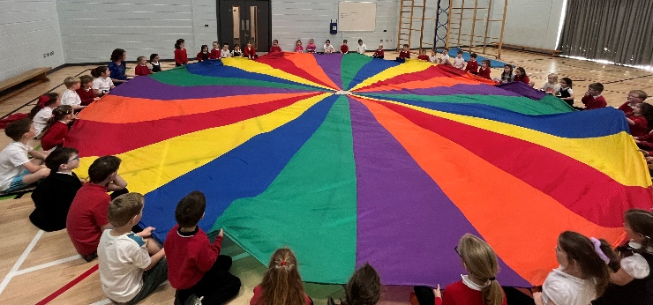
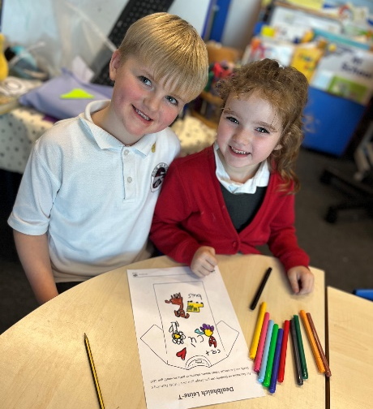

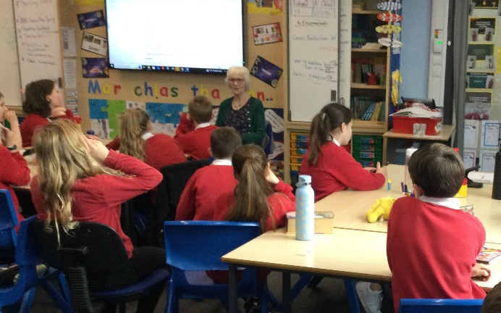

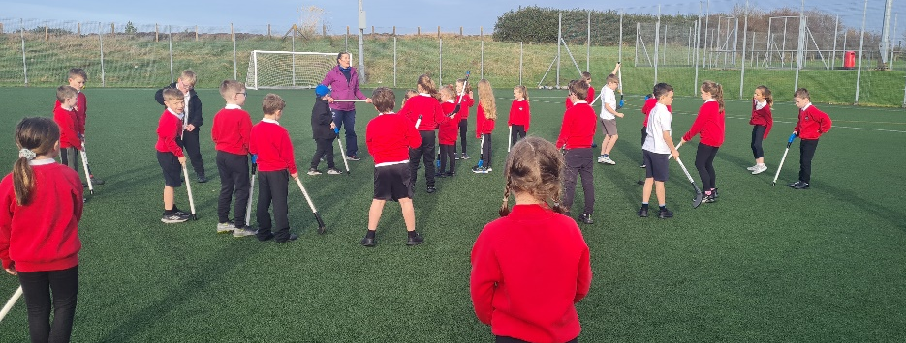

Pupil Led Learning
Well done to pupils from GM5-7 who led our assembly last Friday. They spoke very well about all the exciting learning that has been happening in their class and shared lots of top tips to encourage others to get involved in learning about biodiversity and sustainability. It was wonderful to see how our school priorities are being brought to life in the classroom. Well done also to Mrs D Macleod and Miss Swan. (UNCRC Articles 28 & 29, SDGs)
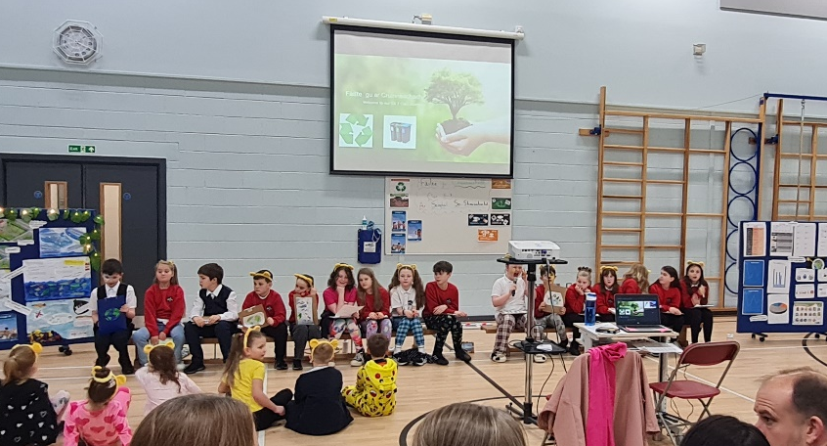

Children in Need
There was an atmosphere of excitement around the school on Friday as the pupils participated in lots of fun activities to raise money for Children in Need. A visit from Pudsey was a highlight of the day for many. Thank you to the Pupil Council, Mrs E Macleod and Miss Swan for organising the day. A total of £786.55 was raised. Thank you to all the families who contributed.
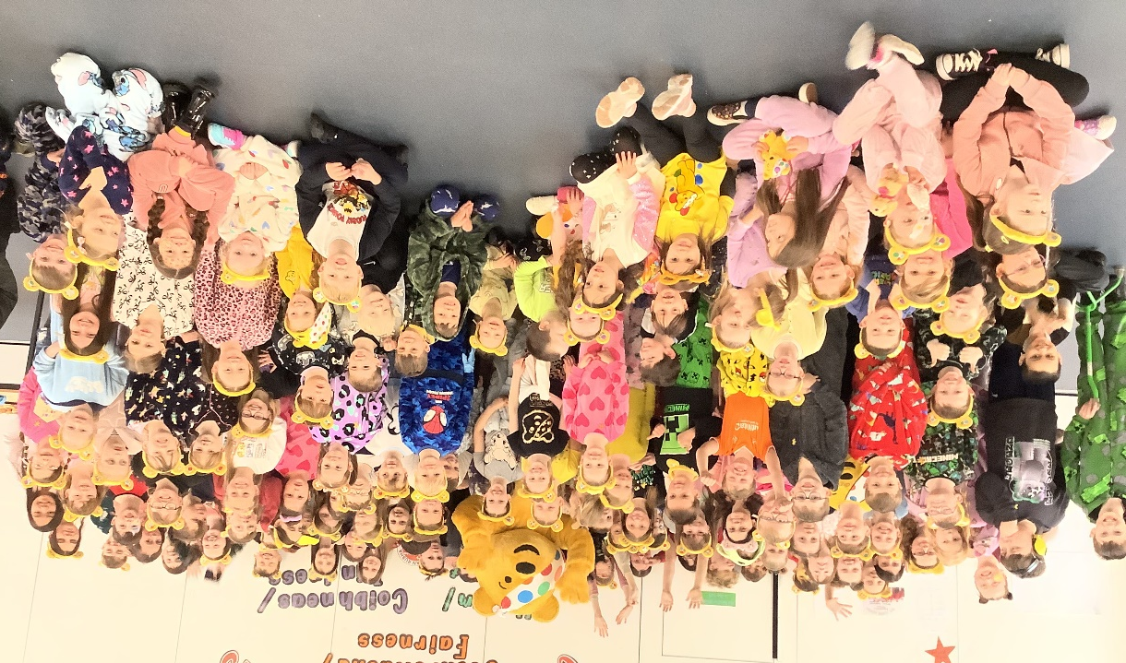

Theatre in Schools Scotland
Pupils from GL1, GL2/3 and GM1-4 thoroughly enjoyed the recent ‘Ginger’ perfomance. The theatre group visited the school and delivered a very entertaining performance followed by a biscuit decorating activity. The children were extremely engaged in the show which was very loud and lively!
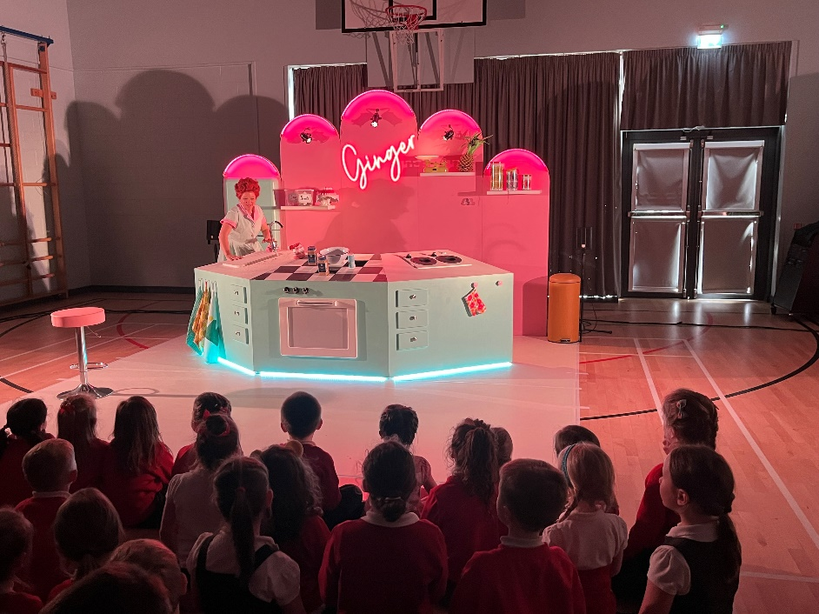

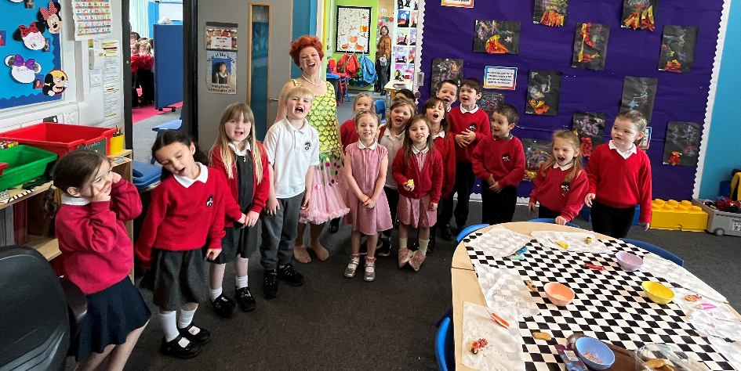

Keep Scotland Beautiful Visit
On Tuesday 5th November, pupils in GM1-4 enjoyed a visit from Jonathan Angell, from Keep Scotland Beautiful, who reinforced the importance of looking after their environment and gave advice on how to look after local wildlife. (UNCRC Article 29, SDGs)

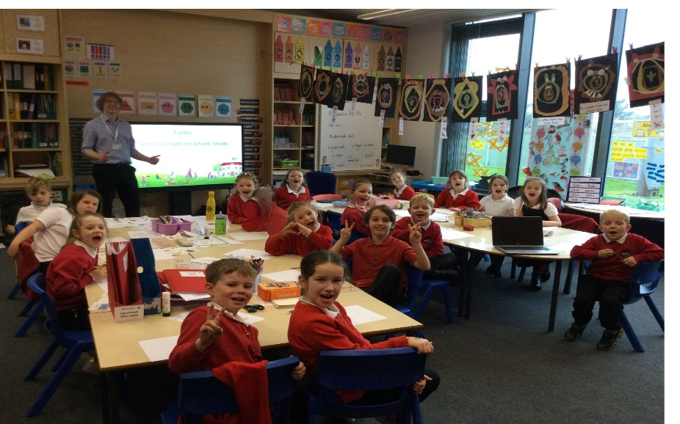

House Captain Update
It was the Puffins who were the winning house this fortnight, earning themselves an early break time.
Well done Puffins!
The pupils below were awarded the house mascots by the captains/vice captains.

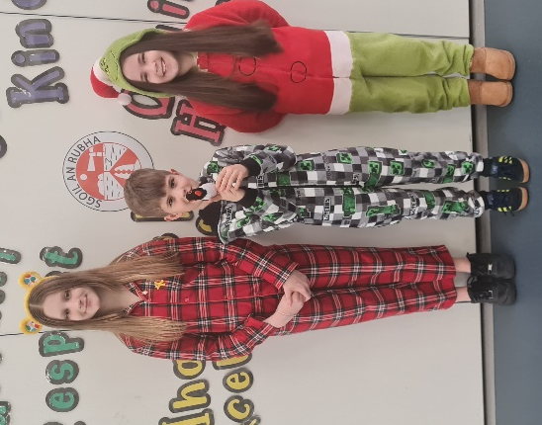
Eagles – Fraser for always listening
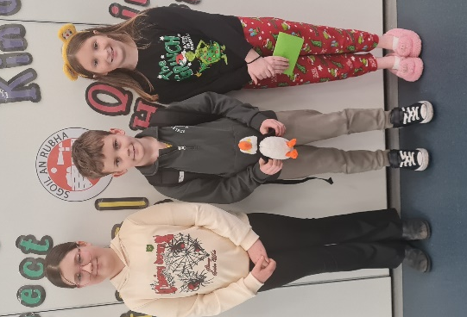
Herons – Evie getting into lines quickly
Oystercatchers – Harry for always listening
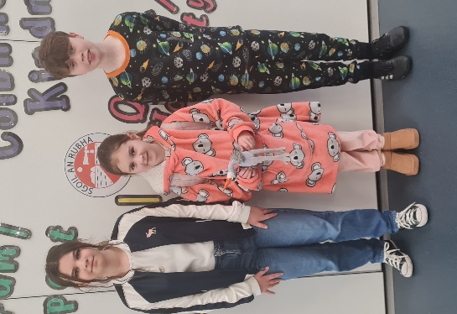
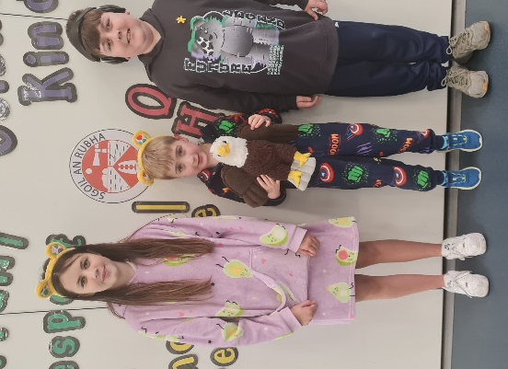
Puffins – Joshua for good behaviour in the lines

November Weekend
The school will be closed on Friday 22nd November and Monday 25th November for the mid-term holiday.



Dates for your diary
Friday 22nd and Monday 25th November | School closed for mid-term holiday
Thursday 21st November 6pm | Parent Council Fundraising meeting (all welcome)
Thursday 21st November 7pm | P7 Trip meeting
Friday 29th November | Feel Good Friday
Thursday 12th December 6:30pm | Christmas Performance
Friday 13th December | Christmas Jumper Day
Tuesday 17th December | Canteen Christmas Lunch
Wednesday 18th December | Christmas Parties
Friday 20th December 11:15am | Christmas Service
Friday 20th December 3:10pm | School closes for Christmas break
Monday 6th January 9:10am | School re-opens for staff and pupils
