Sgoil an Rubha - Parental Update
Friday 1st November 2024

Parent Council Craft Fair
The Parent Council have been extremely busy organising their Craft Fair, which will take place on Saturday 2nd November. It looks like it’s going to be a fantastic event, so please come along and show your support. Many thanks to all the parents who have helped with the organisation, made donations and volunteered to help on the day.
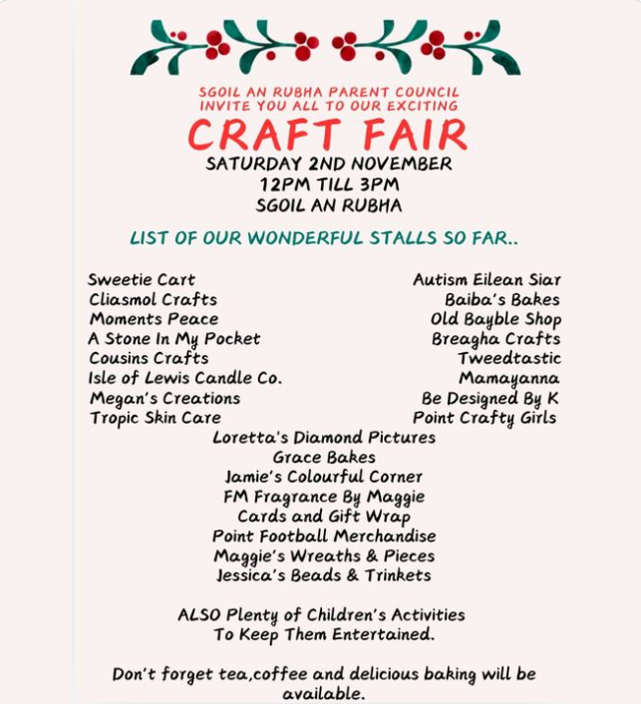

Blythswood Shoebox Appeal
Thank you to all the families who donated towards the recent Blythswood Shoebox Appeal. It is great for our pupils to learn about how they can help and bring joy to people who are less fortunate than themselves.
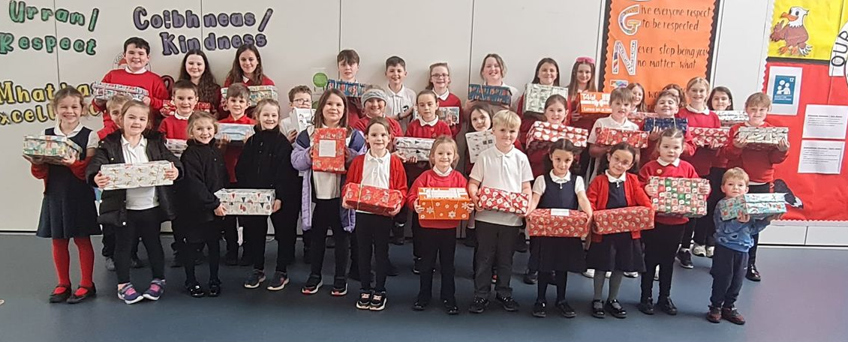

Donations
We are very fortunate to have recently received several donations from the community and parents which will enhance creative opportunities for our pupils.
Chris and Jane Dunn kindly donated several musical instruments which have already been put to use and will be used by our pupils for years to come.
Harris Tweed Hebrides donated several rolls of tweed, some of which was used to create wonderful art as part of a successful enterprise project.
Paul Curtis donated several bags of lovely, very good quality wool. As a result, P7 pupils have expressed an interest in establishing a crochet club. We are also hoping to start up a knitting club and would welcome support from any keen knitters in the community who would be willing to help.
Thank you to Mo and Colin Macdonald who donated art materials which have been quickly claimed by class teachers and will be used for Christmas art projects.
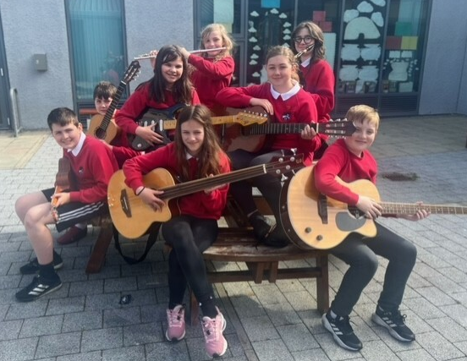
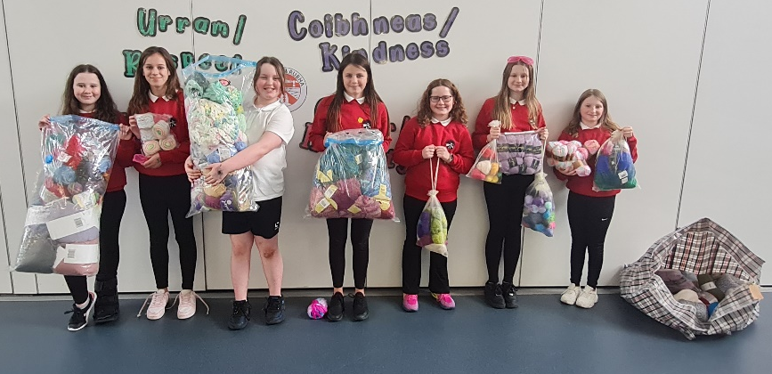

FACLAN Literary Festival
Bha sinn cho fortanach ùghdaran fhaighinn bho Faclan airson a bhith a’ hordh air Clas 3-7 an t-seachdain seo. Thàinig June Graham a-steach a bhruidinn rinn mu dheidhinn an leabhar a sgrìobh I ‘ An Cat Coigreach’. Thàinig Mary NicGilliosa a-steach a bhruidhinn rinn mu dheidhinn an leabhar a sgrìobh I ‘Uncail Dod agus na Dìneasairean’. Abair gun do hord e ris a h-uile duine agus dh’ionnsaich sinn tòrr mu dheidhinn a bhith sgrìobhadh leabhraichean! Tapadh leibh chun dithis aca airson a thighinn!

GM3-7 pupils were very fortunate to welcome 2 local Gaelic authors into their classes this week as part of the FACLAN Literary Festival 2024.
June Graham visited the class to talk about her new book ‘An Cat Coigreach’ and Mary Gillies visited us to talk about her book ‘Uncail Dod agus na Dìneasairean’. The classes listened enthusiastically and engaged well with the authors, as they described their various themes and inspirations for writing.
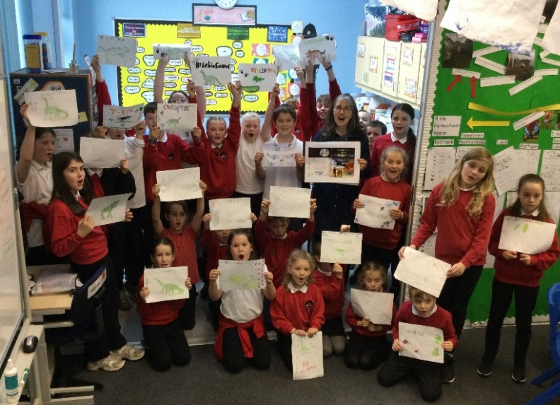
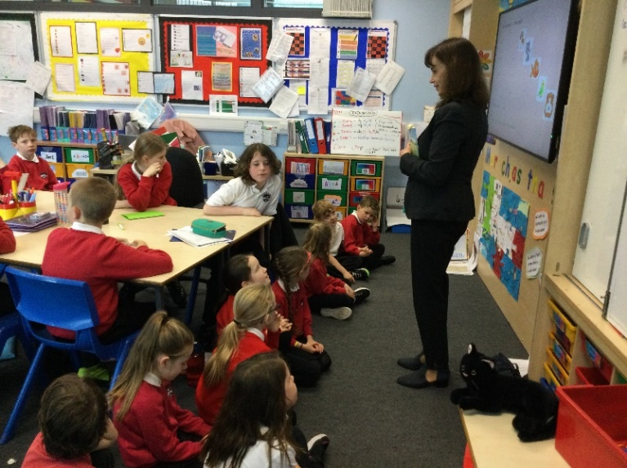
Many thanks indeed to both authors for visiting with us and we look forward to reading their published novels! (UNCRC Articles 17, 29 & 30)
National Mod
Congratulations to Ava Grace Carty who won 1st place in the P2/3 solo singing learner competition at the National Mòd in Oban during the October holidays. We are all very proud of her! (UNCRC Article 30)
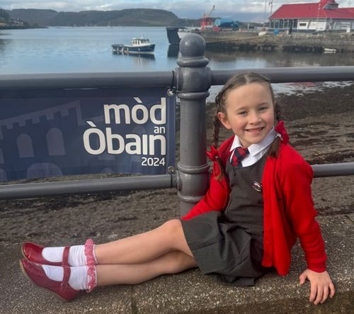

Hallowe’en Lunch
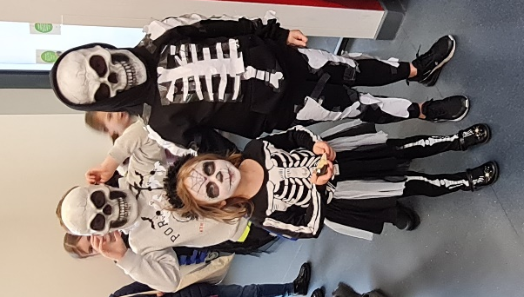
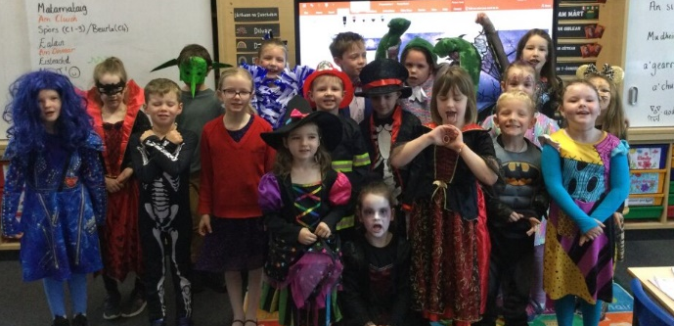
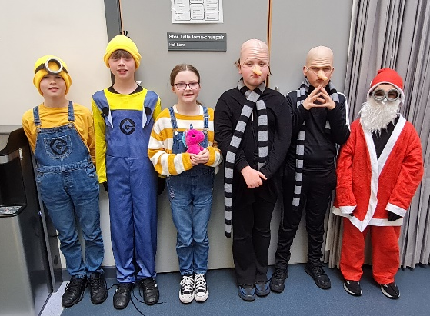
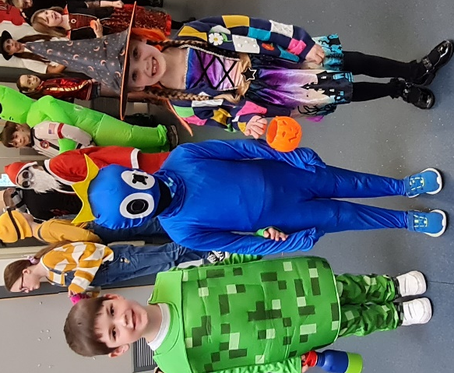
There was an air of excitement around the school as pupils enjoyed the opportunity to dress up for yesterday’s Hallowe’en lunch. We were very impressed with how creative the pupils were.

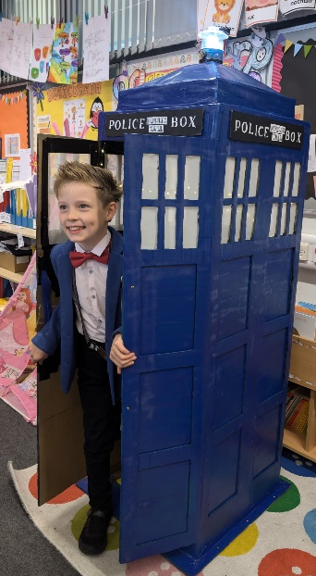

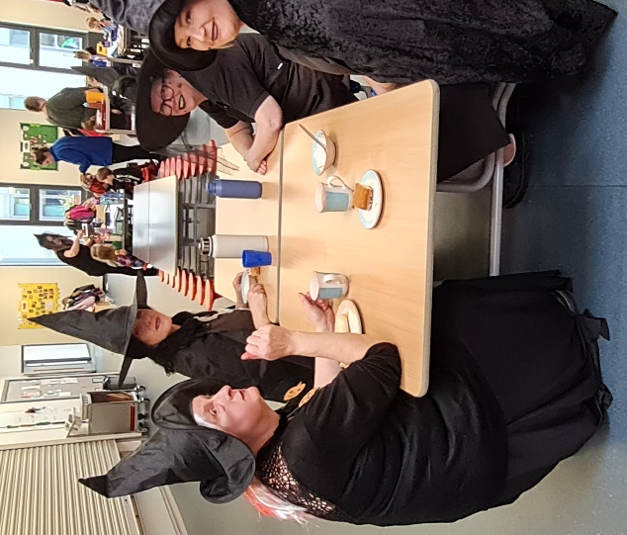

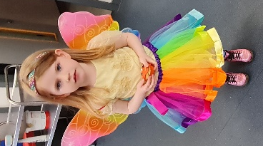

Uni-hoc Finals
Well done to the Red Rockets who earned themselves a place in the Uni-hoc Finals, which were held on Tuesday 29th October. Although the team were not the overall winners, they played extremely well and should be very proud of themselves. (UNCRC Article 24)
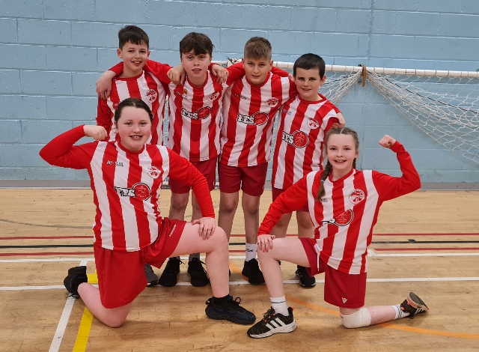

Parents’ Appointments
Appointments for parents to meet with class teachers to discuss their child’s progress will be issued on Monday. Appointments will be spread across Tuesday 12th – Thursday 14th November, if the appointment which is issued is not suitable, please contact the class teacher to rearrange. On Wednesday 13th November some of our partners will have ‘stalls’ in the main hall and the ‘Gaelic Bus’ will also be parked at the front entrance for parents and children to explore.

Poppies
There will poppies for sale in the school between Monday 4th – Thursday 7th November.

Christmas Performance
Our whole school and nursery Christmas Show will be held on Thursday 12th December at 6:30pm.
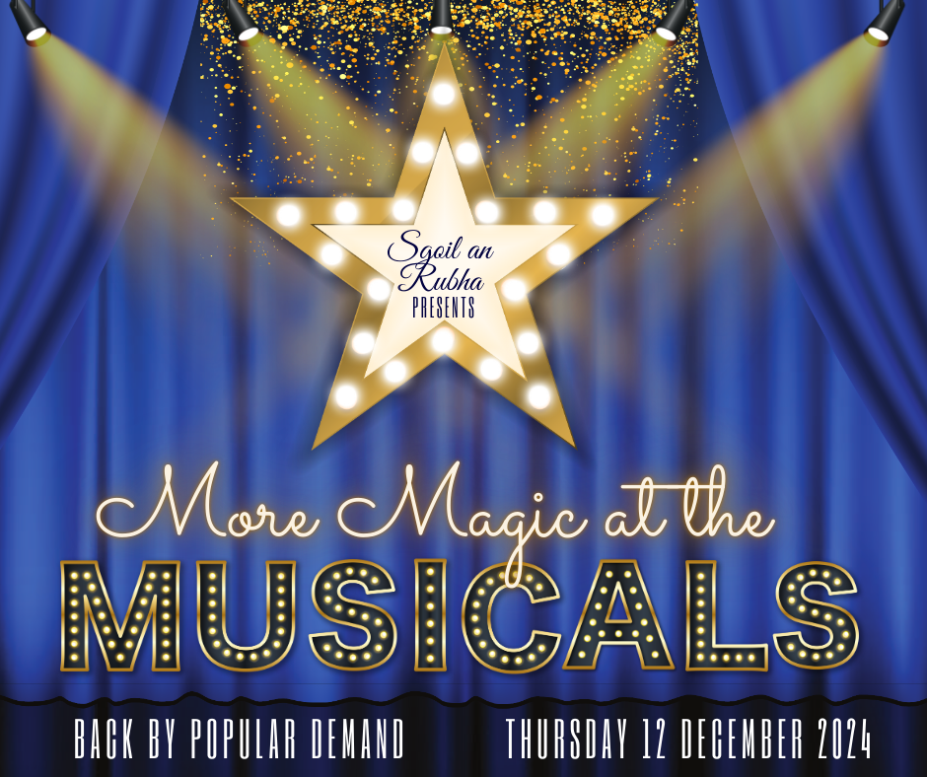

House Captain Update
Today it was the Oystercatchers who were the winning house, earning themselves an early break time.
Well done Oystercatchers!
The pupils below were awarded the house mascots by the captains/vice captains.

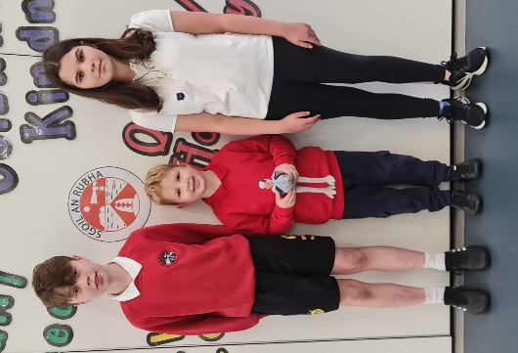
Eagles – Christina for always being well behaved and helpful
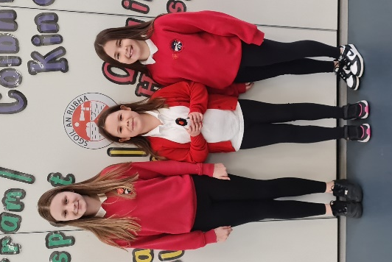
Herons – Harvi for getting into lines quickly and being nice and quiet
Oystercatchers – Ava-Mae for listening well and getting into lines quickly
Puffins – Aaryanna for listening well and getting into lines quickly

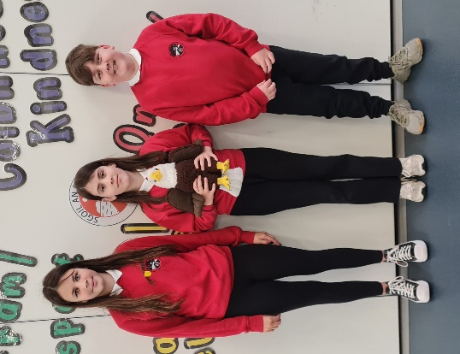
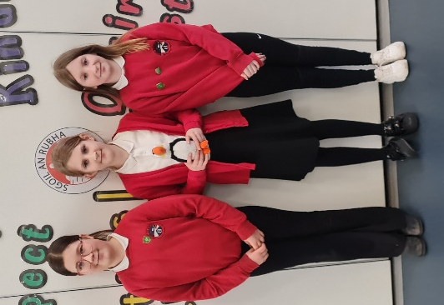

Dates for your diary
w/c 11th November | Seachdain na Gàidhlig
14th -16th November | Parents’ Evenings
Friday 15th November | Children in Need – Pupil Council event
Friday 29th November | Feel Good Friday
Thursday 12th December 6:30pm | Christmas Performance
Friday 13th December *(please note the change of date from 12th) | Christmas Jumper Day
Tuesday 17th December | Canteen Christmas Lunch
Wednesday 18th December | Christmas Parties
Friday 20th December 11:15am | Christmas Service
Friday 20th December 3:10pm | School closes for Christmas break
Monday 6th January 9:10am | School re-opens for staff and pupils
