Sgoil an Rubha - Parental Update
Thursday 10th October 2024
Trip to Ishga
On Tuesday 8th October, pupils from GL3-6 and GM5-7 enjoyed a visit to the Isgha and Hebridean Seaweed factories. They were fascinated to see how the seaweed is processed and very much enjoyed learning about how the lovely Isgha products are made. The trip was part of our whole school focus on Sustainability. Thank you to Mrs D Macleod for organising the trip. (UNCRC Articles 28 & 29)
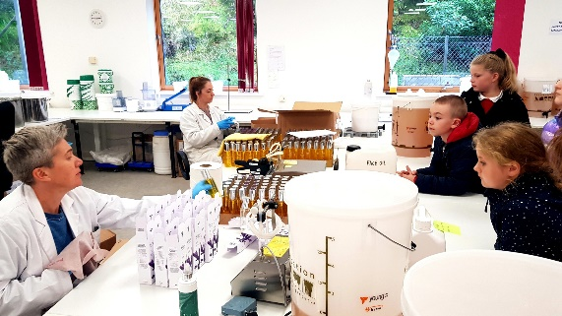
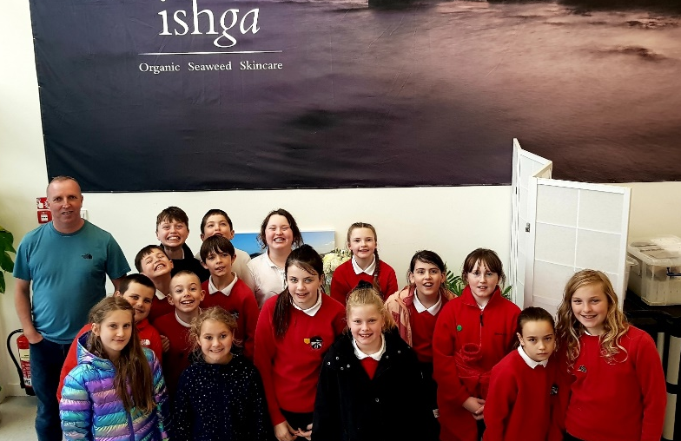

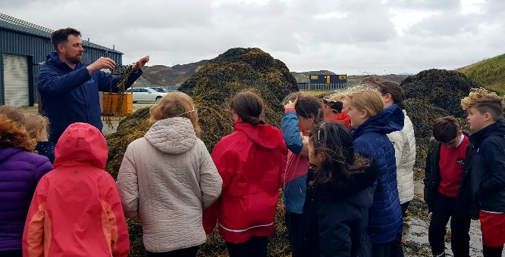

Uni-hoc
Well done to all our pupils who participated in the recent uni-hoc competitions. We are very proud of everyone who took part and were delighted that one of our teams are through to the finals, to be held on 29th October. (UNCRC Article 14)
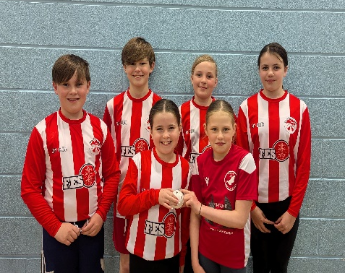
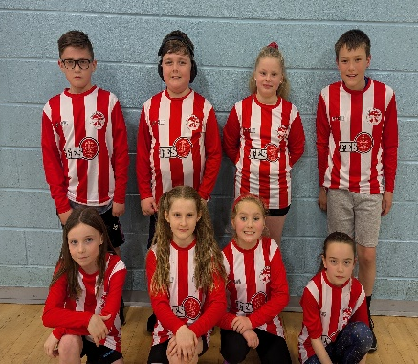
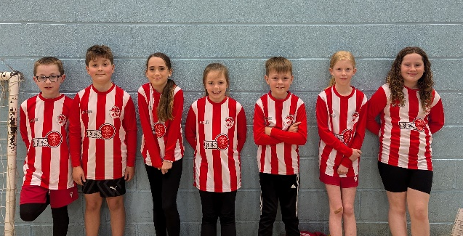
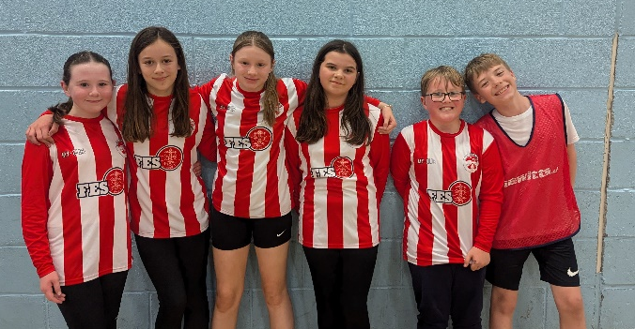

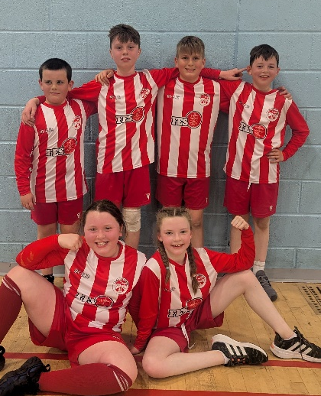

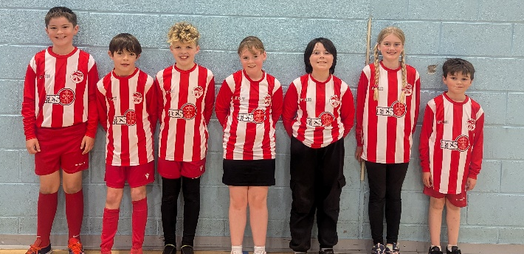

OH-COP 1
As part of the recent Outer Hebrides COP event, pupils from GM5-7 took part in a series of challenges in relation to climate change. We were delighted to receive an email from Sarah Longbottom at Climate Hebrides stating how impressed they were with the pupils’ efforts and research about local ecosystems and biodiversity. The class will receive a ‘Climate Cup’ in recognition of their great work.
(UNCRC Article 29, SDGs)

Celebration Assembly
Today, we held our termly celebration assembly. Pupils from each class shared what they’ve been learning in relation to the 4 capacities (Successful Learners, Responsible Citizens, Effective Contributors and Confident Individuals). It was wonderful to hear the children talking about all the fantastic learning and teaching that is happening across the school, and it was great to see even our youngest learners talking in front of the whole school.
Achiever certificates and Gaelic Speaking certificates were also awarded, recipients are pictured below.
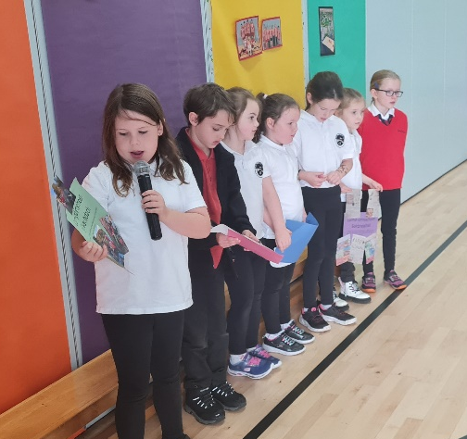
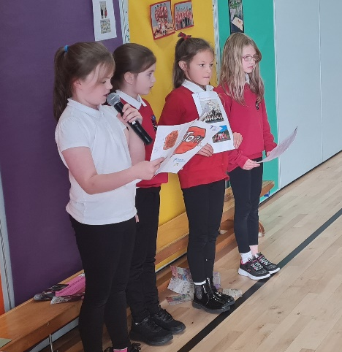
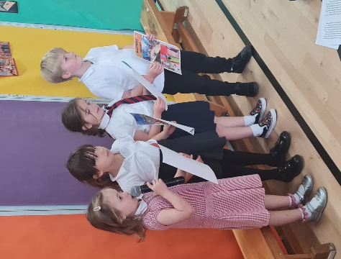

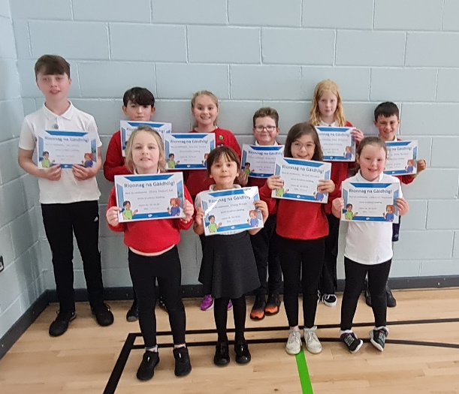
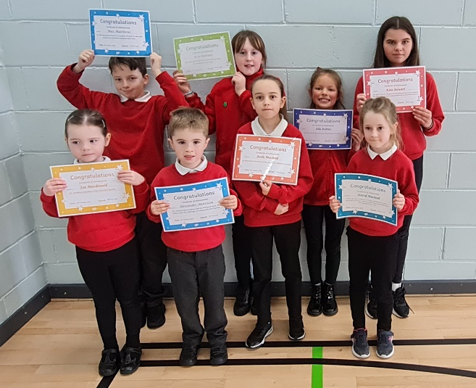

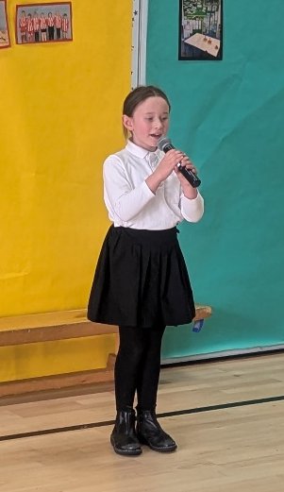

National Mod
Good luck to Ava Grace Carty, who will be competing in the National Mod, in Oban, during the October break. We are already very proud of how hard Ava Grace has worked on her song which she sang beautifully for the whole school during today’s assembly. We wish her the best of luck in her competition.

Christmas Performance
Our whole school and nursery Christmas Show will be held on Thursday 12th December at 6:30pm. Further details to follow at the beginning of next term.

Hallowe’en Lunch
On Thursday 31st October the canteen will provide a special Hallowe’en themed menu, details to follow. Pupils are welcome to dress down or wear a spooky costume.

Dress Down Days for Term 2
Pupils are permitted to dress down on the following days: 31st October, 29th November. No donations necessary.

Penny Wars
Thank you very much to everyone who donated their spare change as part of our ‘Penny Wars’ this week. We raised over £800 for school funds, which is fantastic. Well done to GM5-7 who were the winners of the class treat.

House Captain Update
On Friday 4th October, our house captains and vice captains were very excited to lead their first house meetings. They did a wonderful job in encouraging members of their houses to share their wider achievements.
During today’s ‘Celebration Assembly’ it was the Oystercatchers who were named as the termly winners after gaining the most points across the term. All pupils in the oystercatchers’ house were rewarded with ice cream and laptops in the afternoon. Well done Oystercatchers!
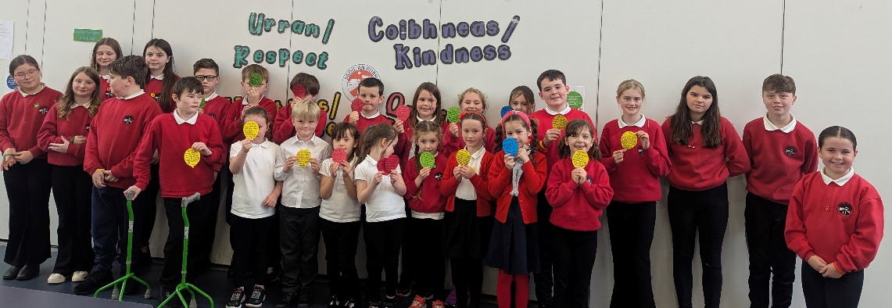
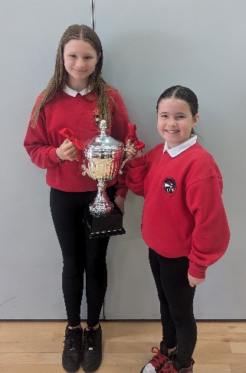

October Break
We hope you all have a restful and enjoyable October holiday and look forward to welcoming back all our pupils on Thursday 24th October.

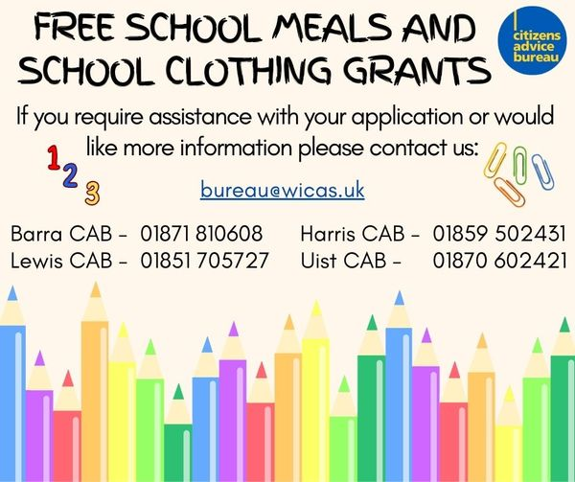

Dates for your diary
Thursday 10th October 3:10pm | School closes for October Break
Wednesday 23rd October | In-service
Thursday 24th October 9.10am | School reopens for pupils
Thursday 31st October | Spooky Feel Good Thursday!
Thursday 31st October | Canteen Hallowe’en Lunch
Tues 14th and Wed 15th November | Parents Evenings
Friday 15th November | Children in Need – Pupil Council event
Friday 29th November | Feel Good Friday
Thursday 12th December | Christmas Jumper Day
Thursday 12th December 6:30pm | Christmas Performance
Tuesday 17th December | Canteen Christmas Lunch
Wednesday 18th December | Christmas Parties
Tuesday 17th December | School Christmas Lunch
Friday 20th December 11:15am | Christmas Service

