Sgoil an Rubha - Parental Update
Friday 27th September 2024
Macmillan Coffee Morning
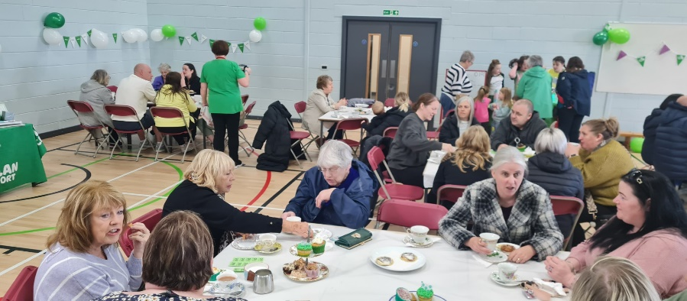
Thank you so much to all the families who contributed baking towards our Macmillan Coffee Morning, it never fails to amaze us how much is donated. It was a fantastic morning and it was lovely to see so many members of the local community in the school, supporting such an important cause. Pupils enjoyed the opportunity to get involved in the coffee morning and sampling the wonderful baking on offer. Thank you to all the parents/carers who made donations and who bought tickets.
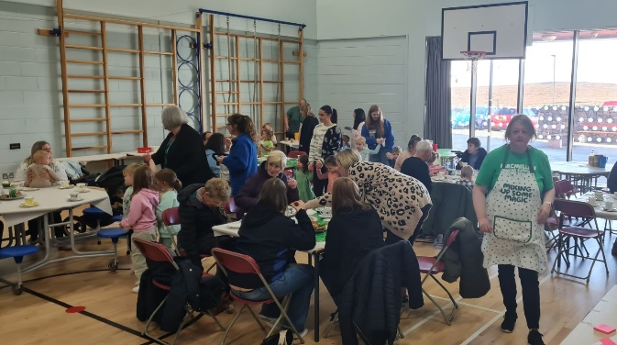
STEM Workshop
GM5-7 pupils really enjoyed participating in the recent Satellite workshop as part of the ‘Our World from Space’ programme. Tim and Scott from the Science Skills Academy visited the class and set missions for the children to complete. (UNCRC Articles 28 & 29)

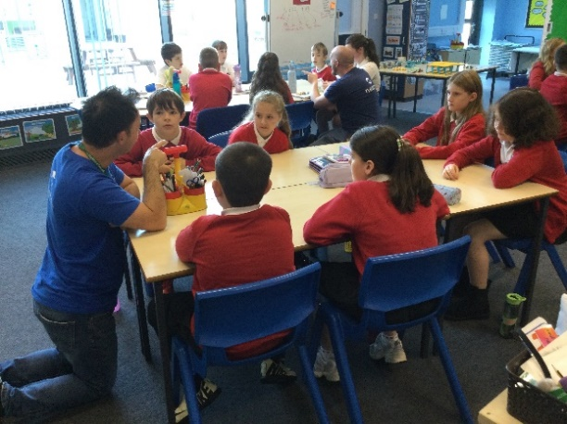
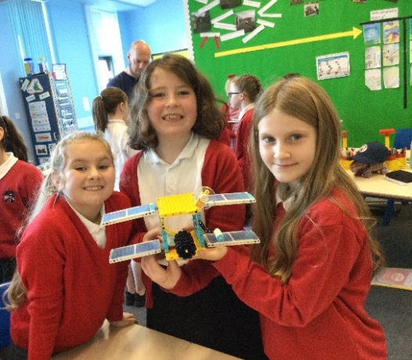

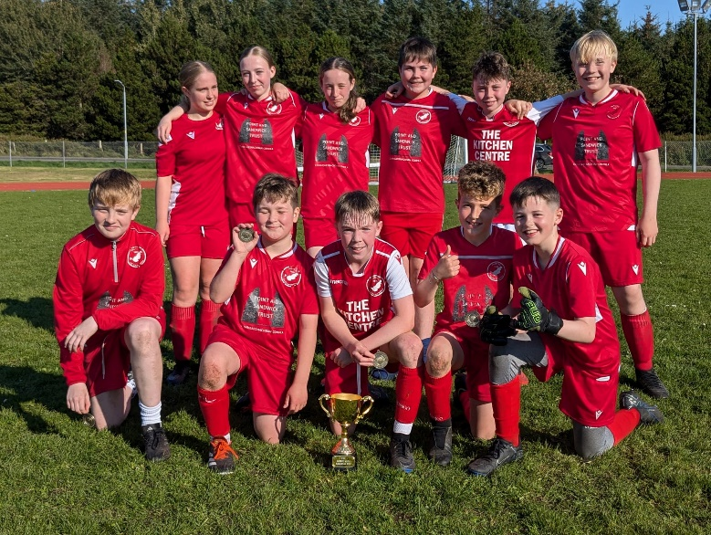

Footballing Success
Well done to all our pupils who participated in the recent football competitions. We are very proud of everyone who took part and were delighted that Point Team A were the winners of the Donnie Mata Cup. (UNCRC Article 14)

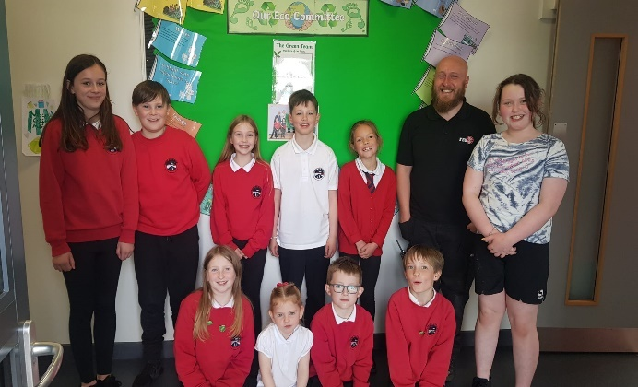
The Green Team
A new eco-committee for 2024-25 has been formed and have already started working together towards their eco-plan. The work of the eco-committee is vital in embedding an ethos of sustainability across the school. We are fortunate to have had such strong eco-committees which, with the support of Mrs D Macleod, Mrs Devine and Aiden, have been instrumental in making the school more environmentally friendly, and in doing so have gained Green Flag recognition. (UNCRC Articles 28 & 29)

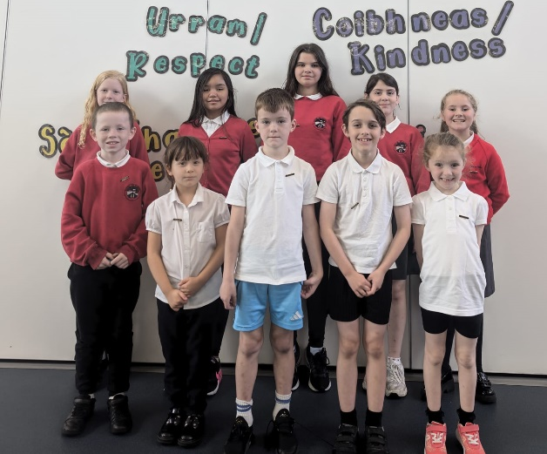

Rights Respecting Steering Group
All classes have now elected new representatives for our Rights Respecting Steering Group. Pupils will work together with teachers and the management team to ensure that children’s rights are an integral part of all the learning that happens in the school. They will play an important role in ensuring that we maintain our Gold RRSA status. (UNCRC Articles 12 & 15)

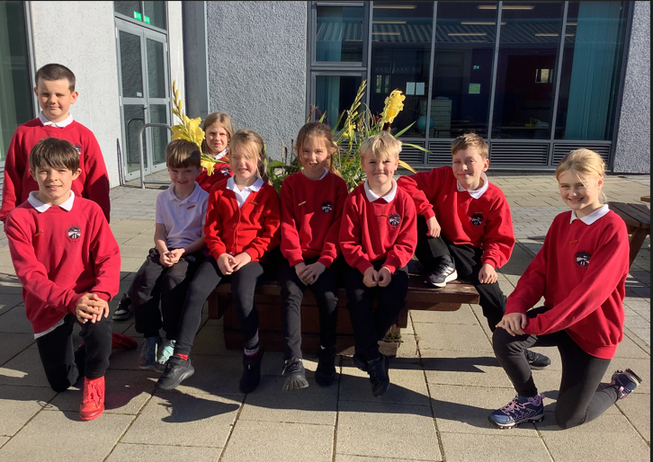

Pupil Council
New class representatives have also been elected to form our Pupil Council for 2024-2025. They will play an integral role in gathering pupils’ opinions and in improving the school. Well done to the pupils who were elected. (UNCRC Article 12 &15)

Iolaire Community Engagement Session
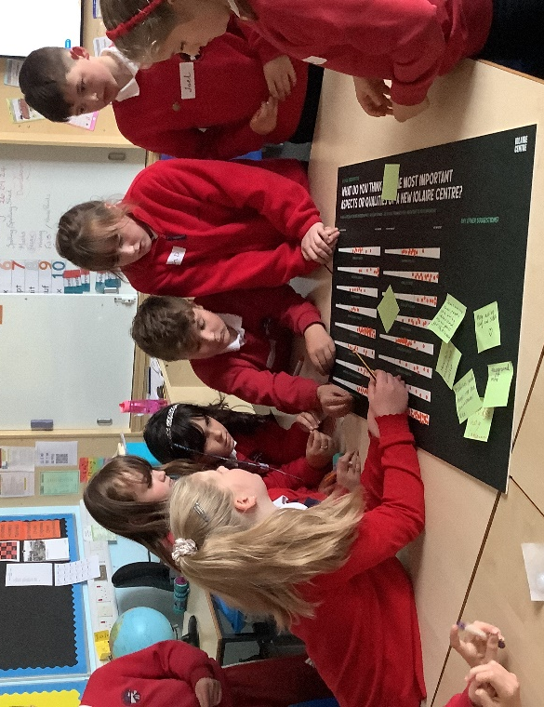
Pupils in GL 6 and GM 6/7 took part in a consultation exercise on the proposed Iolaire Centre in Stornoway on Thursday 26 September. Glasgow Design company, Lateral North, led the highly interactive and fun workshop and pupils were brimming with ideas on how the Centre could be designed and facilities it could include. This is part of a wider community engagement exercise taking place with young people, community groups and local stakeholders. (SDG 11, UNCRC Articles 28 & 29)
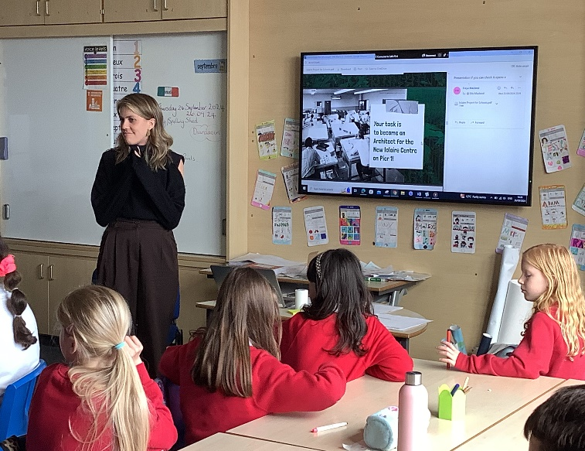

OH-COP1
Well done to Chloe, Sarah and Kate who, as part of the Young Islanders Network, gave a great presentation at the first ever OH-COP event and shared their voices on the impact of climate change in their community. (SDG 11)
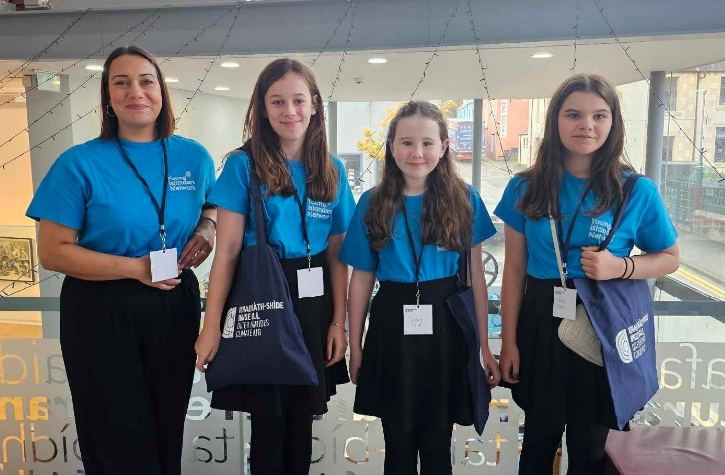

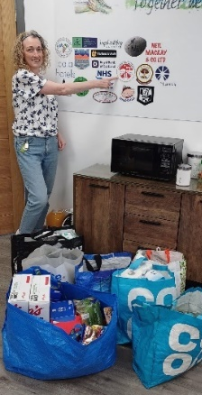

Eilean Siar Foodbank
As our school foodbank was not being utilised we have donated all items to the Eilean Siar Foodbank. They were extremely grateful for the donation. (SDG 2)

House Captain Update
Today it was the Eagles who were the winning house, earning themselves an early break time.
Well done Eagles!
The pupils below were awarded the house mascots by the captains/vice captains.

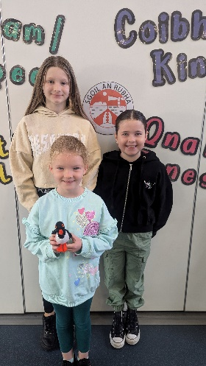
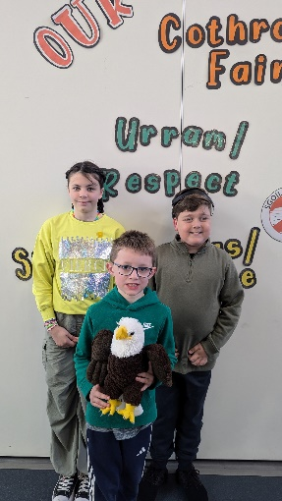
Eagles – Dean for standing nicely in lines
Herons – Bethany for good behaviour in lines
Oystercatchers – Isla for always speaking Gaelic and behaving
Puffins – Maisie for standing nicely in lines
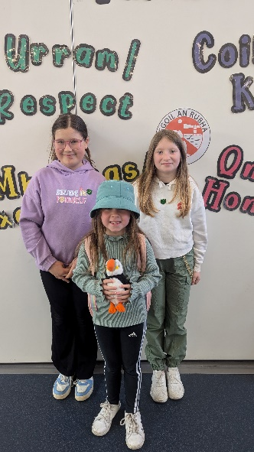
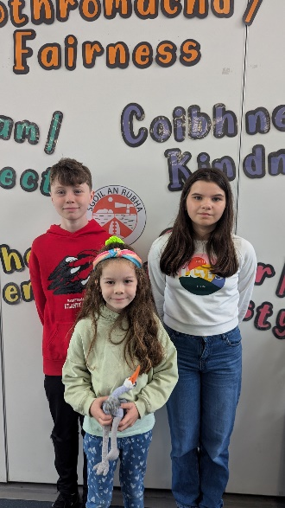

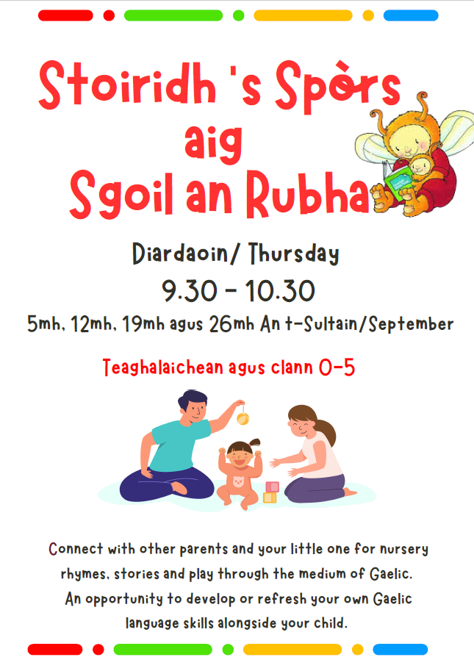

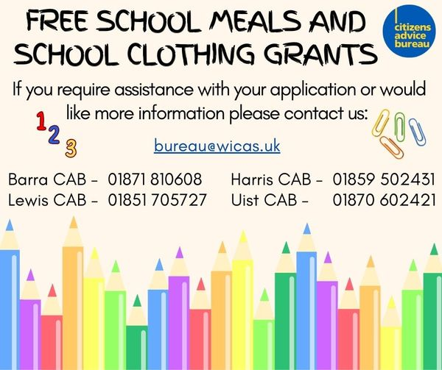

October Break
The school will close on Thursday 10th October at 3:10pm, for the October Break. It will reopen to staff on Wednesday 23rd October and to pupils on Thursday 25th October.

Dates for your diary
Thursday 10th October 3:10pm | School closes for October Break
Wednesday 23rd October | In-service
Thursday 24th October 9.10am | School reopens for pupils
Tues 14th and Wed 15th November | Parents Evenings
Friday 15th November | Children in Need – Pupil Council event
Thursday 12th December | Christmas Jumper Day
w/c 18th December | Christmas Parties
Tuesday 17th December | School Christmas Lunch
Friday 20th December | Christmas Service

