Sgoil an Rubha - Parental Update
Friday 13th September 2024

Parent Council Fund-raising Meeting
There will be a Parent Council meeting specifically to discuss fundraising on 19th September at 6pm. It is vital that we get as many parents as possible to come along to this meeting as all money raised through the Parent Council goes directly to benefit your children.

Stoiridh ‘s Spors aig Sgoil an Rubha
We have recently launched a 0-5 parent and toddler group, ‘Stoiridh is Spors aig Sgoil an Rubha’. Stoiridh is Spors is a fun and engaging group for parents to come into the school with their babies and young children to develop their own and their child's Gaelic language skills. The sessions are led by our GM infant teacher Joanne Macdonald, who has been supported by Elaine Poke, Early Years Curriculum Teacher. One mum, who has attended the sessions so far has said, 'This has given me a great opportunity to learn some Gaelic words and phrases which I can use with my child at home'. All parents with children aged between 0-5 are welcome to attend the group which will run every Thursday in Sgoil an Rubha from 9.30 until 10.30. The group is suitable for, and caters to, all levels of fluency, whether you are a beginner, learner or fluent speaker.
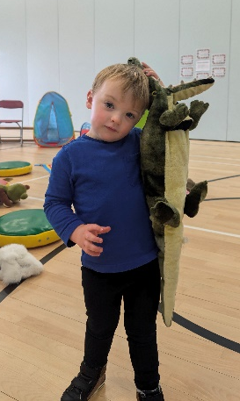

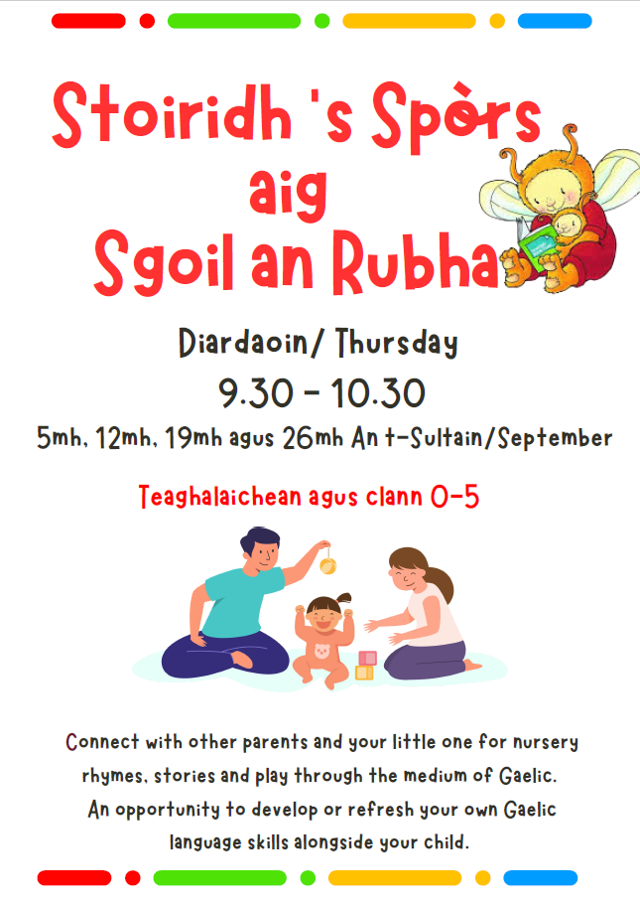

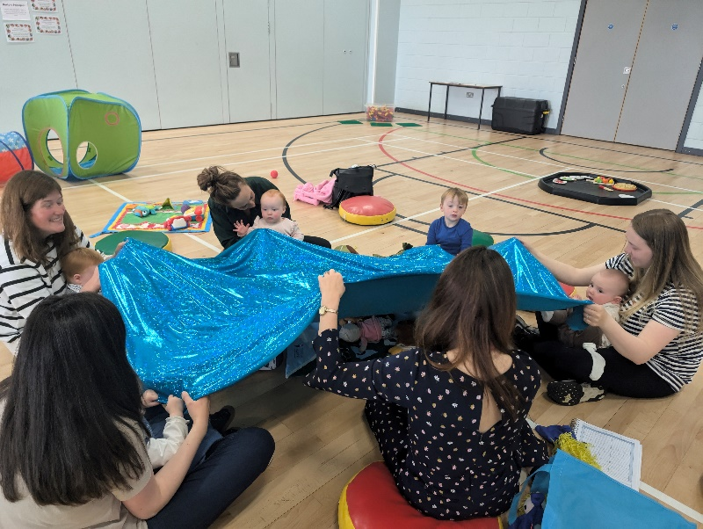

Unihoc
The uni-hoc competition is the first event of this year’s sporting calendar and will take place in the coming weeks. There are lots of pupils who are eager to participate and we hope to enter several teams. A uni-hoc lunch club will start today and Mrs Macphail will communicate further details to those who are involved. As reigning uni-hoc champions, the pressure is on! (UNCRC Article 24)

After-school Club
Georgia Macleod, our Education Attainment Apprentice, has started a new sporting after-school club aimed at P6/7 pupils for term 1. The club started yesterday and was very well attended. From next week the club will switch to Wednesdays.

GM1-4
It was wonderful to be invited along to the GM1-4 class this morning to see the work they have been doing in relation to their ‘Talk for Writing’ stimulus ‘It’s not a box’. The children talked so enthusiastically, in Gaelic, about the models they had made from old cardboard boxes. It was fantastic to see how imaginative they had been and to see them so enthusiastic about creating new story maps and stories. They were excited about sharing their learning with myself and other pupils. (UNCRC Articles 28 & 29)

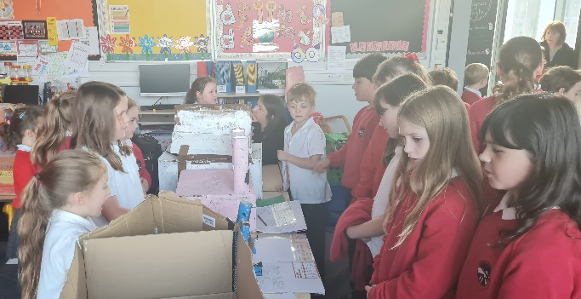
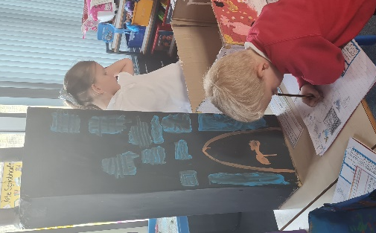
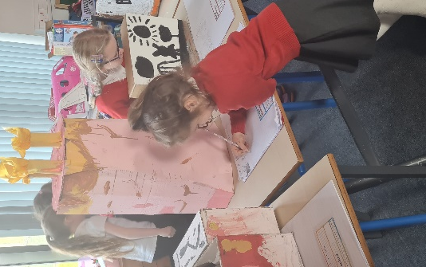

Sports Council
On Thursday the 5th September, interviews for the upper school and votes for the younger pupils took place to determine who would form this year’s Sports Council Committee.
All pupils answered exceptionally well and gave well thought out answers as to what skills they could bring to the committee. The committee will be instrumental in working towards achieving our Sports Scotland Gold Award. (UNCRC Article 24 & 12)
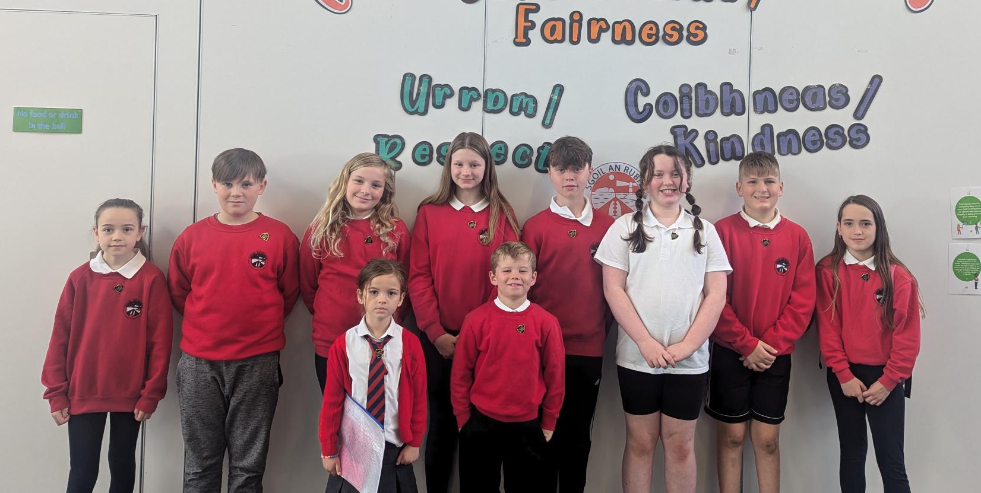

House Captain Update
Today it was the Oystercatchers who were the winning house, earning themselves an early break time.
Well done Oystercatchers!
The pupils below were awarded the house mascots by the captains/vice captains.
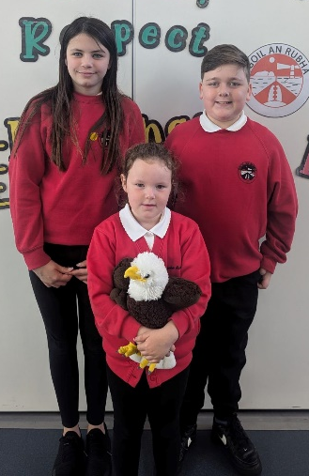
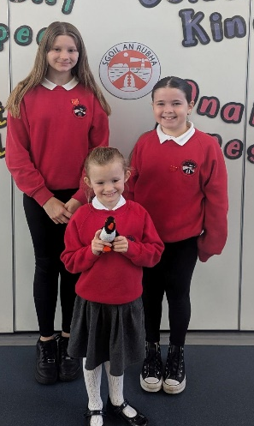
Eagles – Libby Grace for standing nicely and quietly in lines
Herons – Aria for behaving well and listening to instructions
Oystercatchers – Ellie for being respectful and listening well
Puffins – Wallace for being quiet and listening in the lines
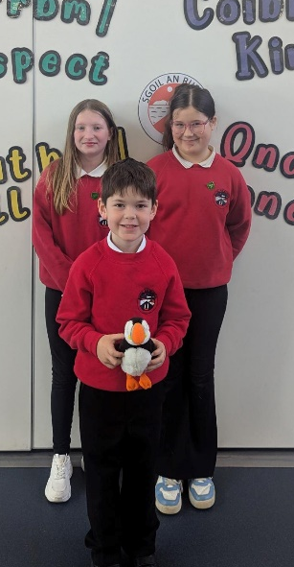
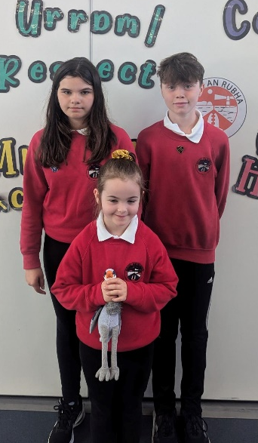

Wider Achievements
Members of choir were presented with certificates, which were kindly created by Catriona Dunn, as a memento of their performance for HRH The Princess Royal.
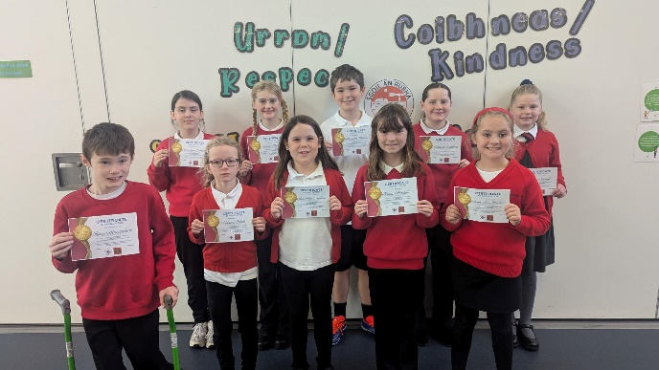

Well done to Flora, Agnes and Hazel who were presented with prizes for their artwork by Jill Thomson from Open Studio Hebrides. Their winning artwork can be viewed in Museum nan Eilean.

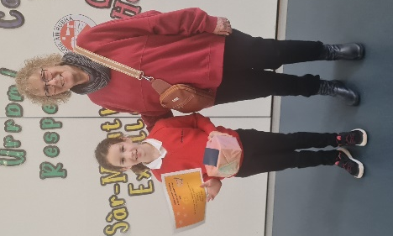
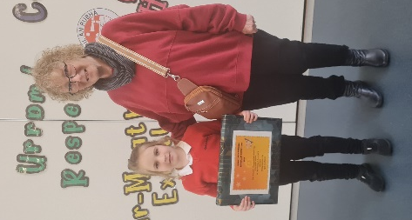
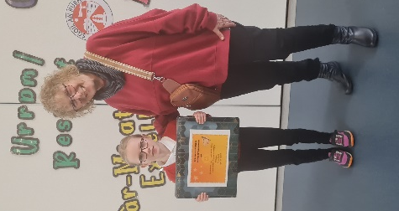

School Uniform
A gentle reminder to all parents that pupils should adhere to our school uniform policy unless it is ‘Feel Good Friday’. Football strips should not be worn in school at any time and, as matter of health and safety, ‘heelys’ are not appropriate footwear for school and should not be worn at any time. Thank you for your co-operation.

Macmillan Coffee Morning
Our annual coffee morning to raise money for the local Macmillan branch will be held on Friday 27th September. This is such a lovely community event and we would encourage as many people as possible to come along.
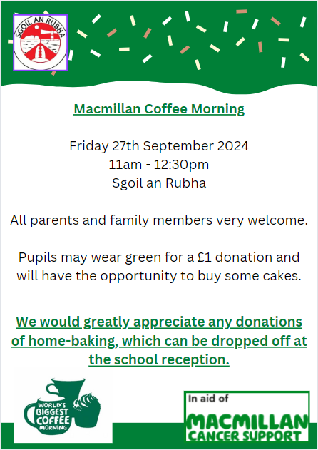

Dates for your diary
Friday 27th September | Feel Good Friday – pupils may dress down
Friday 27th September 11:30am | Macmillan Coffee Morning – all welcome
w/c 23rd September | Flu Vaccines
Thursday 10th October 3:10pm | School closes for October Break

