Sgoil an Rubha - Parental Update
Friday 30th August 2025

New Entrants
We were delighted to welcome 18 new P1 pupils to the school at the beginning of the session. They have settled in very well and are growing in confidence each day. Welcome also to our 2 new pupils who have joined us from other schools.
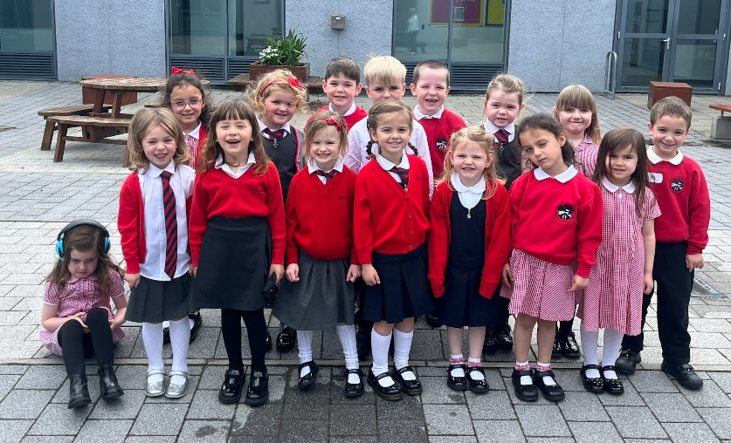
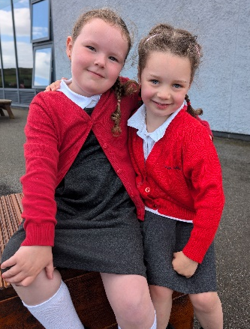

House Captains
Our new P7 pupils are encouraged to take on as many leadership roles as possible, one of the most coveted roles being that of house captain and vice-captain. Several P7 pupils put themselves forward for these roles and the standard of their presentations was excellent, so well done to everyone who nominated themselves. There will be another opportunity in January for P7 pupils to put themselves forward to be house or vice-captain. (UNCRC Article 12)
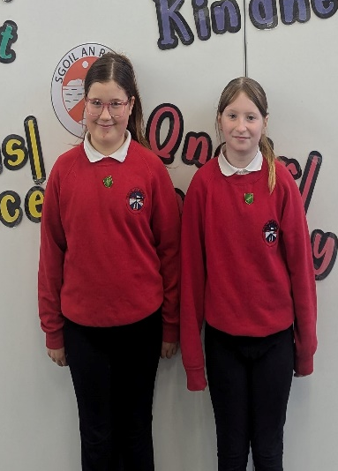
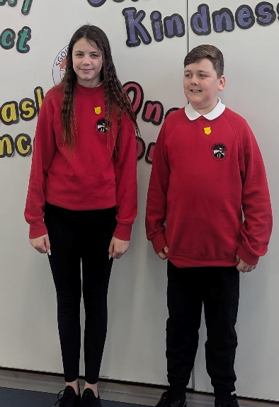
Our new Captains and Vice Captains are pictured below.

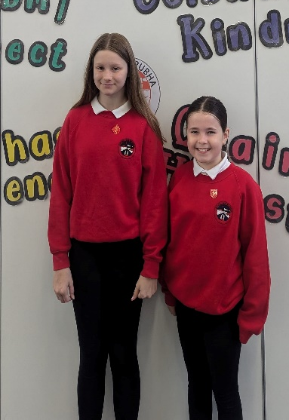
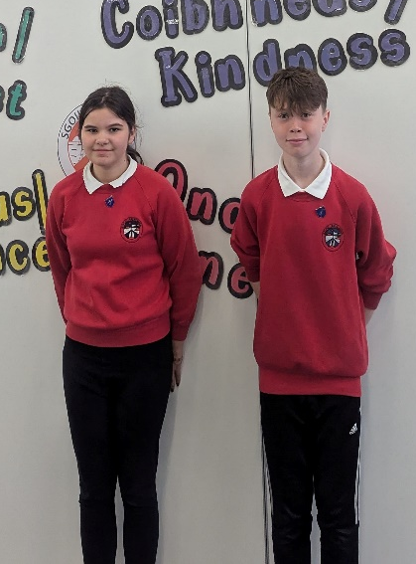

HRH The Princess Royal
We were absolutely delighted that our choir were invited to sing for HRH The Princess Royal at the official opening of Aros an Rubha. The children performed amazingly well and we are so very proud of them. Thank you to Mrs Devine and to their parents who helped prepare them.
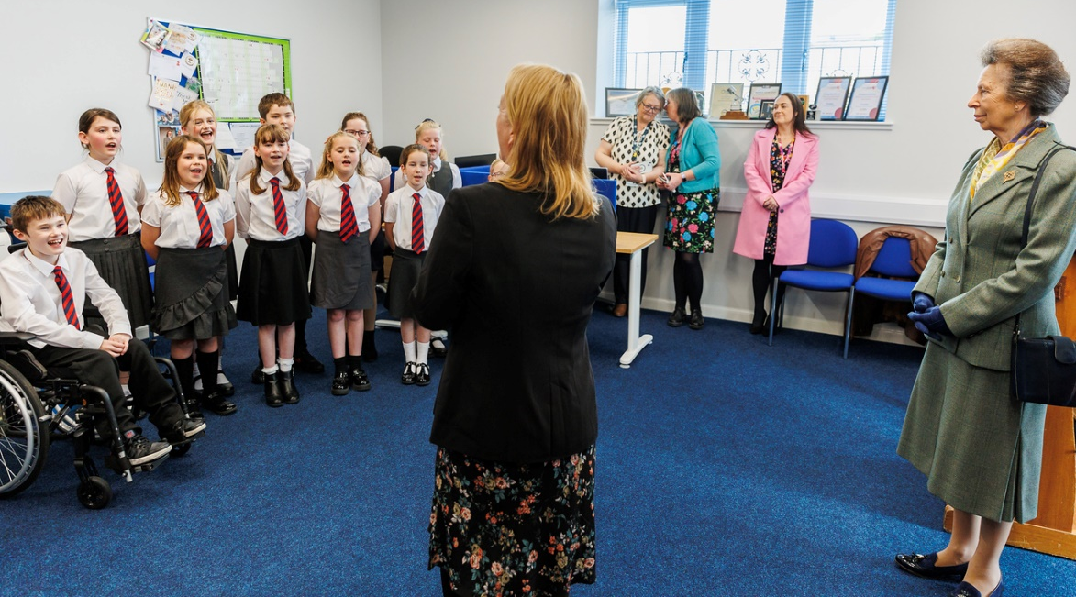

Gaelic Learners
The Education Department has instructed that all English Medium classes are now to be referred to as Gaelic Learner classes. All communication from the school will now be labelled as GM for our Gaelic Medium classes and GL for our Gaelic Learner classes, formerly English Medium.

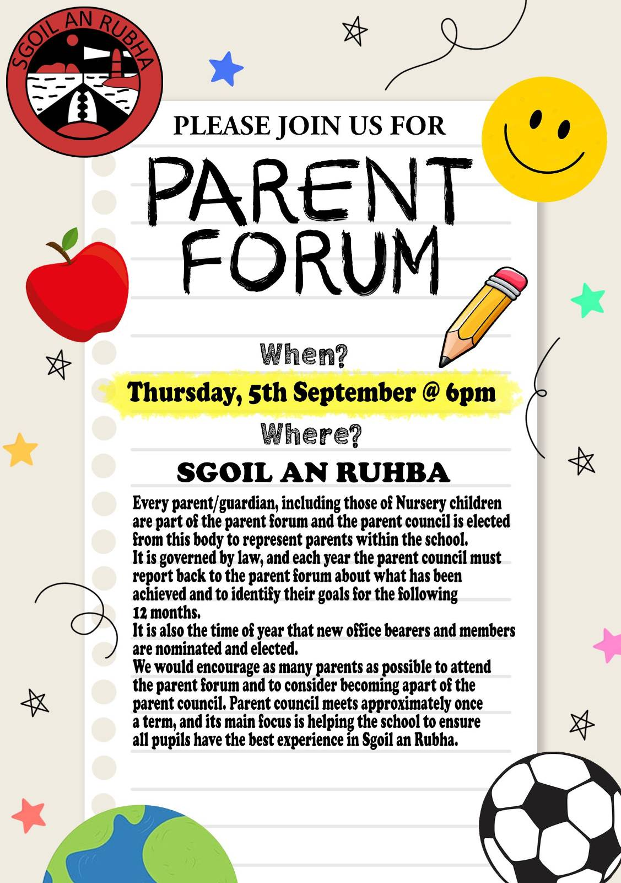

Parent Forum
The annual parent forum will take place on Thursday 5th September at 6pm. We would encourage as many parents as possible to attend as this is when new office bearers are elected. A strong an active Parent Council is vital in ensuring your children receive the best possible experience at Sgoil an Rubha, so please come along.

Medications
Please ensure that if your child requires medication of any sort, including an inhaler, that you have completed a medical form. All medication must be stored in our medical cupboard and must not be kept in school bags.

Drop Off/Pick Up
Polite reminder that as part of our safeguarding protocols, parents should not be going beyond the middle gates during drop off and pick up times. Thank you for your co-operation.

School Improvement Plans
Based on quality assurance activities, including gathering the views of parents, pupils and staff, our improvement projects for this session will be:
- Raising Attainment in English Writing
- Increase Opportunities for Outdoor Learning
- Curriculum Refresh
Please see below for posters which detail the main actions within each project. Our full standards and quality report and improvement plan (SQIP) is available from the school office and will be posted on the school website.

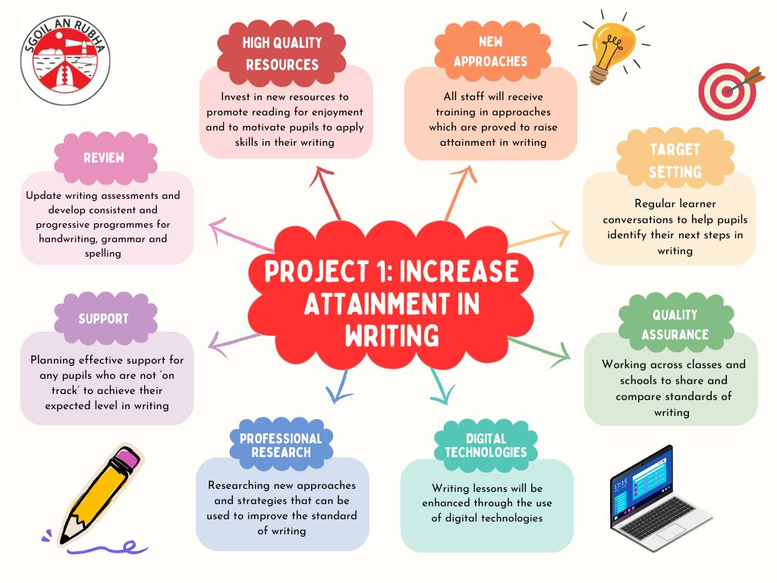

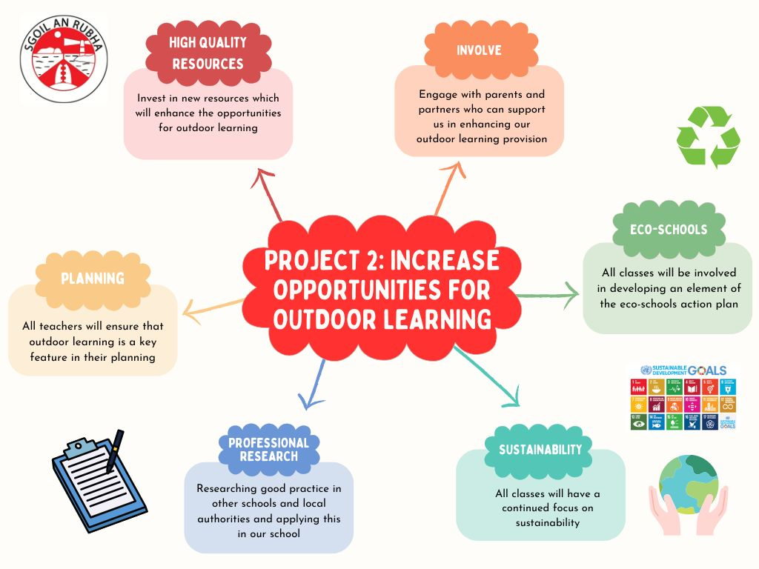

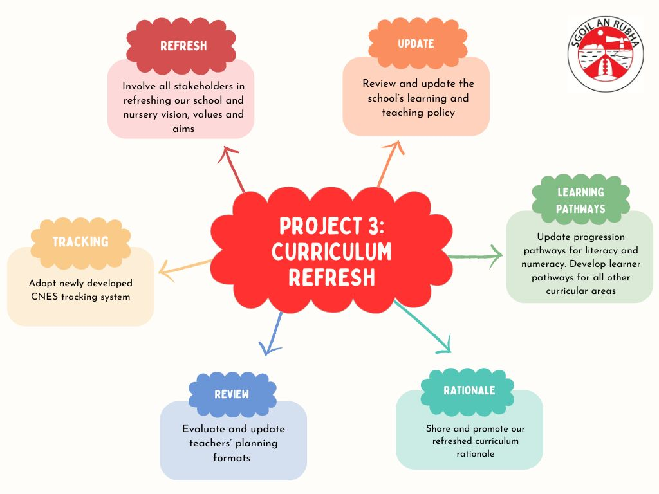

Dates for your diary
Friday 27th September | Feel Good Friday – pupils may dress down
Friday 27th September 11:30am | Macmillan Coffee Morning – all welcome
w/c 23rd September | Flu Vaccines
Thursday 10th October 3:10pm | School closes for October Break

