Sgoil an Rubha - Parental Update
Friday 29th September 2023
Childsmile
All pupils enjoyed a visit from Ali Macleod (Captain Toothpaste) who spoke to them about the importance of oral hygiene. Ali also visited all the classes to see how tooth-brushing is done in Sgoil an Rubha.
(UNCRC Article 24)
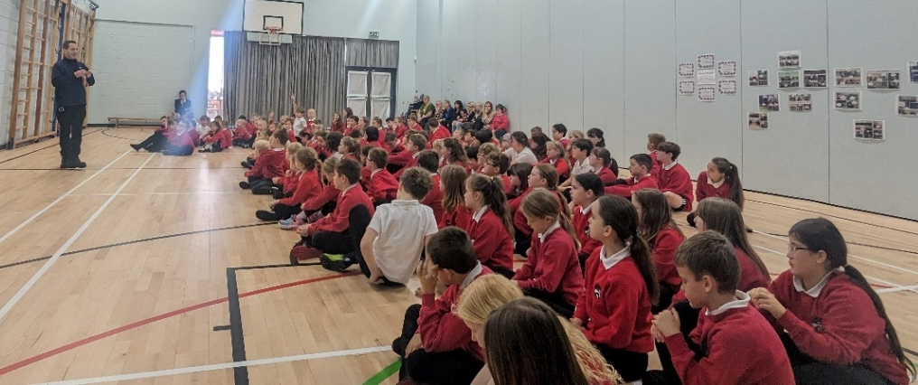

Wider Achievements
A huge well done to Ruairidh Mackenzie and Alex Mackay who were selected to play as part of the Lewis and Harris U11s team in Dingwall on 23rd September. Their team put in an outstanding performance and Ruairidh was also awarded ‘man of the tournament’ – what a massive achievement! Everyone at Sgoil an Rubha is very proud of them. (UNCRC Articles 24 & 15)
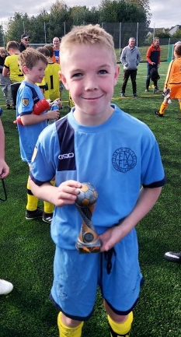
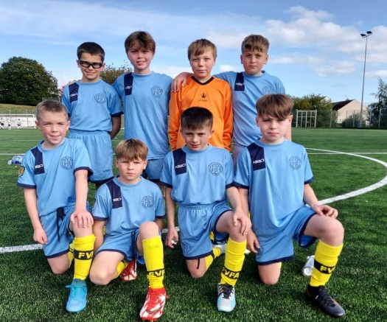

Sports Council
On Thursday the 24th September, Eric Macleod and Anne Macphail held interviews for pupils in P6 and P7 who wanted to form the Sports Council Committee.
All pupils answered exceptionally well and gave well thought out answers as to what skills they could bring to the committee. The timed group task was a challenge, but all pupils had great ideas.
A Sports Committee was selected and will begin working towards achieving the Sports Scotland Gold Award. They will be supported by Mrs Macphail, Eric and the Mini Sports Council, were elected by their peers. (UNCRC Article 24 & 12)

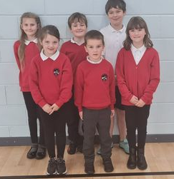
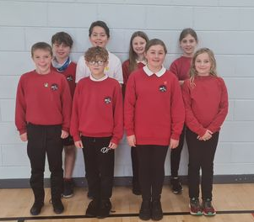

Rights Respecting Steering Group
All classes elected new representative for our new Rights Respecting Steering Group. Pupils will work together with teachers and the management team to ensure that children’s rights are an integral part of all the learning that happens in the school. They will play an important role in implementing our Gold Action plan prior to our accreditation visit scheduled for term 3. (UNCRC Articles 12 & 15)
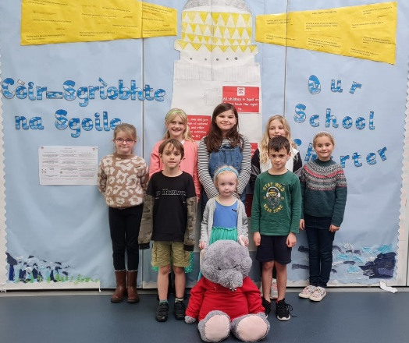

UHI STEM Outreach Programme
P2/3 pupils were delighted to receive a visit from Joan D’arcy, UHI STEM Co-ordinator. She worked alongside the class teacher to deliver some very engaging and interesting activities geared at helping the children learn more about their senses. (UNCRC Article 29)
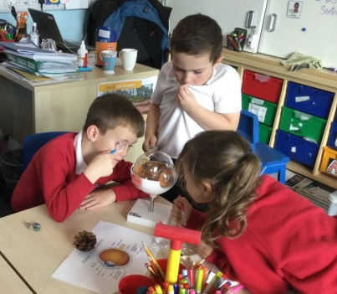
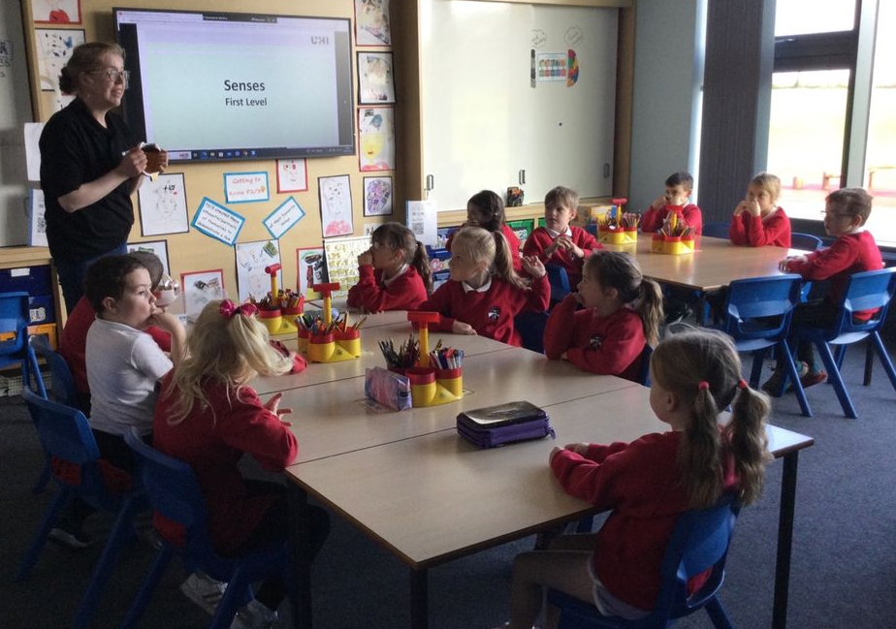
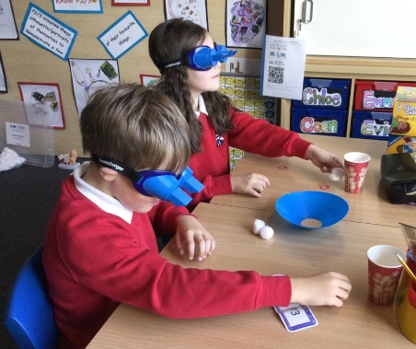

Parent Council Forum
The annual parent forum will be held on Thursday 5th October between 7pm-8pm in the school. We would encourage as many parents as possible to come along and get involved, as the Parent Council plays a very important role in helping the school.
There are a number of positions on the Parent Council that need to be filled including Vice Chair, Treasurer and Secretary. The role of secretary is one which can be paid from a grant from the council, so if anyone would like to carry out this role please let the school know through Janette, or contact the PC Chair, John Moffatt, directly on johnmoffat@mannjudd.co.uk. Nominations for the roles can be submitted beforehand, although they can be intimated on the evening.

Thank You
Thank you to all the families who contributed baking and raffle prizes towards our Macmillan Coffee Morning. It was so lovely to see so many members of the local community in the school, supporting such an important cause. Pupils had an opportunity in the afternoon to select some of the wonderful baking on offer. Thank you to all the parents/carers who made donations.
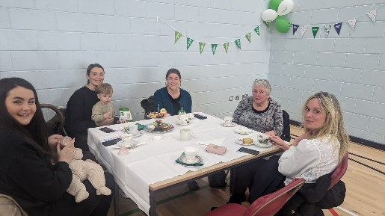
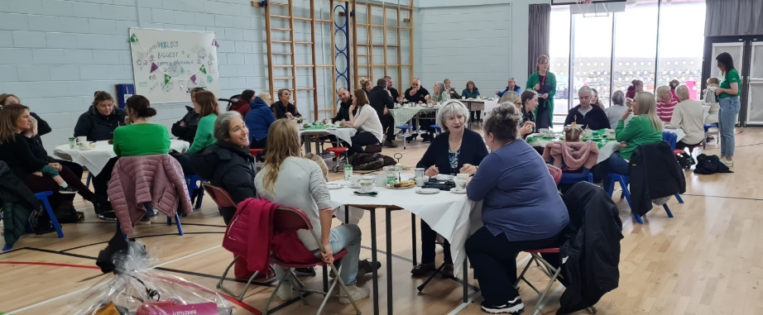

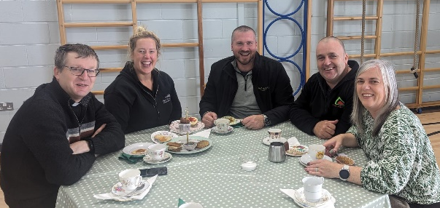

House Captain Update
On Friday 22nd September house points were counted up and it was the Herons who were the house to be rewarded with an early break time. Well done Herons!
The House Captains and Vice Captains were given the difficult task of deciding who should receive the House Mascot. The pupils selected were recognised for their behaviour and adhering to the school values. (UNCRC Article 12)

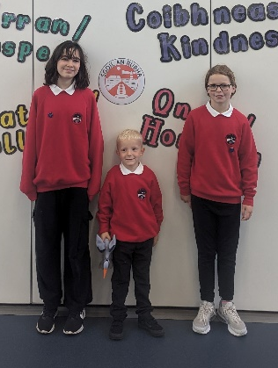
Eagles – Nathan Peck
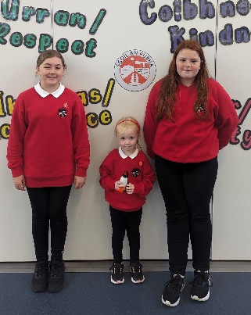
Herons – Finlay Nicolson
Oyster Catchers – Sophia Munro
Puffins – Peggy Macrae

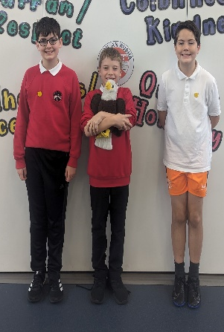
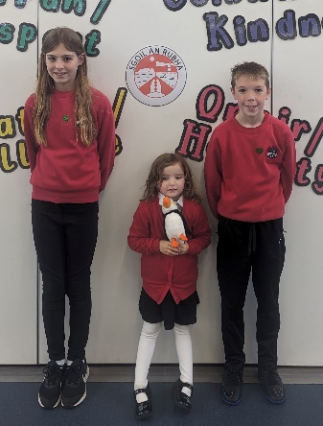



Seasons for Growth® Programme - Learning to live with change and loss
Change and loss are issues that affect all of us at some stage in our lives. It is important to recognise that when changes occur in families through bereavement, separation, divorce and other change-related circumstances, children may benefit from learning how to manage these changes effectively.
Seasons for Growth is a recognised educational programme which is focused on helping children to cope with difficulties they may be experiencing in their lives. The programme is facilitated in small groups and is based on research which highlights the importance of social support and the need the practise new skills to cope effectively with change and loss. It focuses on issues such as self-esteem, managing feelings, problem-solving, decision-making, effective communication and developing support networks.
Families will receive information in the near future with more details about the Seasons for Growth programme. We will also be delivering an information session to all pupils at our whole school assembly in the coming weeks. Additionally, if you think your child would benefit from Seasons for Growth we would encourage you to talk to them about participating in the programme. All participation is subject to parental consent.
Sgoil an Rubha is pleased to be able to offer this important programme and we are confident that it will be a valuable learning experience for those who wish to be involved. If you require further information please contact Mrs Donna Mackay, our ASN Teacher, via the school office. (UNCRC Article 24, SDG 3)

October Break
The school will close on Thursday 12th October at 3:10pm, for the October Break. It will reopen to staff on Wednesday 25th October and to pupils on Thursday 26th October.

Afterschool clubs
Mondays  Monday until Oct Break | CNAG after-school club (3:10-4:45pm)  Georgia’s P5 Sports (3:10-4:30pm)
Tuesdays | CNAG after-school club (3:10-4:45pm)
Wednesdays until 20th Sept. | Georgia’s P3 Sports club (3:10-4:30pm)
Thursdays until Dec Break  Thursdays until Oct Break | Gaelic Homework Support (3:10-4:30pm)  P1 Sports club (3:10pm-4pm)

