Sgoil an Rubha - Parental Update
Friday 14th June 2024
Dileab
Well done to our GM5-7 pupils who delivered an amazing performance on Thursday 23rd May to a ‘full-house’. The children very much enjoyed sharing their learning about our local history and feedback after the show was extremely positive.
Following the success of the Dìleab evening, GM5-7 performed a ten minute abridged version of the play, at the Local Mod. It was a challenge to cut down such a fantastic script but the children worked well and achieved their goal – Their Mod play came in under the ten minute Mod play allowance, whilst still keeping the main plot, dramatisation, expression and Gaelic Language to the fore.
While the performances themselves were the heart of the matter, the process was just as important. The skills our pupils learned, and developed, were very useful to them and will last them a lifetime. The entire Dìleab experience also gave them the opportunity to improve their language skills and use Gaelic in different situations.
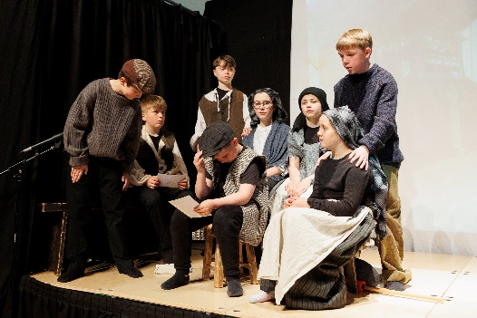
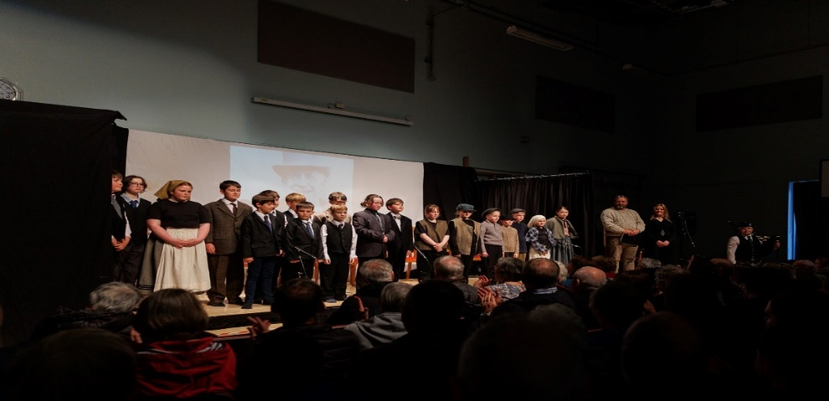
Thank you to Miss Mackenzie, Marisa Macdonald and her whole team for supporting the children in their participation in the Dileab project.

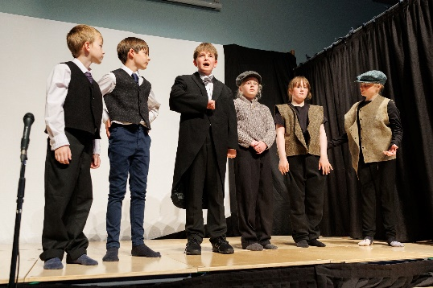

Cuach Na Cloinne
Congratulations to our Sgoil an Rubha stars who took part in CNAG’s National Cuach na Cloinne Finals in Inverness on Wednesday 30th May.

Earlier on in April, Sgoil an Rubha’s ‘Sgioba A’ won the Lewis and Harris heats, where 29 teams took part in the local competition. Three football teams from Sgoil an Rubha played fantastically, that day, whilst our support team brought along the Rubhach supporting spirit!

As a result of Sgioba A’s local win, training took place almost every day, to prepare for the finals in Inverness. Wednesday 30th May finally arrived, and excitement and nerves were building as our team travelled to Ullapool, by ferry, and then onwards to Inverness, in the Point & Sandwick minibus. We are grateful to Point & Sandwick Trust for allowing us use of their minibus.

This year, in total, 109 teams from throughout Scotland competed, and Sgoil an Rubha were delighted to come home with silver medals! We are all very proud of you. They played fantastically and demonstrated superb sportsmanship throughout the tournament. Our team played football of a very high standard during the tense final against Glasgow Gaelic School. Our congratulations go to them on their win. Many thanks to Mgr. Macrae and Sarah Mackay for coaching our wonderful team. Our thanks also go to the parents who accompanied us on our trip. Tapadh leibh.
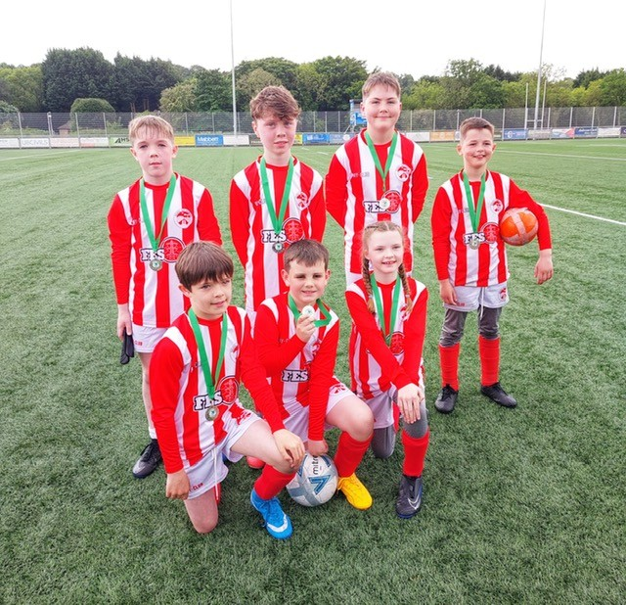


RRSA Award
We are delighted to have officially achieved the Rights Respecting Schools Gold Award. It is wonderful that the excellent work of the staff and pupils to embed Children's Rights across the school and curriculum has been recognised. The assessor identified our focus on sustainability, the strong pupil voice and the caring and inclusive ethos of the school as some of the key strengths.

Euroquiz
Well done to our P6 pupils who recently travelled to Edinburgh to take part in the Euroquiz Final, held in McEwan Hall at The University of Edinburgh. Following their success in the Western Isles Heat, they demonstrated great motivation and commitment to preparing for the Final and, despite not winning, we are extremely proud of how well they represented the school and the Islands! Many thanks to Mrs Macleod for coaching them and leading the trip. Thank you to Mr Macrae who also accompanied the children on the trip.
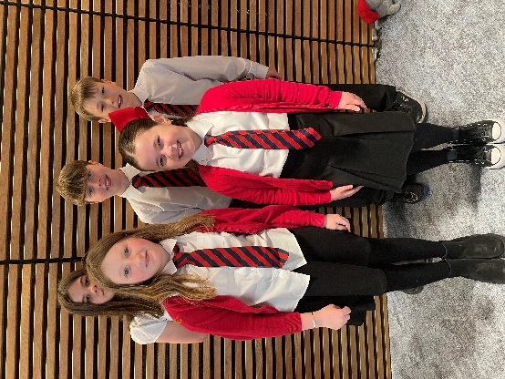
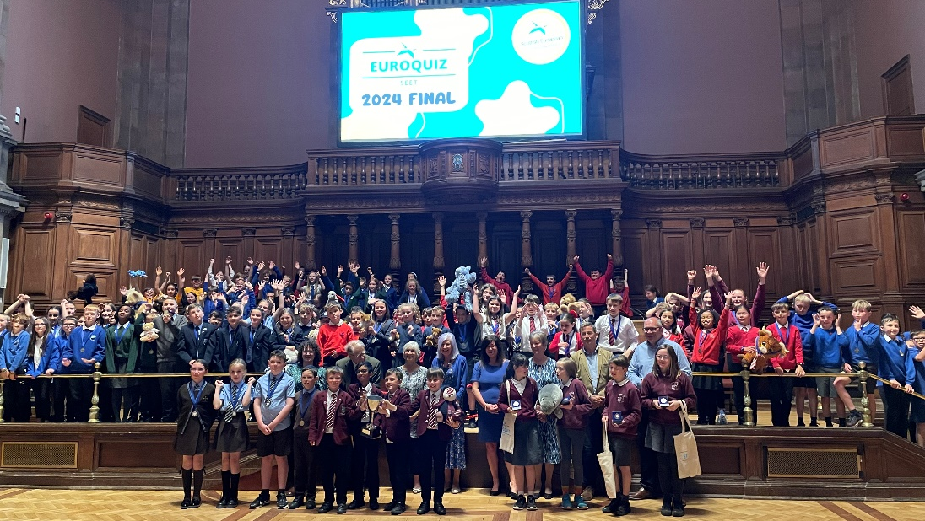

Mòd Ionadail Leòdhais
Bha a h-uile neach ag obair cruaidh ag ionnsachadh na piosan aca fad an teirm seo, ag obair le ar luchd-cuideachaidh saor-thoileach Gàidhlig agus Ceòl a h-uile Diluain ‘s Dimàirt agus cuideachd ag obair cruaidh aig an taigh le na paranantan aca. Bha feadhainn den na cloinne gu math soirbheachail agus fhuair iad duaisean ann na fharpaisean aca fhèin! Fhuair Orla a'chiad àite ann an solo luchd-ionnsachaidh airson clas 4/5 agus an dàrna aite airson aithris bàrdachd luchd-ionnsachaidh clas 4-5. Fhuair Ava Grace an treas àite ann an co-fharpais seinn airson luchd-ionnsachaidh clas 1-3.Fhuair Katie an dàrna àite agus Ellen an treas àite airson aithirs bàrdachd luchd-ionnsachaidh clas6/7 agus fhuair Alyson an dàrna aite airson solo luchd-ionnsachaidh clas 6/7. Fhuair Iain James an treas àite airson seinn traidseanta. Fhuair Anna Jane an treas àite ann an sgeulachd fileantaich. Cuideachd, mar chlas fhuair Clas 1-4 Gàidhlig an treas aite anns na dealbhan-cluiche airson clasaichean Gaidhlig 1-7.
'S math a rinn sibh uile. ‘S e rud mor gaisgeil a th'ann a bhith a’ seasamh air àrd-ùrlair leat fhein no le buidheann! Abair gu bheil rionnagan againne nar sgoil agus tha na tidsearan cho moiteil asaibh! Tapadh leibh cuideachd do ar luchd-cuideachaidh saor-thoileach Gàidhlig agus Ceòl; Ishbel Mackay, Catriona Dunn, Alma Jamieson agus Sarah Mackay airson a’ chlann a chuideachadh ag ionnsachadh nam piosan aca. Tha sinn uile cho taingeil! 'S math a rinn sibh uile.
Sgoil an Rubha had a very successful week at the Lewis Local Mod at the beginning of June. 56 children from the school took part across the fluent and learner categories between individual and group recitations, solo singing, traditional singing, storytelling, playlets and our choir. All the children enjoyed taking part in the mod and are keen to take part again next year, promoting Gaelic within our school and local community.
Every child who took part worked hard all of term 4 to learn their poems, songs and lines, working with our amazing community volunteers every Monday and Tuesday, also working at home with their parents to prepare. Children who learned and performed at the Mod should feel very proud of themselves and some were extremely successful earning prizes and placings as a reward for their hard work. Orla (P5) earned a 1st for her learner’s solo and a 2nd place for her learner’s recitation. Ava Grace (P1) came 3rd in her learners solo, Alyson earned a 2nd place for her solo and Katie (P6) and Ellen (p7) earned 2nd and 3rd place respectively for their learner’s recitations. Iain James (GM7) sang his way to a 3rd in the traditional singing category and Anna Jane (GM5) came 3rd in her Gaelic storytelling competition with a true story about the goings on in Bayble on Halloween many years ago! GM1-4 also placed 3rd for their playlet telling the story of Mariella the Princess of Point.
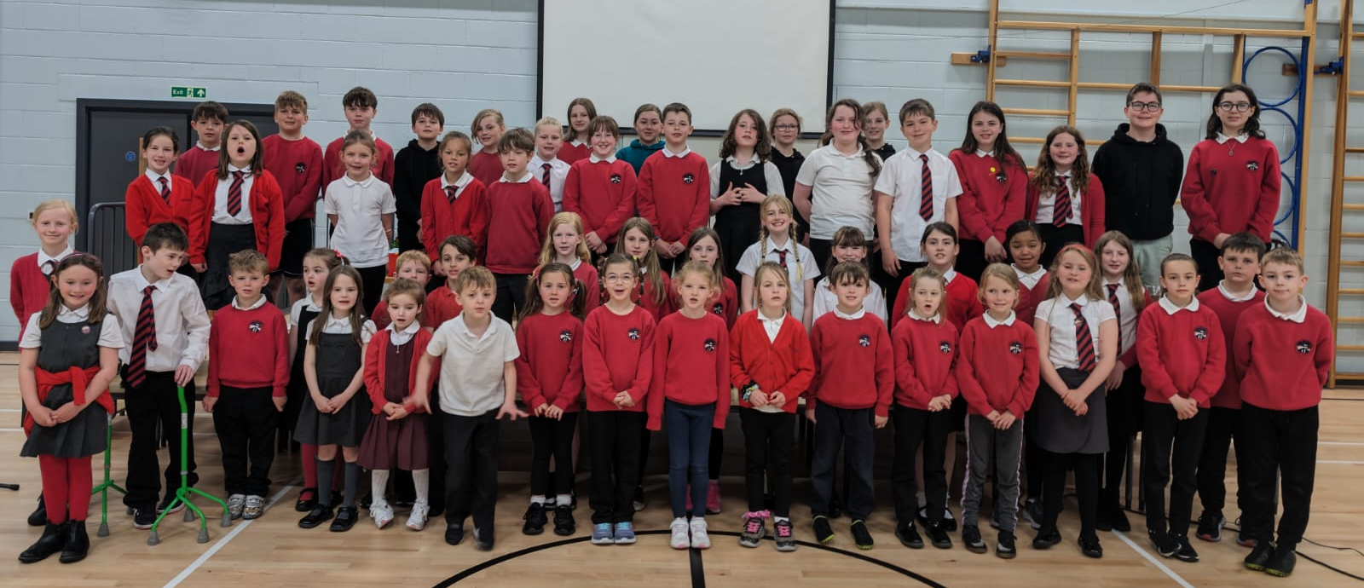
Well done to every child who took part in this year’s Mod. It was amazing to watch them perform with poise and confidence both as individuals and groups on stages around Stornoway including An Lanntair and the Town Hall. They are all stars and we are so proud of them all as a school! We must also thank our fantastic community volunteers who supported their learning of Gàidhlig and music ; Ishbel Mackay, Catriona Dunn, Alma Jamieson and Sarah Mackay. The school is so fortunate to have such wonderful community support.

Developing the Young Workforce (DYW) Week
Many, many thanks to all our parents and partners who volunteered to be part of this week’s DYW Focus Week. There was a fantastic atmosphere all around the school and nursery as we welcomed a wide range of visitors who worked with the children and discussed the skills required for their profession. The pupils have been wholly enthusiastic about the week and have been inspired by the input they’ve had.
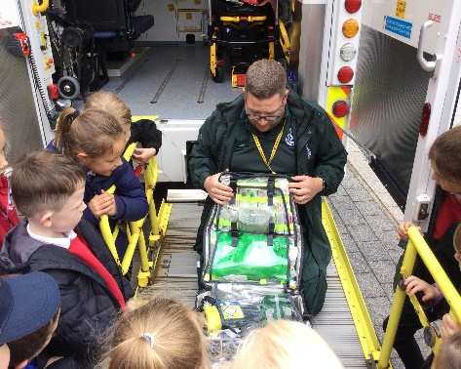
During the week many of the children also had the opportunity to get out into the community to learn about the wider world of work and the work of the Point and Sandwick Trust. Many thanks to Baiba, O’Mac and D.J. Macsween for hosting our visits.
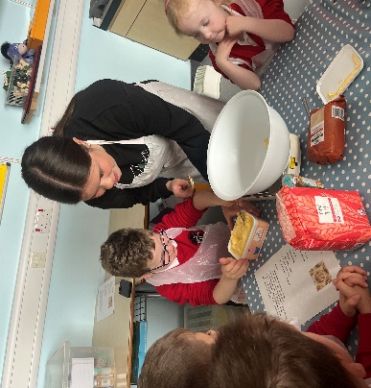
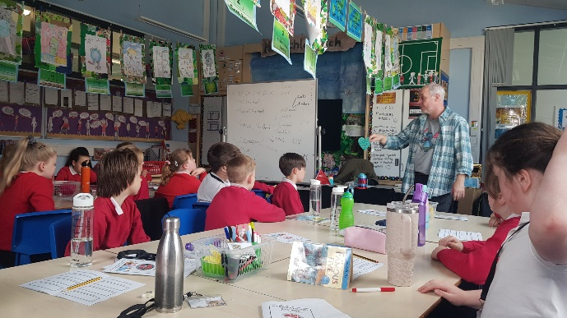
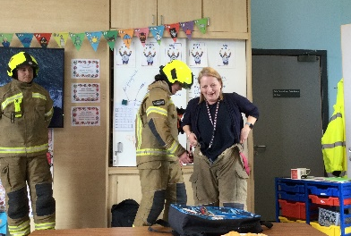
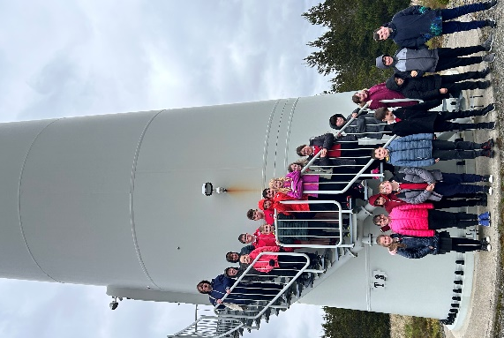
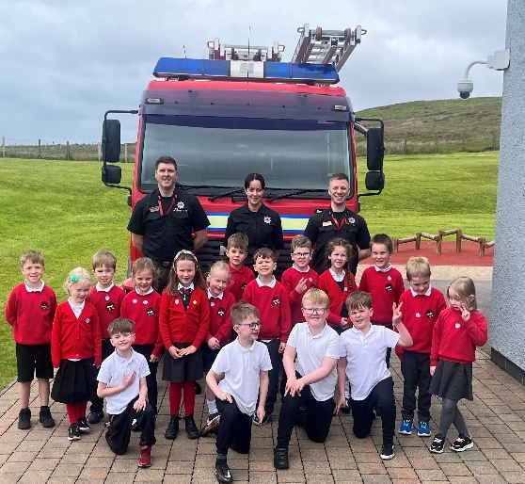
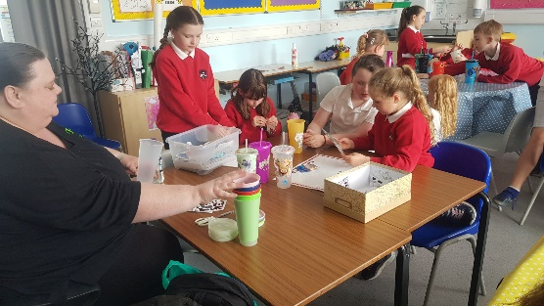
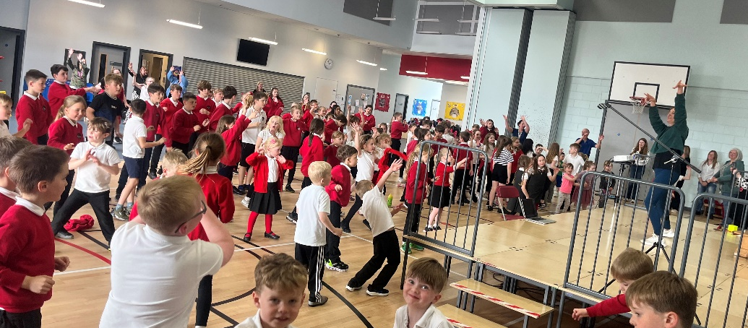
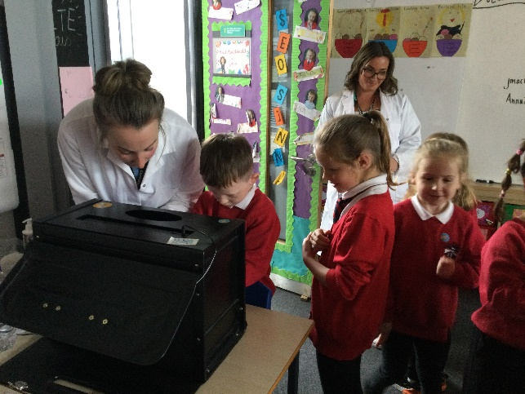

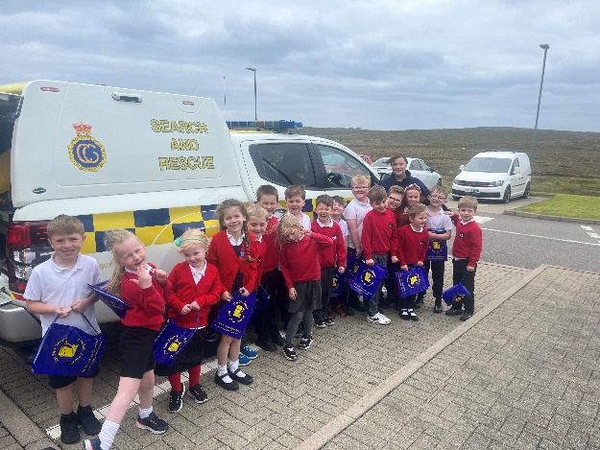

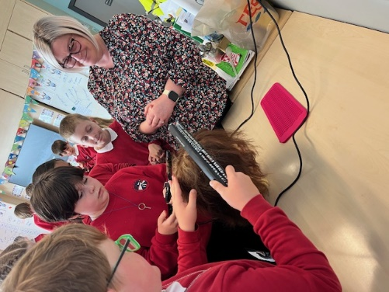

Eco-Committee Update
The ‘Green Team’ recently successfully campaigned to FES to provide a raised bed and an area for outdoor planting. They received a donation of topsoil from O’Mac, kindly delivered on Friday by Donnie Mackay, and will soon start growing our own school vegetables. (UNCRC Article 29)

One of green team members recently wrote about how the shredding from the school is being re-purposed:
Fhuair sinn pàipear leòbach bho oifis Sgoil an Rubha airson ath-chleachdadh a dhèanamh air.
An toiseach, chleachd sinn am pàipear airson leabaidh chofhurtail a thoirt dha na cearcan gain.
An uairsin, chleachd sinn e a-rithist airson compost a chruthachadh dha na lusan agus na lusragan gain.

Our family were able to reuse the shredded paper we got from the school office.
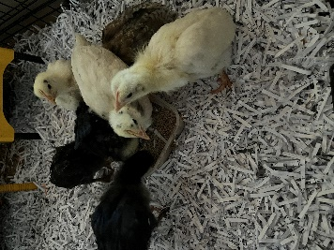
Firstly, we used it to make a lovely, comfortable bed for our hens. Then, we used it to add to our compost heap for growing herbs and vegetables.
Ava Mae GM3 Sgoil an Rubha Eco Committee

P7 Leavers’ Assembly
P7 pupils are busy preparing for their final Primary assembly. They will lead their assembly on Friday 21st June at 2pm. All P7 parents and family members are invited to attend.

Prizegiving
Our annual Prizegiving Assembly will be held on 25th June at 1.30pm. Letters will be issued to parents of pupils who will receive prizes, although all parents are invited to attend. Please note that certificates for participation in the Pupil Council, Eco-Committee, RRSA Steering Group and Sports Council will be issued in the morning and this will not form part of the main Prize-giving event.

End of Year whole school trip
The whole school will head out on their annual trip over to Ness Playpark on Wednesday 26th June. We are very grateful to Point and Sandwick Trust for financing the transport for the trip.

Dates for your diary

Wednesday 19th June | Charlie Nicolson Cup
Thursday 20th June | P7 Leavers’ Lunch
Friday 21st June | P7 Leavers’ Assembly
Tuesday 25th June | Prizegiving
Wednesday 26th June | Whole school outing
Wednesday 26th June | Nursery Graduation
Thursday 27th June 3.10pm | School Closes for Summer break
Monday 12th August | School reopens for staff
Thursday 14th August | School reopens for pupils

