Sgoil an Rubha - Parental Update
Friday 10th May 2024
P7 Trip
It was an early start for our P7 pupils on Wednesday as they headed off on their trip to Fairburn Activity Centre. The whole group have been having a wonderful time and making the most of the activities on offer. We look forward to welcoming them back to school on Monday and hearing all about their experience. Thank you to Point and Sandwick Trust who funded the entire trip again this year.
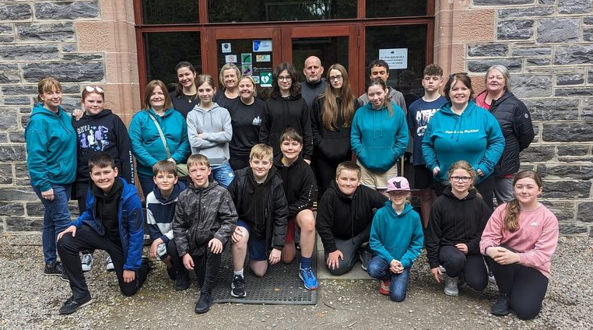

Bikeability
Last week, some of our pupils travelled up to Stornoway to participate in part 2 of Bikeability training. Despite getting pretty wet, the children had a great time cycling around the streets in town and around the castle grounds. They all listened very well and were very well behaved. (UNCRC Article 24)
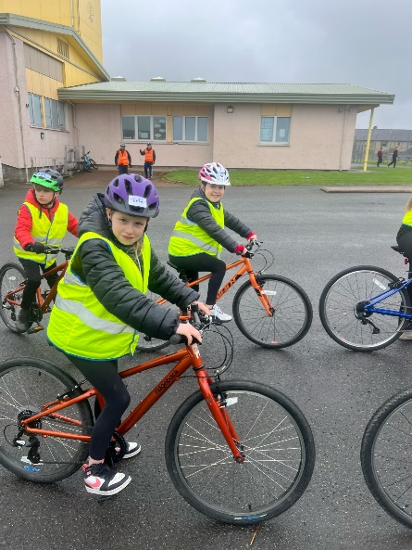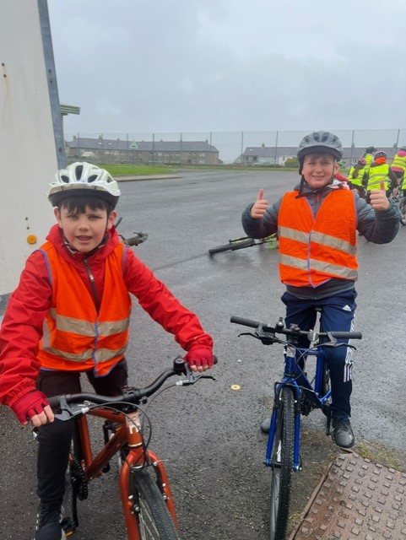

Dìleab 2024
GM5-7 pupils are busily preparing to showcase what they have learned through the Dileab project with a performance to be held on Thursday 23rd May at 7.30pm. Tickets for families are now on sale. Tickets will go on sale to the general public on Monday 13th May. (UNCRC Articles 29 & 30)
https://www.eventbrite.com/e/dileab-2024-leverhulme-sgoil-an-rubha-tickets-902190113917?aff=oddtdtcreator

Eco-Committee
The ‘Green Team’ continue to work hard in ensuring the school is as eco-friendly as possible. They recently organised for extra recycling bins in the playground and designed posters to encourage pupils to use the new bins properly. Nathan and Ella created the winning posters. (UNCRC Article 29)
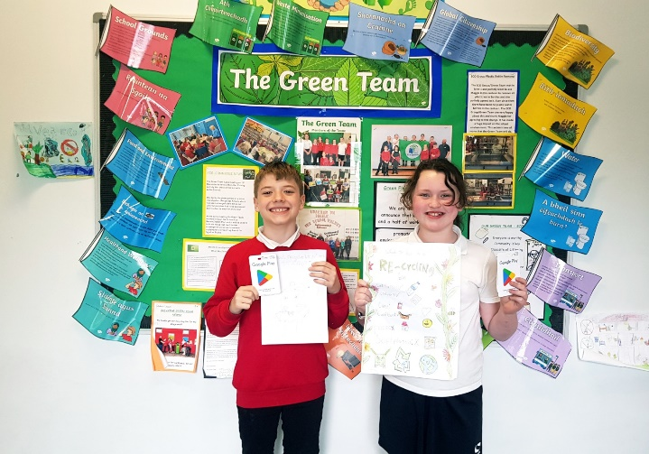

Parent Council Meeting
​There will be a Parent Council meeting on Thursday 23rd May at 6pm. All parents are encouraged to come along and share their views.

DYW Focus Week
Many thanks to all the parents who have volunteered to be part of our DYW Focus Week between 10th-13th June. We are really looking forward to having lots of visitors in the school to work with the pupils to enhance their understanding of skills for work. There is still time to volunteer or to make suggestions, so please get in touch via the school office.


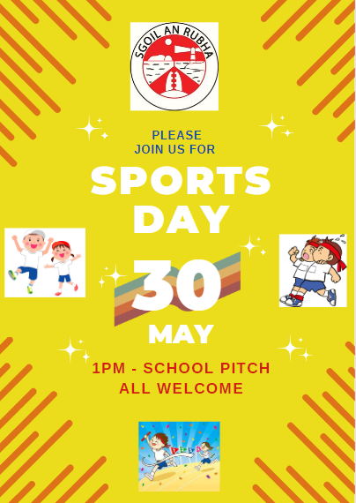

Parental Questionnaire
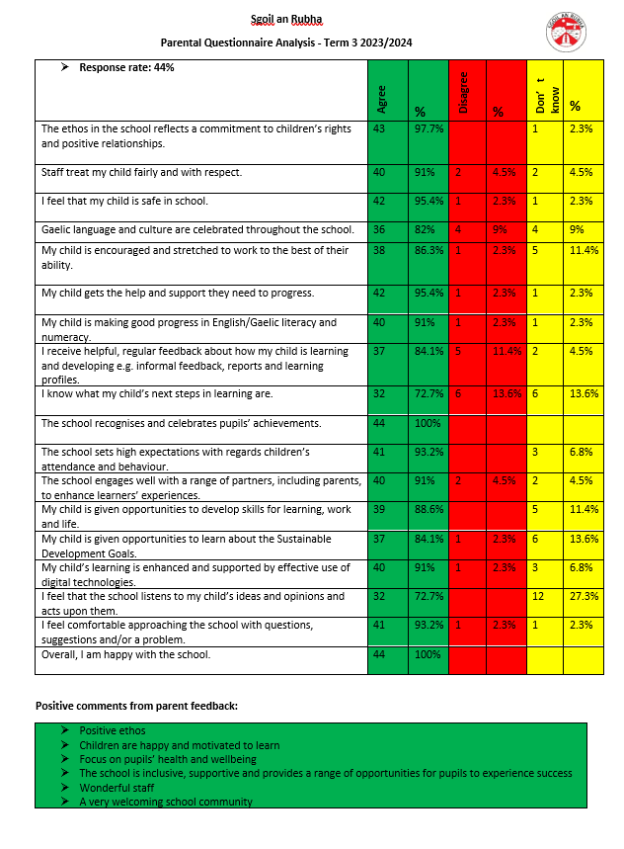
Thank you to all the parents who took the time to complete the recent parental questionnaire. The response rate was good. The results and planned actions are detailed below. Please do not hesitate to get in touch if you have any further comments or ideas on how we can continue to improve the school.
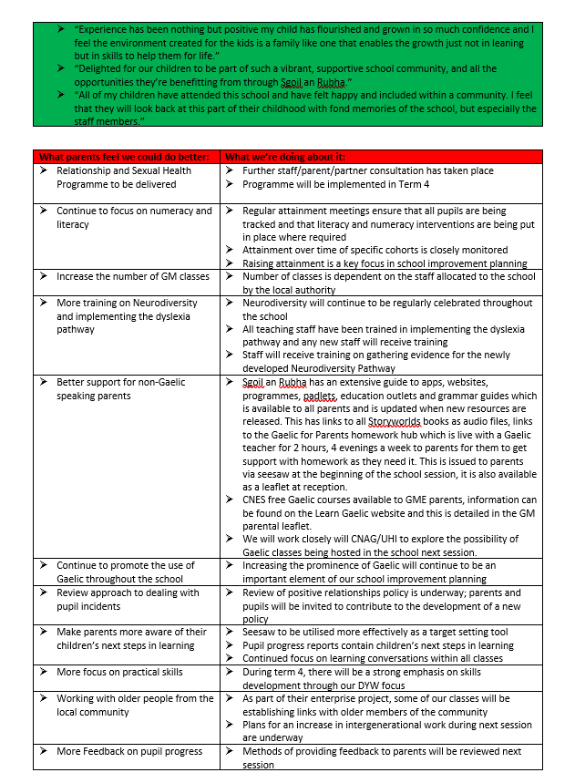




Dates for your diary

8th – 10th May | P7 Trip to Fairburn
Thursday 23rd May 6pm | Parent Council meeting
Thursday 23rd May 7.30pm | Dileab Performance
Wednesday 29th May | Cuach Na Cloinne Finals (Inverness)
Thursday 30th May | School Sports Day
Friday 31st May | WIIGA (Rural Sports)
Saturday 1st June | The Leanne Fund 5K & 10K
Tuesday 4th – Friday 7th June | Mod
Monday 10th – Thursday 13th June | DYW Focus Week
Monday 10th June | Euroquiz Final (Edinburgh)
Friday 14th June | Craft fair/enterprise day
Wednesday 12th & Thursday 13th June | P7 Transition days to The Nicolson Institute
Wednesday 12th June 9.30-12.00pm | P1 Transition morning
Friday 21st June | P7 Leavers’ Assembly
Tuesday 25th June | Prizegiving
Wednesday 26th June | Whole school outing
Wednesday 26th June | Nursery Graduation

