Sgoil an Rubha - Parental Update
Thursday 25th April 2024
Cuach Na Cloinne
Well done to all GM pupils who took part in the recent Cuach Na Cloinne Competition. All GM4-7 pupils were given the opportunity to participate and 3 teams were entered, we were delighted when one of these teams won the competition. The team will now progress to the final to be held in Inverness on 29th May. Thank you to Miss Mackenzie, Mr Macrae and Sarah Mackay who all helped to the coach the children. Thank you to FES for sponsoring our new kit. (UNCRC Article 24)
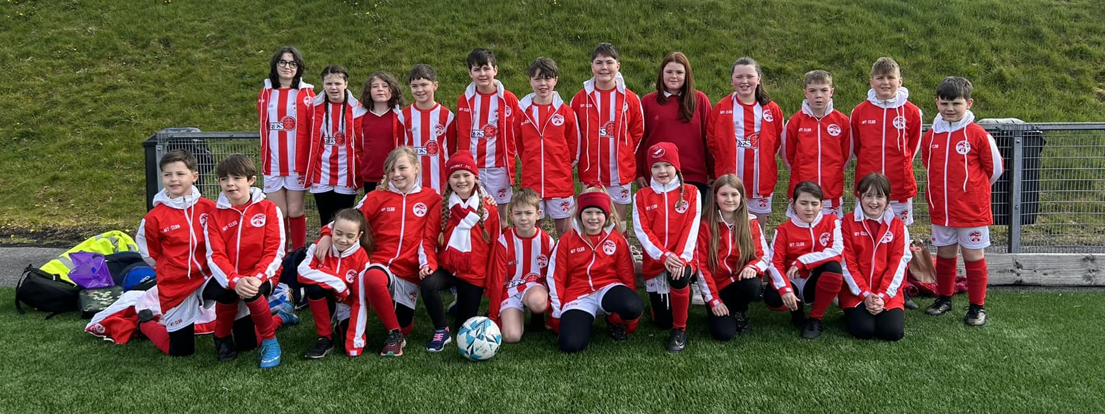

Easter Assembly
Last term ended with a wonderfully engaging Easter Assembly led by Rev. Tommy Macneil. The children learned about the true meaning of Easter in a fun and interesting way. It was lovely to welcome Tommy into the school, as the latest member of our expanding chaplaincy team.
(UNCRC Article 14)
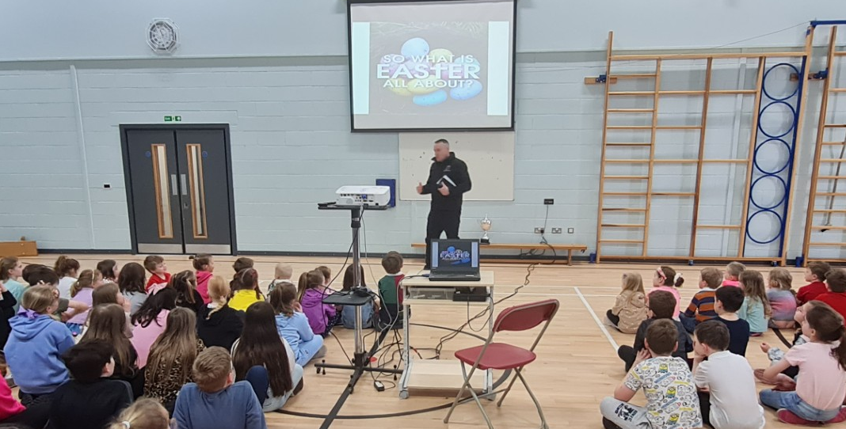

Relationships and Sexual Health Programme (RSHP)
Letters and RSHP planners were issued to all parents yesterday. Please take the time to review the resources that will be used and to completed the form to confirm whether your child will participate in the lessons or not.
https://forms.office.com/e/zTEmYu6ne4

Sharing the Learning
At the end of last term, each class had the opportunity to share their learning, in relation to the 4 capacities, with the whole school. It was fantastic to hear the children talking about their learning so enthusiastically and to see all the excellent work that is being done in every class to ensure that our pupils are becoming successful learners, responsible citizens, effective contributors and confident individuals. Achiever of the Term and Gaelic speaking certificates were also awarded. (UNCRC Articles 28 & 29)
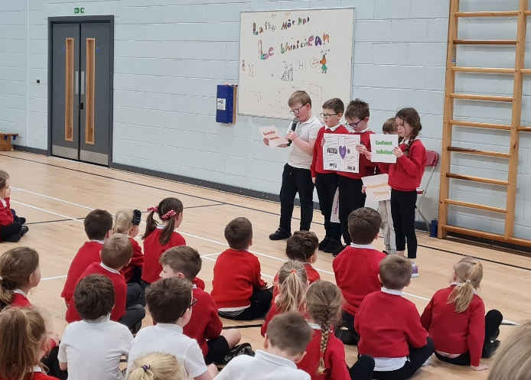
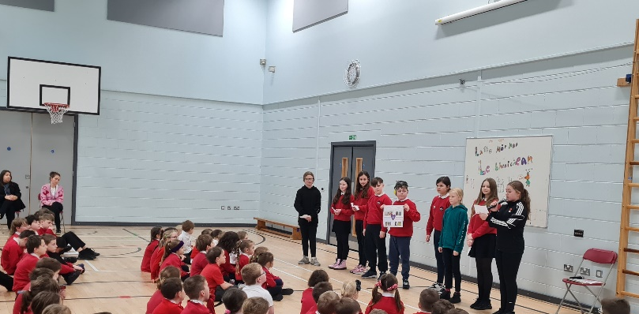
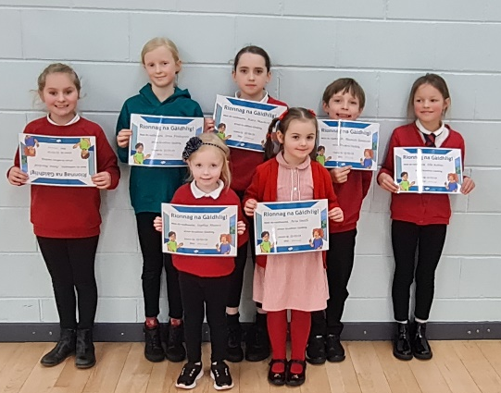
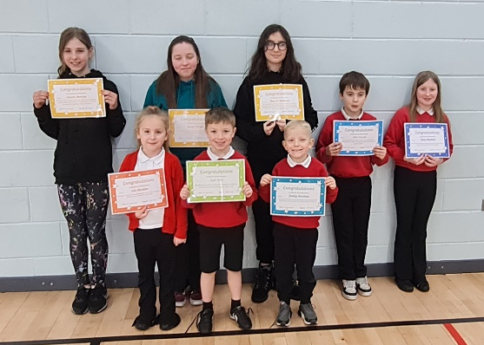
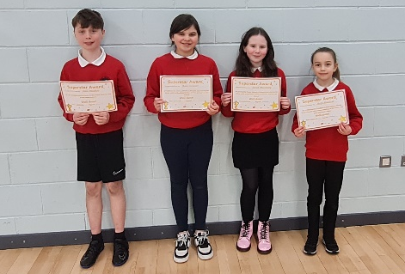

Parental Questionnaire
Thank you to all the parents who took the time to complete the recent parental questionnaire. The response rate was good and we will share the results and planned actions with you in the coming weeks.

Parent Council Fundraising Meeting
​There will be a Parent Council meeting on Thursday 2nd May at 6pm to discuss possible fundraising activities. All pupils benefit from the funds raised by the Parent Council, so we would encourage as many parents as possible to come along the meeting.

Dìleab 2024
GM5-7 pupils have continued their work on the Dileab project and are now busy preparing for a community drama performance. We are very fortunate to have had Catriona Dunn, Anna Frater and Marisa Macdonald working with the class.
The performance is scheduled to take place on Thursday 23rd May at 7.30pm. Information regarding tickets will be issued shortly.


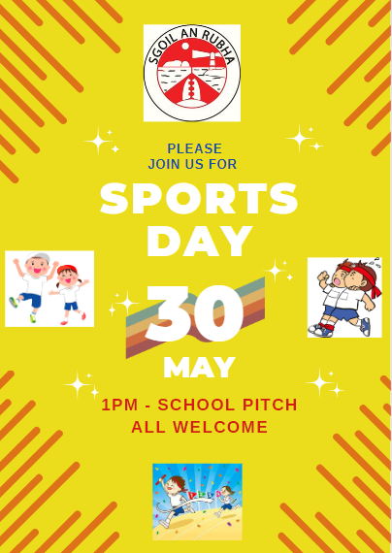

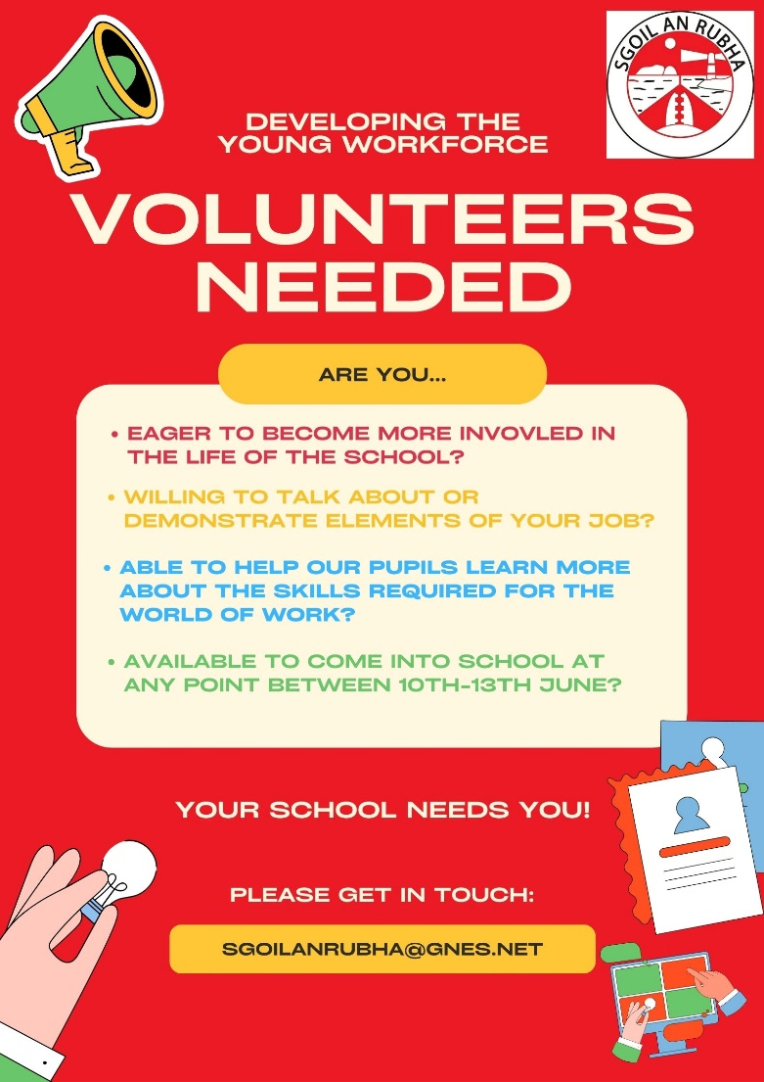

Dates for your diary

Friday 26th April | School closed
Monday 29th April | School closed
Tuesday 30th April | Meeting for P7 parents regarding Fairburn trip
Thursday 2nd May | Parent Council fundraising meeting
Monday 6th May | P6 Bikeability 2
8th – 10th May | P7 Trip to Fairburn
Thursday 23rd May 6pm | Parent Council meeting
Thursday 23rd May 7.30pm | Dileab Performance
Wednesday 29th May | Cuach Na Cloinne Finals (Inverness)
Thursday 30th May | School Sports Day
Friday 31st May | WIIGA (Rural Sports)
Saturday 1st June | The Leanne Fund 5K & 10K
Tuesday 4th – Friday 7th June | Mod
Monday 10th – Thursday 13th June | DYW Focus Week
Monday 10th June | Euroquiz Final (Edinburgh)
Friday 14th June | Craft fair/enterprise day
Wednesday 12th & Thursday 13th June | P7 Transition days to The Nicolson Institute
Wednesday 12th June 9.30-12.00pm | P1 Transition morning
Friday 21st June | P7 Leavers’ Assembly
Tuesday 25th June | Prizegiving
Wednesday 26th June | Whole school outing

Safe Families Western Isles
Safe Families Western Isles is a local charity that supports families going through difficult times. This support is given by trained volunteers who are keen to support their community; and can support a family by being the parent’s befriender, a helper and befriender to their children, and/or by offering overnight stays at their own home so that the family can have a break.
Safe Families Western Isles will support families who have a child/children within the ages of 3-15, and there are no limits on who can refer a family to us. This includes social workers, health visitors, GPs, schools etc. We also take self-referrals. For more information, please contact us on 01851 827308, or
e-mail westernisles@safefamilies.uk

