Sgoil an Rubha - Parental Update
Friday 26th January 2024

New House Captains and Vice Captains
Every January we re-elect our House Captains and Vice Captains, to allow all P7 pupils the opportunity to take on a leadership role. Well done to the pupils who put themselves forward for election, the standard of presentations was very good. Our new Captains and Vice Captains are pictured below.

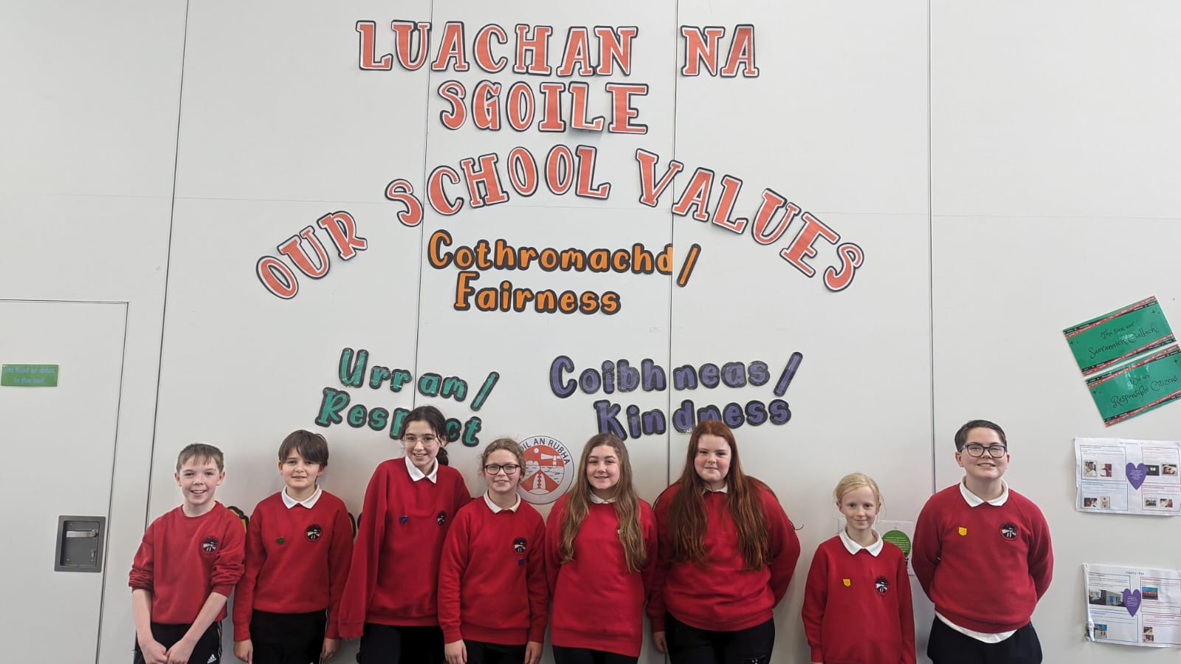

Wizard of Oz
Last Friday, P4-6 pupils enjoyed a trip to An Lanntair to see the ‘The Wizard of Oz’. They had a fantastic time and really got involved in all the fun. Many thanks to our parent volunteers who came along to help with supervision.
Well done to our pupils who were selected to be part of the dance team in the Panto. They did a terrific job and we are very proud of them all.


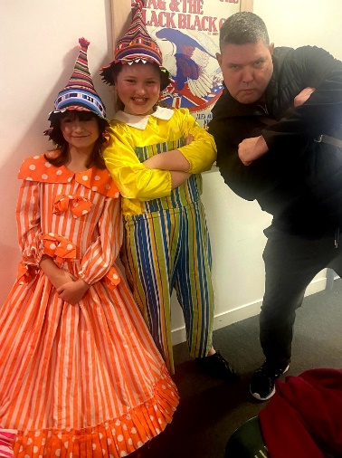
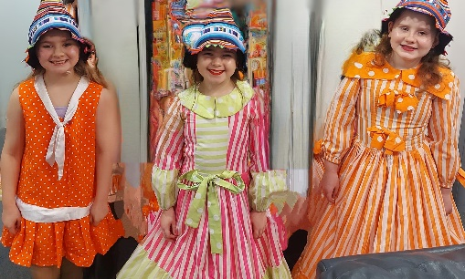


Summative Assessments
All P5 pupils have now completed their Cognitive Ability Tests (CATs) and results have been issued to parents, today. If you wish to discuss your child’s results, please do not hesitate to get in touch with their class teacher via the school office.

New Entrants Open Afternoon
Parents of children who are eligible to enrol in school in August 2024 are invited to attend our information afternoon.

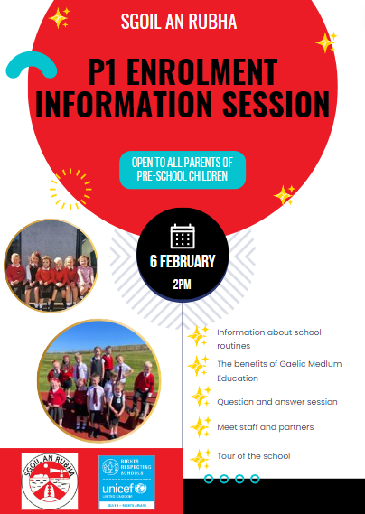

Safe Families Western Isles
Safe Families Western Isles is a local charity that supports families going through difficult times. This support is given by trained volunteers who are keen to support their community; and can support a family by being the parent’s befriender, a helper and befriender to their children, and/or by offering overnight stays at their own home so that the family can have a break.
Safe Families Western Isles will support families who have a child/children within the ages of 3-15, and there are no limits on who can refer a family to us. This includes social workers, health visitors, GPs, schools etc. We also take self-referrals. For more information, please contact us on 01851 827308, or
e-mail westernisles@safefamilies.uk

Dates for your diary

Friday 26th January | Feel Good Friday
Thursday 1st February | Childsmile Visit
Tuesday 6th February | Safer Internet Day
Thursday 15th February 3:10pm | School closes for mid-term break
Wednesday 21st February | Staff In-service
Thursday 22nd February 9:10am | School reopens for pupils
Friday 23rd February | Feel Good Friday
Friday 29th March | Feel Good Friday
Friday 29th March | Pupil Progress Reports to be issued
Friday 29th March 3:10pm | School closes for Easter Break

