Sgoil an Rubha - Parental Update
Friday 27th October 2023
Welcome back
A very warm welcome back to all our learners. We hope everyone had a restful break and are ready for the busy term ahead. It was great to end the short week with Feel Good Friday, pupils had great fun dressing up. (UNCRC Article 31)
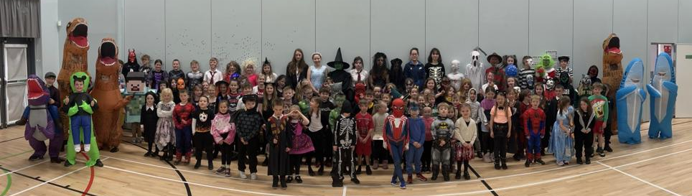

Design Workshop
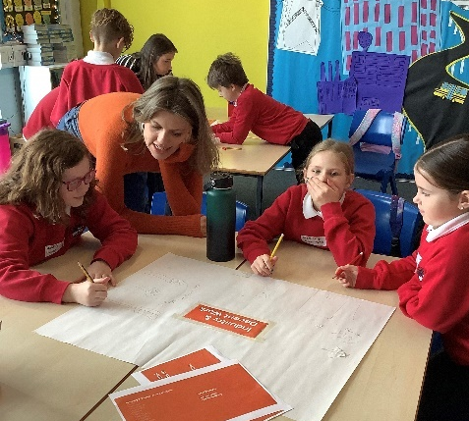
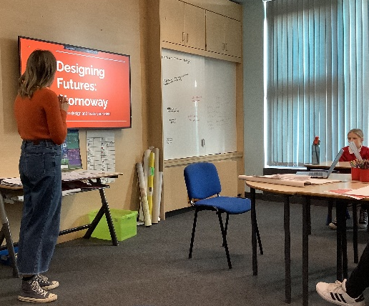
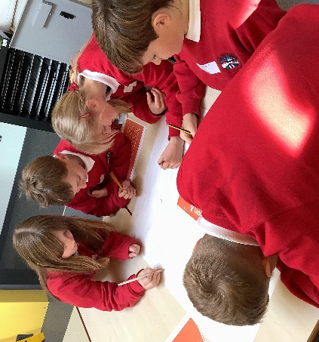
During the last week of last term P5/6 pupils took part in a design workshop with Mrs Macleod’s daughter, Freya. Freya taught the class design skills like perspective, mapping, model making and drawing skills to plan how they might want to improve Stornoway in a sustainable way. Look out for their model town, coming soon. (SDGs 8 & 9)

Blythswood Appeal
Thank you so much to all the families who donated towards the Blythswood Shoebox Appeal. It is an important appeal in educating our pupils about children in other parts of the world who are less fortunate than themselves, and I’m certain the boxes will be very much appreciated by the recipients. The boxes will be delivered to the depot this afternoon.
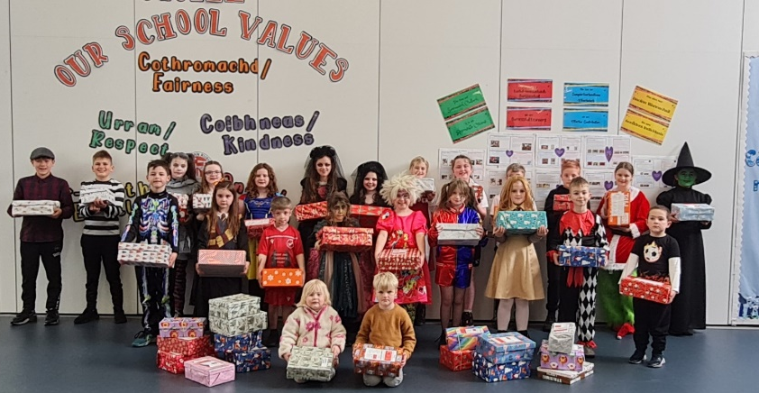

Ella’s Letter
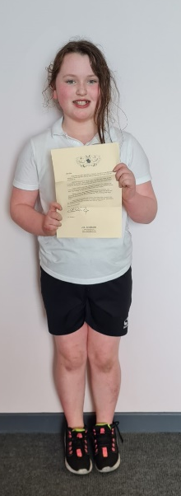
As part of GM5-7’s learning in English Language, the children developed their letter writing skills. As a class, they discussed inspirational people, and listed what made them stand out above the rest. They then selected their own inspirational person and wrote a thank you letter to them. The letters were all fantastic. Some wrote to family members, some wrote to famous people such as Tom Grennan and Cristiano Ronaldo, whilst others wrote to school staff members, including our fantastic canteen staff.
Ella Mackay in GM5 wrote to J.K. Rowling in the hope that she would get a reply. On Thursday 26 October, Hedwig the Owl delivered a letter all the way from Hogwarts and left it on Ella’s desk in the GM5-7 classroom. Her wish had come true – J.K. Rowling did receive her letter and did reply to her. Ella was delighted as were the rest of the class. There was a buzz around the class and it was wonderful as Ella shared her letter with all the class. Sgoinneil, Ella!
The children are now hoping that they receive some more letters, especially from Harry Styles! They have asked him to come to Sgoil an Rubha for a school performance…Watch this space. (UNCRC Article 28 & 29)

Parents’ Evenings
Parents’ evenings will take place on Tuesday 14th and Wednesday 15th November. Appointments will be issued from the school office next week. On Wednesday evening some of our partners including the school nursing team, active schools, safe families and family support services will be available in the assembly hall to chat to parents about how they support the school community and families.

Open Afternoon
On the afternoon of Wednesday 22nd November between 2pm-3pm, parents and family members are invited to come into the school to hear from the children all about their learning about ‘Our Sustainable World’. (UNCRC Articles 28 & 29)

Christmas Performance
Our Christmas performance will take place on Thursday 14th December at 6:30pm. Information regarding tickets will be shared in due course.

Calendar of Events
14th & 15th November | Parents’ Evening
14th November | P1 Health Checks
Friday 17th November | Children in Need
Wednesday 22nd November 2pm | Sharing the Learning Open Afternoon
Thursday 7th December | Christmas Jumper Day
Thursday 14th December | Christmas Performance
Thursday 21st December 3:10pm | School closes for Christmas break

