Sgoil an Rubha - Parental Update
Friday 15th March 2024
GM1-4 Leading the Learning
Well done to our GM1-4 pupils who did a fantastic job in leading last week’s assembly. Their focus was World Book Day, they highlighted the benefits of reading and made some excellent book recommendations.
Thank you to all the parents and family members who were able to come along the assembly.
(UNCRC Articles 17, 28 & 29)
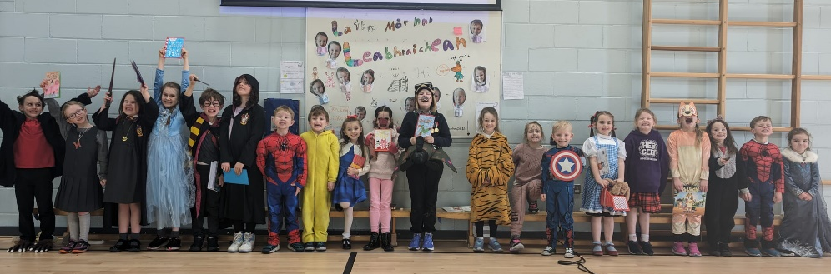

World Book Day
It was wonderful to see so many children dressed up to celebrate World Book Day. We were very impressed by how creative some of the costumes were and it was lovely to hear the children chatting about their favourite reads. (UNCRC Articles 17 & 28)
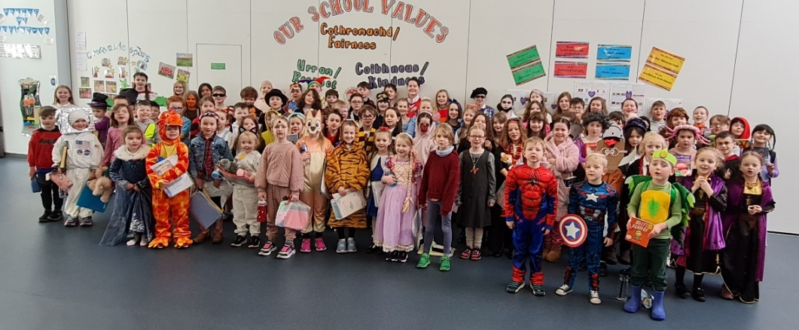

Bikeability 1
P6 pupils didn’t let their costumes hinder their participation in their Bikeability 1 training, which took place Friday, and it was very interesting to see some unusual characters riding around the school grounds! Passers-by may have had to do a double take when they saw an Oompa Loompa and Captain Underpants cycling past! (UNCRC Article 24)
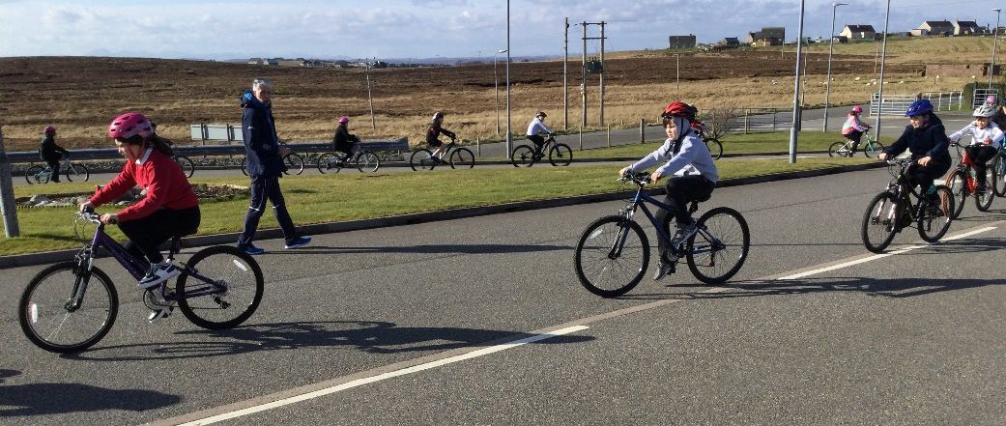
Glasgow Science Centre
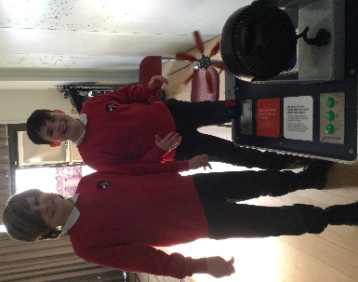
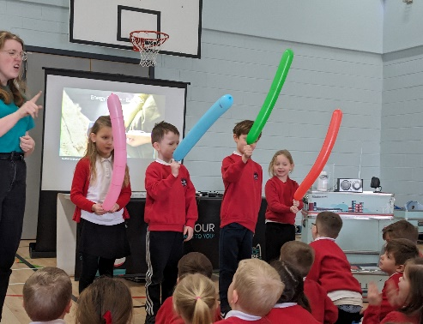
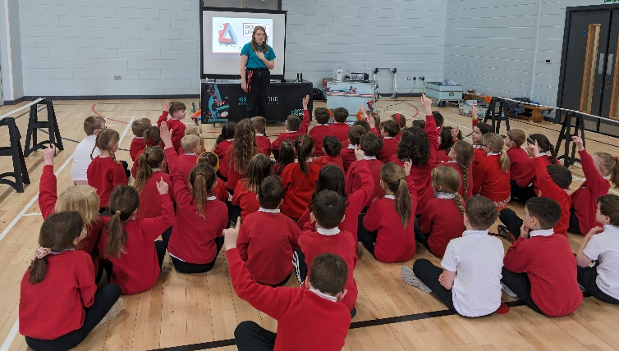
On Monday 4th March, we were delighted to have a visit from Glasgow Science Centre’s Learning Lab. There were several exciting and fun ‘hands on’ science workshops throughout the day, it was wonderful to see all pupils so enthusiastic and engaged with the activities. (UNCRC Articles 28 & 19)
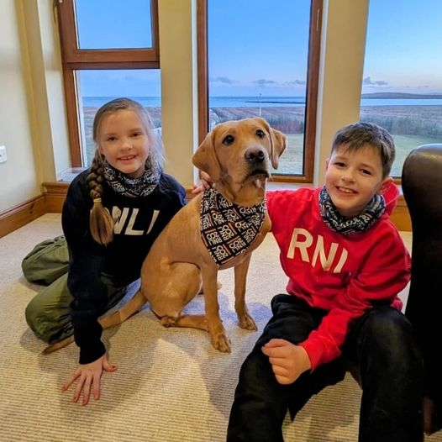

Fundraising for the RNLI
Well done to Joel and Orlaith who recently completed a 230mile challenge to raise money for the RNLI. They have raised a fantastic amount of money for such an amazing cause! Well done!

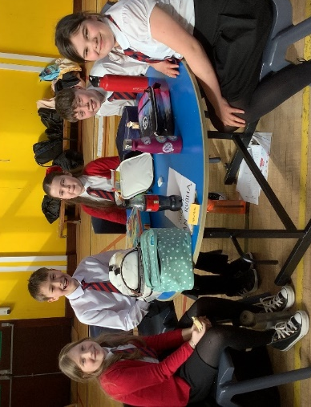

Euroquiz Western Isles Heat
Huge congratulations to our Euroquiz team who won the Western Isles heat last week. We are proud of the commitment they demonstrated in preparing for the event and how well they represented the school, answering some very tricky questions. Thank you to Point and Sandwick Trust who provided transport for the team. The team will now progress to the Euroquiz Final which will be held in Edinburgh.

Parent Council Meeting
​The date of the next Parent Council meeting is Thursday 21 March from 6.00pm-7.00pm. We would encourage as many parents as possible to come along and to get involved. A strong Parent Council is vital in supporting the school to provide the best possible opportunities for your children.

The post of Parent Council Secretary is vacant and they are urgently looking for someone to take on this role. There is grant funding available for payment to be made for this post. If you are interested please contact the Chair of the Parent Council (johnmoffat@mannjudd.co.uk) or contact the school office (sgoilanrubha@gnes.net).

P7 Transition Workshops
Erica Clark will start working with P7 pupils from Monday 18th March. These sessions will focus on coping with change, friendships and the practical side of life in The Nicolson Institute. The pupils will also work towards achieving their Dynamic Youth Award. These workshops have been very well received by previous P7 cohorts and we hope that they will be of benefit to our current P7 pupils.
Parental Questionnaire
At Sgoil an Rubha we recognise that parents, carers and families are the most important influences on children’s lives and greatly value the contribution that they make in supporting children’s learning. The promotion of parental involvement and partnership working is therefore a key priority for Sgoil an Rubha.
We would appreciate if as many parents as possible could share their views on current practice and suggestions on how Sgoil and Rubha can continue to improve, by completing the questionnaire below by Monday 25th March. Thank you.

https://forms.office.com/e/X4Utm5TB16
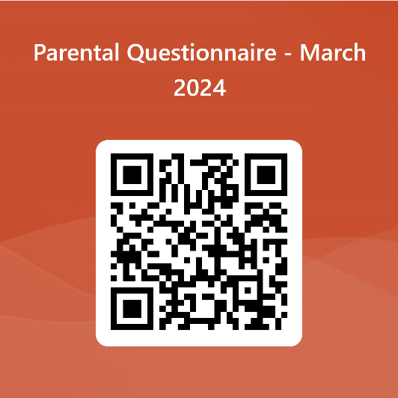

Below are some of the suggestions which were made by parents in our last parental questionnaire and what we did in response.

What parents feel we could do better: | What we’re doing about it:
- Consolidate means of communication | - All updates and important information will be issued via groupcall email.  - The use of seesaw was reviewed and it is now used as a learning log.  - New communication guidance issued to staff and parents.
- More emphasis on reading, writing and maths | - Continued close monitoring of attainment data and summative assessment information to ensure all pupils are ‘on track’ with their learning in reading, writing and maths. Support provided for any children who are ‘not on track’.  - Involvement in Local Authority project to improve writing at P4.  - Investment in ‘Talk for Writing’ resources for P1-4.  - Investment in new maths resources, including the ‘Number Stacks’ intervention.
- More interaction between the Gaelic and English medium classes | - Project work planned for upper GM class to work with another EM class.  - Continuation of eco project involving GM and EM classes.  - Increased prominence of Gaelic throughout the school, as part of school improvement plan.  - During Fun 31 and for pupil choice groups, pupils from all upper classes are able to mix.
- RSHP to be delivered in full | - Wider Local Authority parental consultation undertaken.
- Encourage inclusivity | - Continued focus on specific events which promote inclusion. Inclusion is part of the health and wellbeing curriculum.  - Increased emphasis on celebrating diversity.  - New ‘diversity’ section added to the school library.
- More outdoor learning and focus on environmental awareness | - Strong focus during terms 1 and 2 on sustainability.  - Awarded Green Flag status by Eco-schools Scotland  - Term 4 focus
- Less sweets | - Further parental consultation which concluded that almost all parents were happy with sweets being given out at times of celebration and at the discretion of the teacher.

Dìleab 2024
As part of Comhairle nan Eilean Siar’s Dìleab 2024 initiative, our pupils at Sgoil an Rubha are now ‘full-steam ahead’ on this informative, interesting and collaborative project. During the first 4-week block of the project, we are learning about Lord Leverhulme and his efforts in the regeneration of Lewis, over 100 years ago. We are very excited to be working on this project with our local history experts, and the pupils in all our uppers classes have all learned a great deal, during the first sessions. The support we are receiving from Catriona Dunn and Ishbel Mackay is greatly appreciated by all pupils and it is wonderful to see their interest in learning about that time in the history of Lewis. We are very fortunate to have people who are so willing to bring our history to life for our pupils.
For the remainder of the 10-week project, GM5-7 will be learning about the Land Struggles. This year, marks just over one hundred years since the Land Settlement Act in Scotland. The Act aimed to resettle populations following the end of the First World War through the creation of smallholdings and crofts. As a result, a great deal of resettlement was made possible in areas that had suffered population declines over previous years. Among those was the settlement of 21 previously landless families from Point, at Portnalong, Skye, which then transformed into a populated and thriving township.
Not only will GM5-7 be learning about the history of the land struggles and resettlement, they shall also be preparing a drama performance that will showcase all that they have learned. We look forward to welcoming another history and language expert, Anna Frater, in to school, in the coming weeks. Anna Frater has written the play, and together with our local drama expert, Marisa Macdonald, she will be sharing her expertise with the class. Marisa and her team will work closely with all the pupils and we look forward to showcasing the end result with you all.
During the week beginning 20th May, we hope to perform the play in Sgoil an Rubha. This shall be open to all Sgoil an Rubha pupils, family members, and the wider community. We are going to be very busy until the end of May but we are sure that there will be a fantastic night (or maybe two) in Sgoil an Rubha and that it will be enjoyed by both young and old. More information on the exact dates and the tickets for the Sgoil an Rubha event will be available, next month.
While the performances themselves are the heart of the matter, the process is just as important. The skills our pupils are getting are very useful to them and will last them a lifetime. It also gives them the opportunity to improve their language skills and use Gaelic in different situations.
Tesco Tokens
If you’re shopping in Tesco, don’t forget to show your support for our bid by popping your blue tokens into the box. We hope to buy lots of new sports equipment which will benefit all pupils in the school and nursery.

Western Isles Cross Country Championship
There will be a Primary relay race as part of the Cross Country Championship, which will take place on Saturday 16th March. Mrs D Macleod has been working with our P4-7 pupils and has organised 6 relay teams. Letters have been issued to the pupils who are participating.
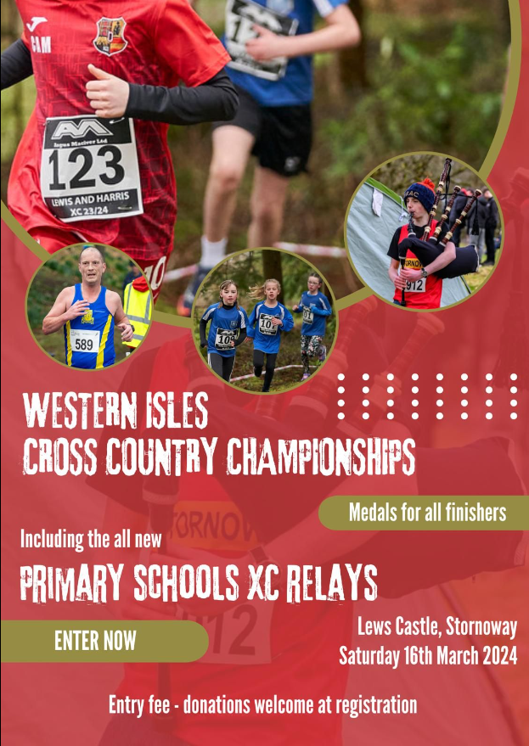

Dates for your diary

Friday 15th March | Comic Relief dress down day
Saturday 16th March | Western Isles Cross Country Championship
Thursday 21st March 6pm | Parent Council meeting
Friday 29th March | Feel Good Friday
Friday 29th March | Pupil Progress Reports to be issued
Friday 29th March 3:10pm | School closes for Easter Break
Monday 15th April 9:10am | School reopens for pupils and staff
Friday 26th April | School closed
Monday 29th April | School closed
8th – 10th May | P7 Trip
Saturday 1st June | The Leanne Fund 5K & 10K
Tuesday 4th – Friday 7th June | Mod
12th & 13th June | P7 Transition days to The Nicolson Institute

Safe Families Western Isles
Safe Families Western Isles is a local charity that supports families going through difficult times. This support is given by trained volunteers who are keen to support their community; and can support a family by being the parent’s befriender, a helper and befriender to their children, and/or by offering overnight stays at their own home so that the family can have a break.
Safe Families Western Isles will support families who have a child/children within the ages of 3-15, and there are no limits on who can refer a family to us. This includes social workers, health visitors, GPs, schools etc. We also take self-referrals. For more information, please contact us on 01851 827308, or
e-mail westernisles@safefamilies.uk

