Sgoil an Rubha - Parental Update
Friday 1st March 2024

P2/3 Leading the Learning
Well done to our P2/3 pupils who led today’s assembly. It was really interesting to hear all about the excellent learning that’s happening in their class and how it relates so well to the Articles of the UNCRC. Thank you to all the parents and family members who were able to come along the assembly.
(UNCRC Articles 30, 7 & 8)
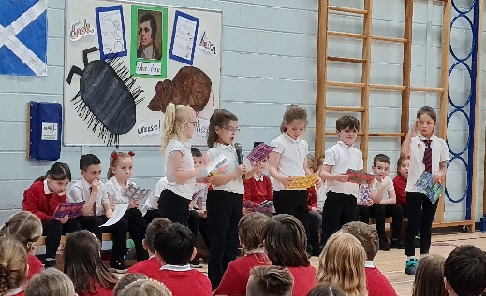
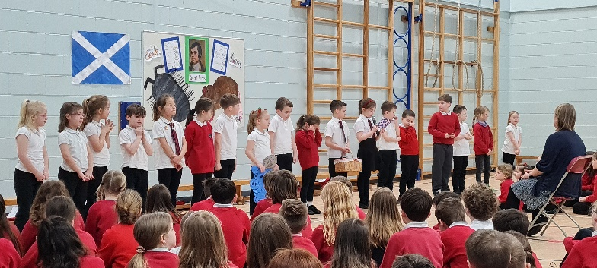

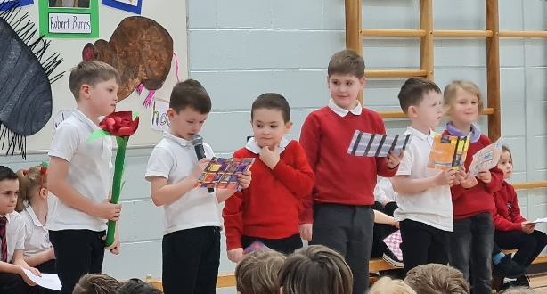

Girls’ Football Festival
On Tuesday 27th February, some of our P6/7 girls travelled over to Back to participate the recent Girls’ Football Festival organised by Lewis & Harris Women’s Football Club (L&HWFA). The festival was a fun and friendly event which gave our pupils the opportunity to play with children from schools across the Broadbay area. (UNCRC Article 24)
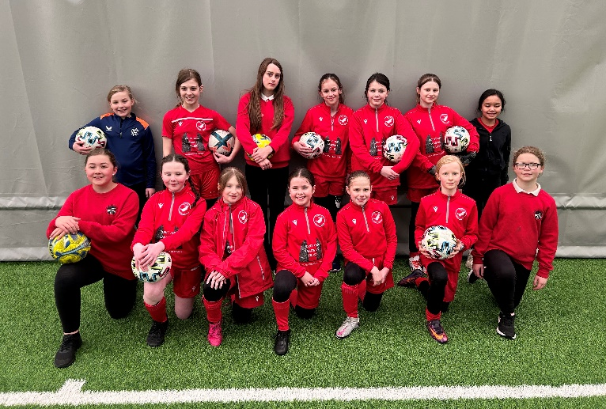

Glasgow Science Centre
We are delighted that we will be having a visit from staff from Glasgow Science Centre on Monday 4th March. They will bring along lots of exciting equipment and resources to enable all pupils to participate in several science workshops. (UNCRC Articles 28 & 19)

Communication Policy
A polite reminder, that in accordance with our recently updated communication policy, seesaw should be used for commenting on pupils’ learning and progress and should not be used as a messaging tool for pastoral matters. Any pupil concerns or general issues should be communicated through the school office.

World Book Day
We will celebrate World Book Day on Friday 8th March, a day later than the official date. GM1-4 pupils will lead a whole school assembly around this theme. All pupils are invited to dress up as their favourite character, if they wish to. In the current cost of living climate, we would discourage parents from buying costumes and to be as creative as possible. Pupils who do not wish to dress up should wear their usual school uniform. (UNCRC Article 17)

Science Fair
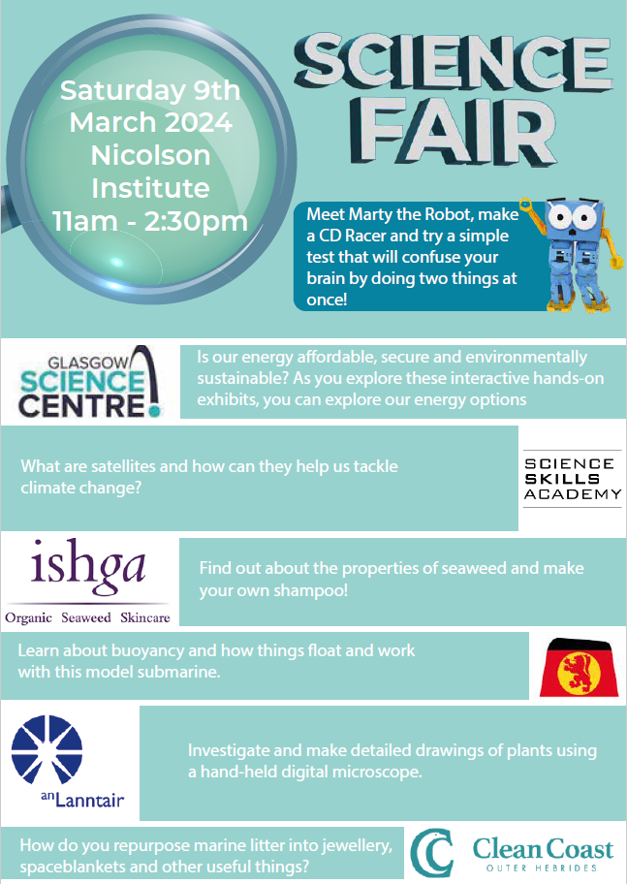

Safe Families Western Isles
Safe Families Western Isles is a local charity that supports families going through difficult times. This support is given by trained volunteers who are keen to support their community; and can support a family by being the parent’s befriender, a helper and befriender to their children, and/or by offering overnight stays at their own home so that the family can have a break.
Safe Families Western Isles will support families who have a child/children within the ages of 3-15, and there are no limits on who can refer a family to us. This includes social workers, health visitors, GPs, schools etc. We also take self-referrals. For more information, please contact us on 01851 827308, or
e-mail westernisles@safefamilies.uk

Dates for your diary

Monday 4th March | Glasgow Science Centre Visit
Wednesday 6th March | Euroquiz (P6)
Friday 8th March | GM1-4 Assembly 11:10am  Dress up for World Book Day
Saturday 9th March | Science Fair
Friday 15th March | Comic Relief
Friday 29th March | Feel Good Friday
Friday 29th March | Pupil Progress Reports to be issued
Friday 29th March 3:10pm | School closes for Easter Break

