Sgoil an Rubha - Parental Update
Friday 9th February 2024
Cross Country
Well done to all our pupils who braved the weather to take part in the second cross country race on Saturday 27th January. Congratulations to Alex Mackay, who came first in the U11 boys’ category again. Well done! (UNCRC Article 24)
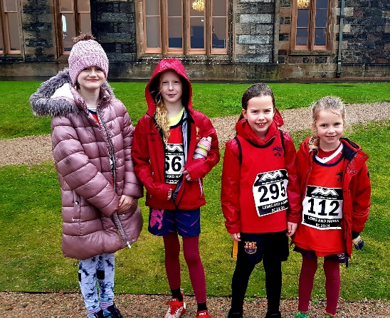

Fun in the Snow
The children were delighted to see the snow again on Wednesday morning. Lots of laughter, from pupils and staff, could be heard across the playground as everyone enjoyed playing in the snow. (UNCRC Article 31)

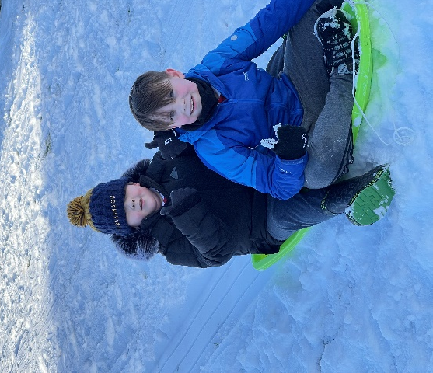
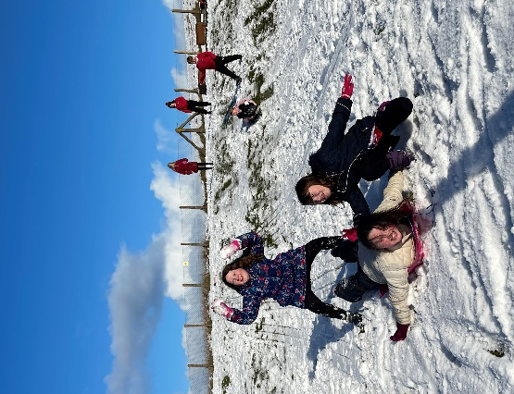

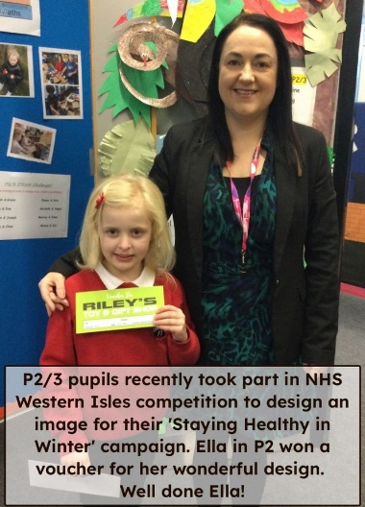

NHS Poster Competition
Well done to Ella Macmillan who won a prize in the NHS poster competition. Ella was delighted to be presented with her voucher for Riley’s Toy Shop. (UNCRC Article 24)

Pupil Choice Groups
We have recently reintroduced our pupil choice groups, which will run every fortnight on a Friday afternoon. The groups allow pupils to develop new skills and knowledge, with a range of activities available from sewing to microbits. Pupils are given choices about which group they would like to attend, and are very much enjoying the opportunity to learn with pupils from different classes. It is wonderful to have some members of the community and parents involved in helping with some of these groups.
(UNCRC Articles 12 & 15)

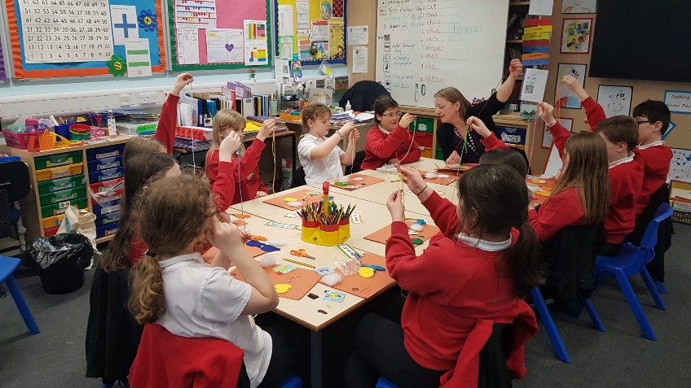

Safer Internet Day
Tuesday 6th February was Safer Internet Day. During last Friday's assembly, all children were involved in discussing the benefits and dangers of using the internet. They came up with lots of tips about how to stay safe online. Use the link below to get advice on how to help your child stay safe online.
(UNCRC Articles 17 & 19)

https://saferinternet.org.uk/safer-internet-day/safer-internet-day-2024/parents-and-carers?fbclid=IwAR12UHco0eUoClCeqyMItXSIW1n1wsk0MsdoukC9BC07mie6BUFdhHa01fs

House Captain Update
Today it was the Eagles who were the winning house, earning themselves an early break time.
Well done Eagles!
The pupils below were recognised for their behaviour and adhering to the school values.

Eagles – Nathan Peck
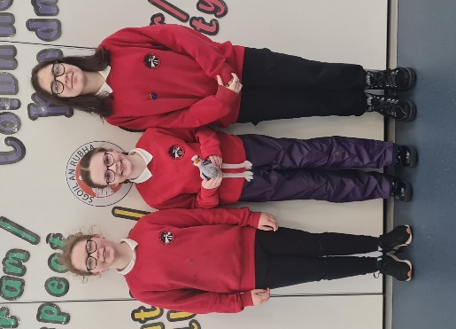
Herons – Orlaith Mackinnon
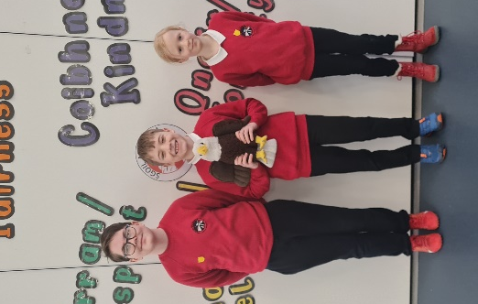
Oyster Catchers – Agnes Dalzel-Job
Puffins – Elliza Vinalay
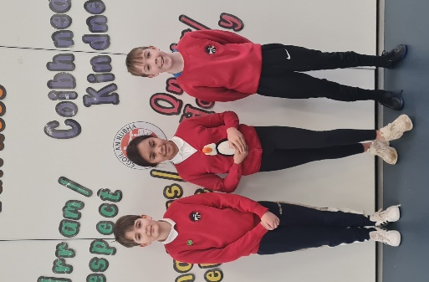
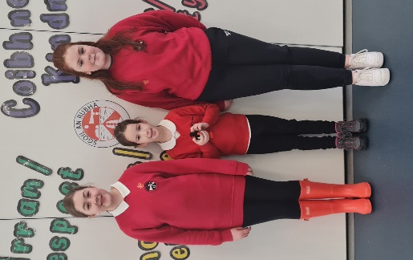

End of Day Arrangements
Any changes to the end of day arrangements for pupils should be communicated through the school office. Parents who are picking up their children are asked to wait until the school buses have departed before using the bus lane/picking up. In line with safeguarding protocols, parents should not be collecting pupils from bus lines. Thank you for your co-operation.

Safe Families Western Isles
Safe Families Western Isles is a local charity that supports families going through difficult times. This support is given by trained volunteers who are keen to support their community; and can support a family by being the parent’s befriender, a helper and befriender to their children, and/or by offering overnight stays at their own home so that the family can have a break.
Safe Families Western Isles will support families who have a child/children within the ages of 3-15, and there are no limits on who can refer a family to us. This includes social workers, health visitors, GPs, schools etc. We also take self-referrals. For more information, please contact us on 01851 827308, or
e-mail westernisles@safefamilies.uk

Dates for your diary

Thursday 15th February 3:10pm | School closes for mid-term break
Wednesday 21st February | Staff In-service
Thursday 22nd February 9:10am | School reopens for pupils
Friday 23rd February | Feel Good Friday
Friday 29th March | Feel Good Friday
Friday 29th March | Pupil Progress Reports to be issued
Friday 29th March 3:10pm | School closes for Easter Break

