Sgoil an Rubha - Parental Update
Friday 5th January 2024

Welcome Back
It was wonderful to welcome all our children back this week after what we hope was a fabulous Christmas break. Today, the Herons were treated to a postponed house treat for being the team with the most points at the end of last term. What a fantastic way to start the term!

Christmas Events
The Christmas performance was a huge success, and we appreciate all the positive feedback received from parents. Thank you to all the families who came along to support our pupils.
The children also very much enjoyed their Christmas parties, especially the visit from Santa. Many thanks to the Parent Council who have pledged to cover the cost of the Christmas gifts.
On Wednesday 20th December, it was lovely to welcome the school community back into the school for our Christmas Service, led by Rev. Iain Thomson and P4/5 pupils.
The term ended on a high with hot chocolate and some Scottish Country dancing!
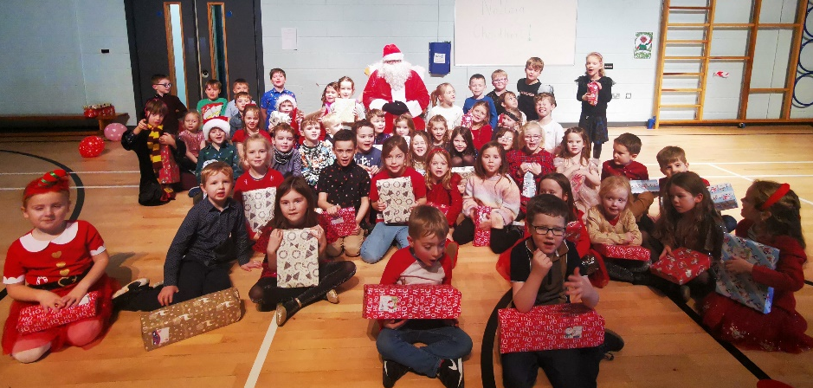
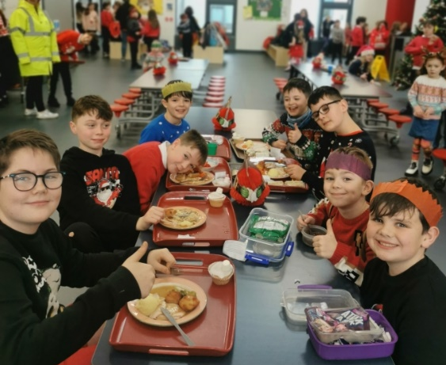

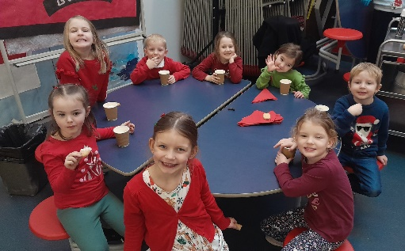
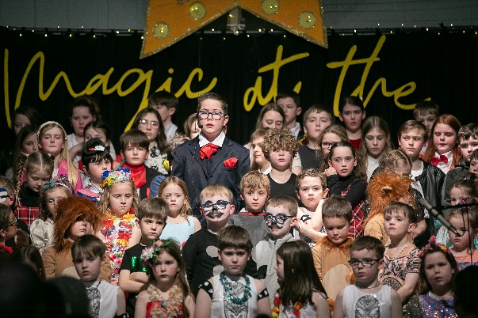

Wizard of Oz
As part of their Christmas gift, pupils in P4-6 were very fortunate to receive a ticket to the forthcoming pantomime, ‘The Wizard of Oz’. They will attend on Friday 17th January, further details will be issued next week. What a lovely trip to look forward to.

Parent Council Hampers
Thank you very much to all the families who donated items, bought tickets and helped to sell tickets for the Parent Council Christmas Hamper Raffle. A total of £2062 was raised, which is really fantastic considering the current cost of living climate. We really appreciate and value the support of the Parent Council.
Summative Assessments
In January, all P5 pupils will undertake Cognitive Ability Tests (CATs) and P7 pupils will sit Standardised National Summative Assessments (SNSAs). The results of these tests will be shared with parents as they become available and will be used to inform next steps in learning.

Term 3
Teaching staff are currently busy planning the learning and teaching for the coming term, and curriculum overviews will be issued within the next couple of weeks. As always, if you have any suggestions or feel that you could support the learning and teaching in the school, please do not hesitate to get in touch via the school office.

P7 GME
The Nicolson Institute will hold their annual meeting for P7 GME pupils and their parents on Monday 22nd January between 7pm-8pm.

Safe Families Western Isles
Safe Families Western Isles is a local charity that supports families going through difficult times. This support is given by trained volunteers who are keen to support their community; and can support a family by being the parent’s befriender, a helper and befriender to their children, and/or by offering overnight stays at their own home so that the family can have a break.
Safe Families Western Isles will support families who have a child/children within the ages of 3-15, and there are no limits on who can refer a family to us. This includes social workers, health visitors, GPs, schools etc. We also take self-referrals. For more information, please contact us on 01851 827308, or e-mail westernisles@safefamilies.uk.

Dates for your diary

Friday 19th January | P4-6 pupils outing to An Lanntair
Friday 26th January | Feel Good Friday
Thursday 15th February 3:10pm | School closes for mid-term break
Wednesday 21st February | Staff In-service
Thursday 22nd February 9:10am | School reopens for pupils
Friday 23rd February | Feel Good Friday
Friday 29th March | Feel Good Friday
Friday 29th March 3:10pm | School closes for Easter Break

