Sgoil an Rubha - Parental Update
Friday 8th December 2023
Christmas Jumper Day
The school was feeling very festive today as pupils and staff donned their Christmas jumpers. If you wish to donate to The Leanne Fund please use the link below.
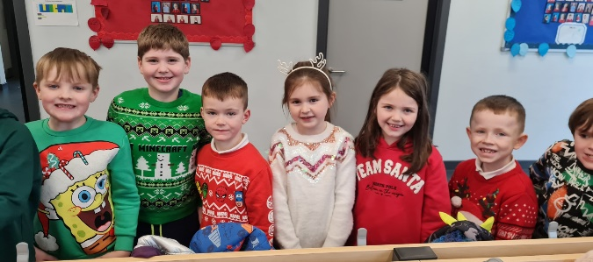
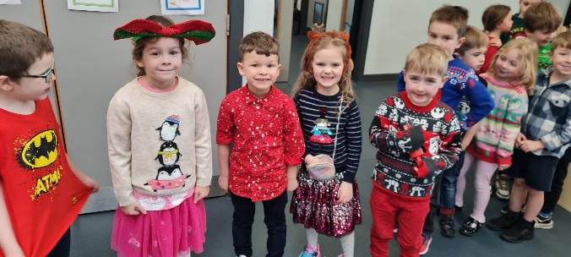
https://www.justgiving.com/leannefund
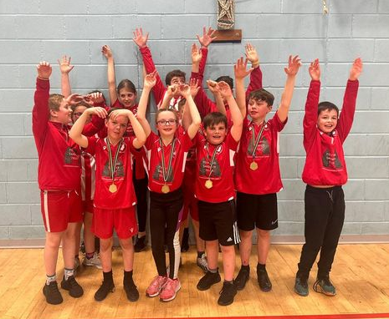
Uni-hoc Competition
Well done to all pupils who took part in the second heat of the recent uni-hoc competition. Two of our teams progressed to the final, held on 28th November and we were delighted that one of our teams won the competition! Both teams in the final were commended for their positive attitude and behaviour. Well done!
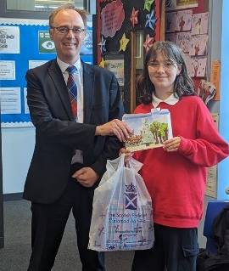

Christmas Card Competition
Well done to Rosa O’Halloran, who won Alasdair Allan’s annual Christmas Card Competition. Her design will be used on all the cards issued by the MSP this year. Well done Rosa!

GM5-7 Food Bank Enterprise Project
Thank you so much to all the families who donated items towards GM5-7’s appeal, we were overwhelmed by the generosity of the community with over 1300 items collected. The project really highlighted the importance of giving during the festive season.
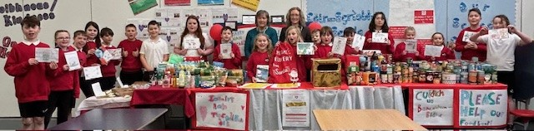
For every item donated, pupils received a golden ticket. There was much excitement on Wednesday morning as the golden ticket draw took place. Abigail and Kayden were delighted to be the winners of the chrome books, with Harvi and Eliza winning co-op vouchers.
The Green Team and Old Shop Bayble Eco Community Grant
Following on from a successful project in June with Old Shop Bayble, our Eco Committee (The Green Team), applied to the Old Shop Bayble Association for their community grant.
We are delighted to announce that the Sgoil an Rubha Green Team were awarded a grant of £1000 to develop our sustainable clothing ideas further. Mrs Rebecca Proops, from Old Shop Bayble, kindly presented the Committee with their cheque on Tuesday 5th December.
This money will allow for Sgoil an Rubha to form a partnership with the UHI Stornoway campus and their Fashion Design Course Leader, Netty Sopata, on another exciting opportunity in 2024.
We are very much looking forward to making good use of these funds to educate and encourage our pupils to reuse and repurpose their pre-loved clothing.
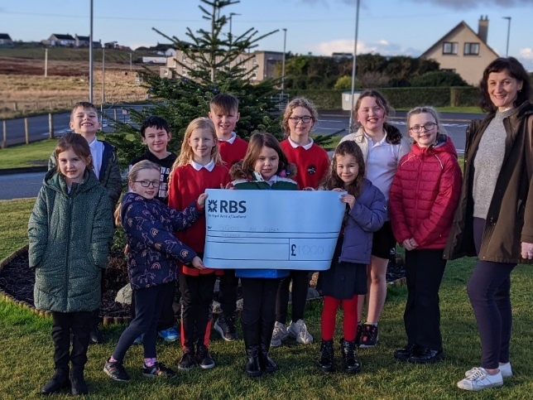

Soup and Pudding
Thank you to everyone who came along to our Soup and Pudding event last Saturday. The event was run by P7 pupils and their parents to raise money for school funds. There was a lovely atmosphere and a grand total of £600 was raised. This money will go directly towards the costs of the Christmas performance.
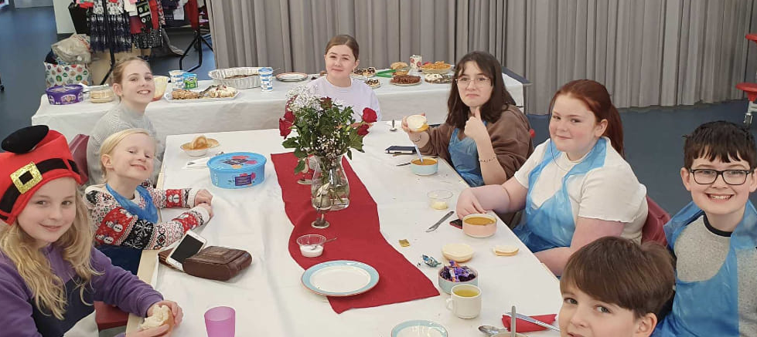
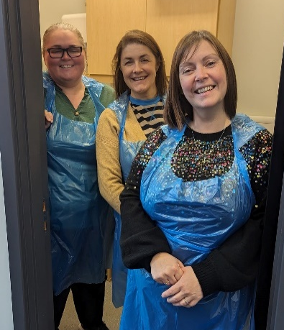

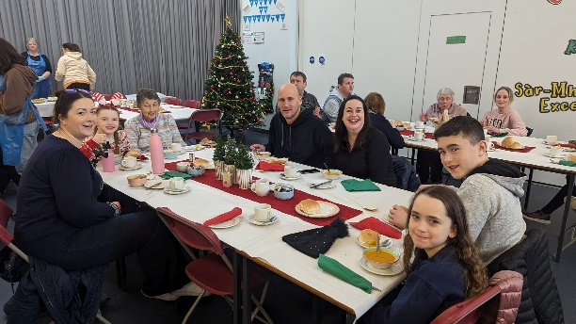

Christmas Performance
Rehearsals are well underway for our Christmas performance, which will take place on Thursday 14th December at 6:30pm. Doors will open at 6pm. Please use the Church car park.


Canteen Christmas Lunch
Christmas lunch will be served in the canteen on Tuesday 19th December. Pupils are encouraged to wear their Christmas jumpers/accessories.


Christmas Service
This year’s Christmas Service will be held in the school on Wednesday 20th December at 11:15am. It will be led by Rev. Ian Thomson and Canon William Maclean. There will readings from P4/5 pupils and carol singing. All family and community members are warmly invited to come along.


Christmas Parties
School Christmas parties will take place on Monday 18th December. P1-3 pupils will party in the morning and P4-7 pupil will party in the afternoon. Pupils may wear what they wish.
The nursery Christmas party will take place on the afternoon of Wednesday 20th December.

Easy Fundraising
Thank you to all the parents who have already signed up to support the school through our easyfundraising page. There is no cost to join and every time you shop you can support the school, without any additional expense.
https://www.easyfundraising.org.uk/causes/sgoilanrubha/?utm_source=facebook&utm_medium=social&utm_campaign=pmc&utm_content=gs-fb1&fbclid=IwAR2ibbUCsjttHbqKFAr29Fm45K-Kcoi6WkFLX2suX7UGakmr-XeAqk8nzWs



Dates for your diary
Thursday 14th December 6:30pm | Whole School Christmas Performance
Monday 18th December | School Christmas Parties (non-uniform)
Tuesday 19th December | Canteen Christmas Lunch (Christmas jumpers encouraged)
Wednesday 20th December 11:15am | Christmas Service (School uniform)
Thursday 21st December 3:10pm | School closes for Christmas break (non-uniform)
Thursday 4th January 9:10am | School reopens for pupils

Financial Hardship Support / Foodbank
Comhairle nan Eilean Siar continues to have support available for people in hardship. Anyone who is in need of support can contact the Comhairle confidentially on 01851 600501. Support can also be given in the form of energy and fuel vouchers.
There is also Foodbank support available to those in need. Families of children who are eligible for Free School Meals and who find themselves in need of additional food, or are experiencing difficulty in heating their home, can access support in the form of food parcels or vouchers. If you feel your family could benefit from this confidential service please call Rachel on 07970 959193 or email at rmacdonald1s@gnes.net

