Sgoil an Rubha - Parental Update
Thursday 23rd November
STEM Open Afternoon


It was wonderful to welcome parents and family members into the school yesterday, to see the fantastic work that is going on through the school. The pupils are really enjoying their learning about ‘Our Sustainable World’ and are gaining important STEM skills whilst becoming more aware of how to be responsible citizens. If you did not manage to complete an evaluation form, you can submit your thoughts via the link below.
(UNCRC Article 29, SDGs)
https://forms.office.com/Pages/ResponsePage.aspx?id=oyzTzM4Wj0KVQTctawUZKShvos914IFCmRr_xa_ZsB9UNVNFUkZCUEFIWFE2SUpLSzdYNk1LVFA2RS4u
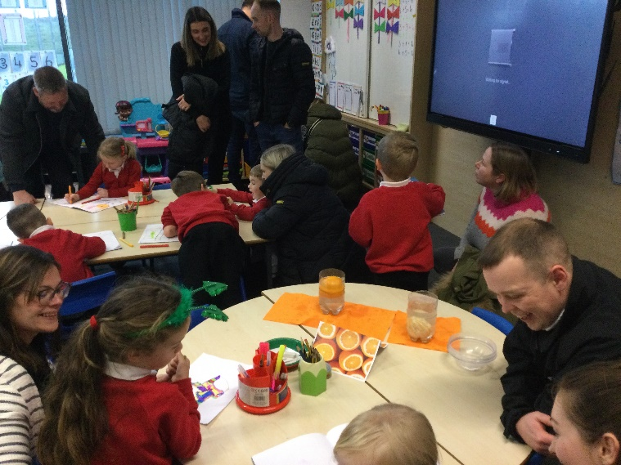
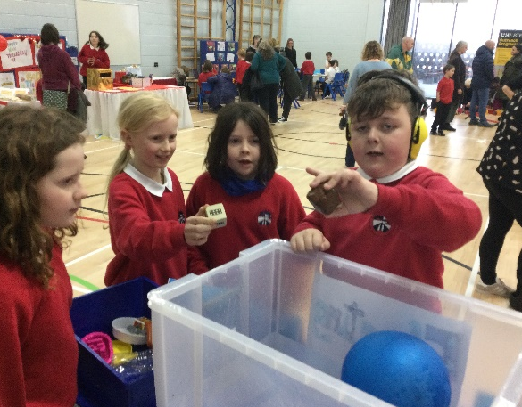

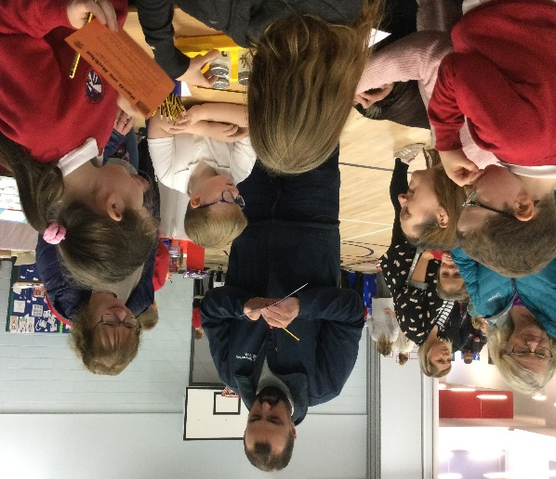

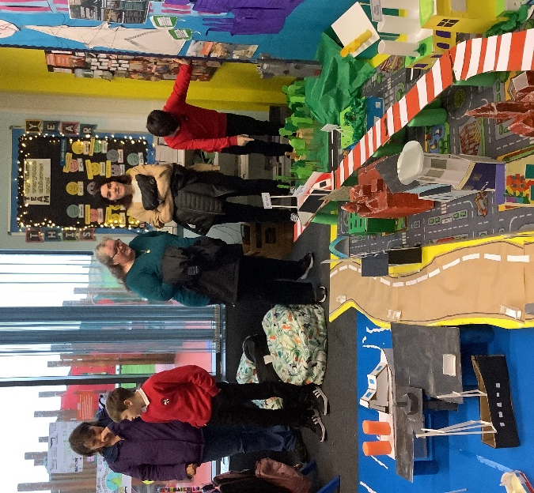

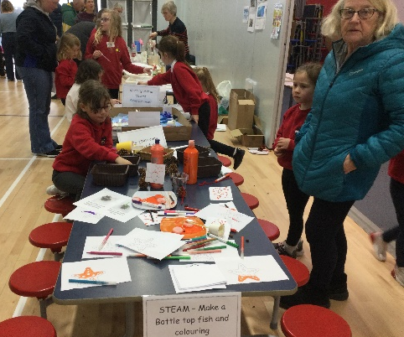

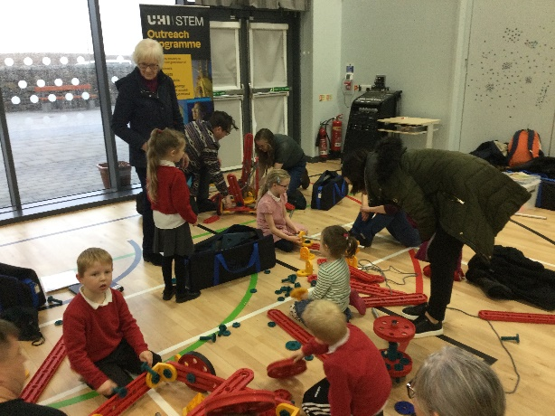

Beach Clean
As part of their learning about the Sustainable Development Goals, GM1-4 and P2/3 pupils decided to undertake a sponsored beach clean of the Braighe. They were accompanied by Janet Marshall, from Clean Coasts. They did a wonderful job and collected a substantial amount of rubbish. They also raised an amazing £1200 through sponsorship. Well done!
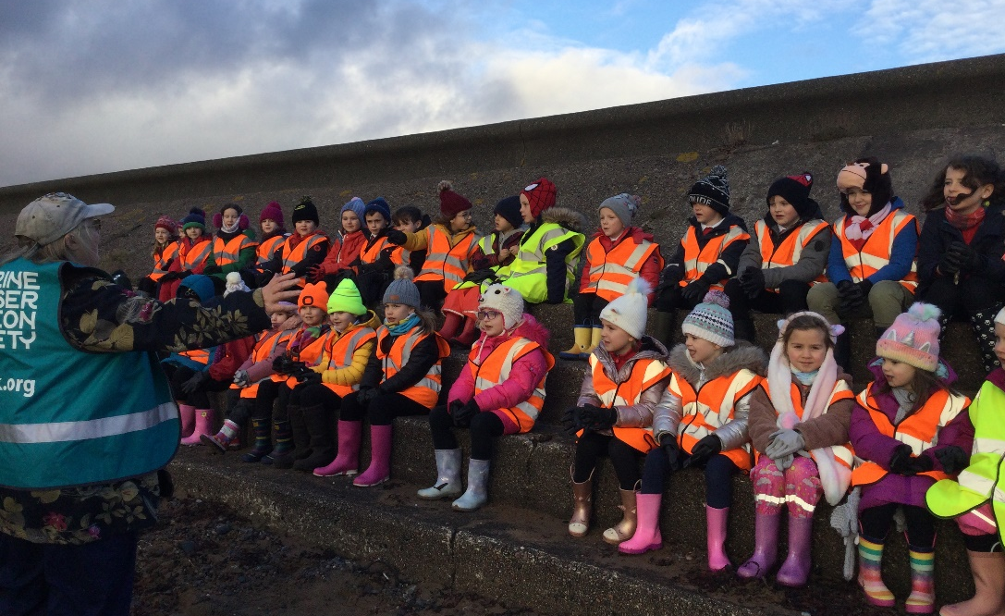

Deep Water Terminal Visit
P5/6 pupils were incredibly lucky to get a VIP sneak peek of the new Deep Water Terminal. They were accompanied by an escort vehicle and had Harbour Master Alasdair Smith as their bus tour guide as they convoyed out to the DWT.
They then visited Arnish Point, Goat Island and finished their morning in the boardroom of Amity House with a presentation from representative, Brenda Jones.
We are extremely grateful to the Port Authority for accommodating the children and we particularly appreciated how they highlighted the Sustainable Development Goals throughout their presentations, making it easy for our pupils to link what they are learning about in class with the real world. Lots of industry, innovation and infrastructure to be seen today!
It was a huge privilege to get this opportunity and be the first school group to visit the DWT. We may even have some budding engineers on our hands in P5/6!
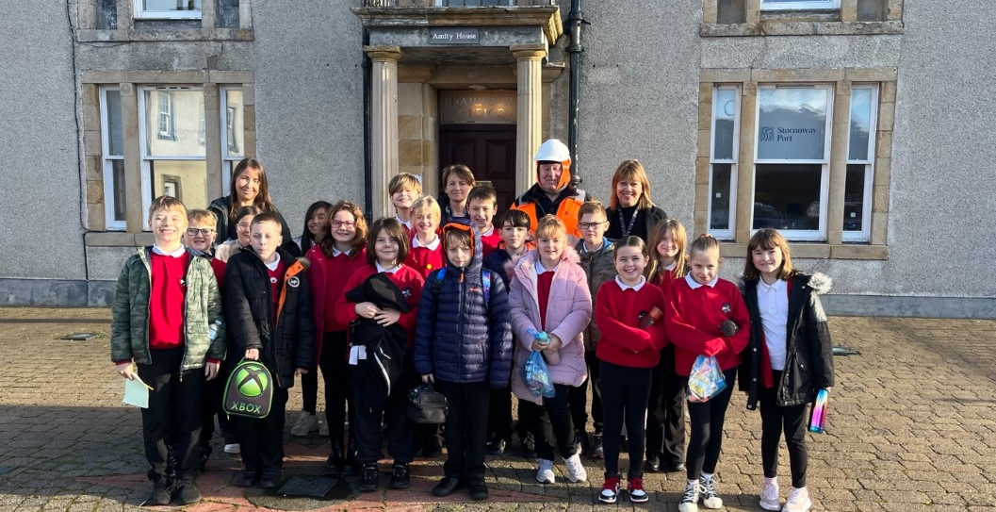

Reporting Absence
A polite reminder to all parents to phone or email the school office every day your child is unexpectedly absent from school. This is a safegaurding measure and we would appreciate your co-operation. The temporary school phone number is: 01851 870977 and the email address is: sgoilanrubha@gnes.net



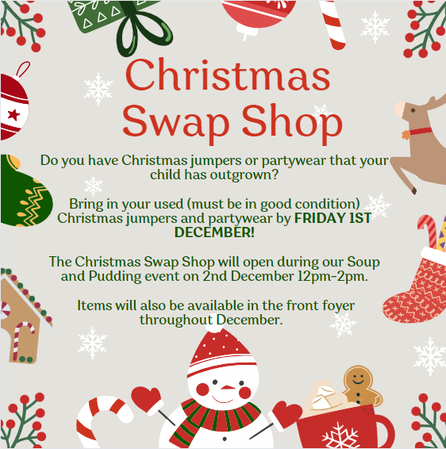

Canteen Menu
Next week will be week 1 on the canteen menu.
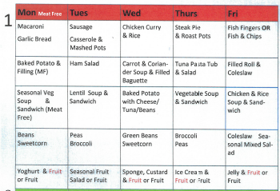




Christmas Performance
Our Christmas performance will take place on Thursday 14th December at 6:30pm. Information regarding tickets will be shared in due course.


Term 2 - Calendar of Events
Saturday 2nd December | Soup and Pudding
Thursday 7th December | Christmas Jumper Day
Thursday 14th December 6:30pm | Christmas Performance
Monday 18th December | Christmas Parties – more details to follow
Tuesday 19th December | Canteen Christmas Dinner (pupils may wear Christmas jumpers)
Thursday 21st December 3:10pm | School closes for Christmas break

