Sgoil an Rubha - Parental Update

Friday 10th November
Remembrance Assembly
Well done to our P5 and P6 pupils who led today’s Remembrance Assembly. The children shared their learning about past and present conflicts and discussed the symbolisim of the poppy. The pupils walked down to the local memorial, this afternoon, to lay a wreath on behalf of the whole school. (UNCRC Articles 38 & 29)
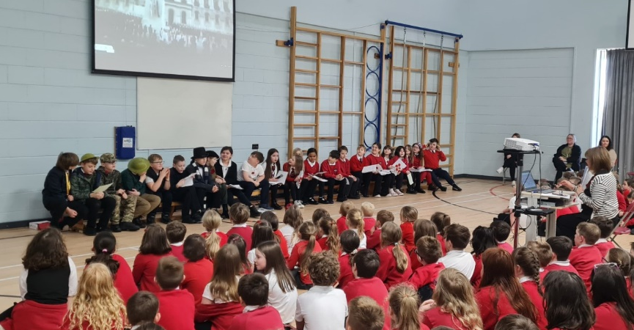

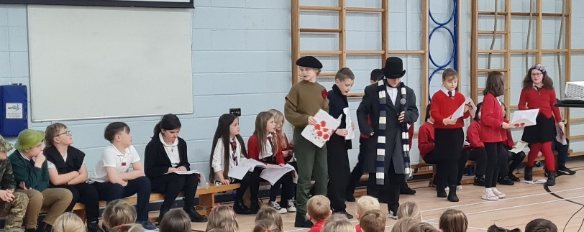

Tighean Innse Gall
P4/5 and P6/7 pupils enjoyed a visit from TIG, this week. They learned about the importance of insulating houses and ways to keep our houses warm and toasty, especially at winter time. P4/5 made their own houses and wrote about how they'd save energy in them. (SDGs 7 & 13)
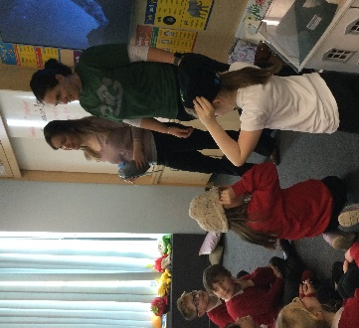
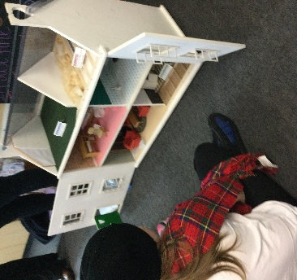
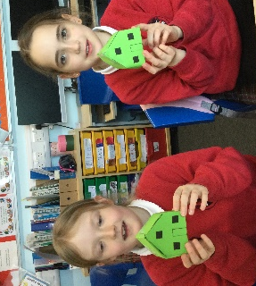

Author Visit
On Tuesday 7th November, P1/2 and P2/3 pupils were very fortunate to have a visit from children’s author and illustrator, Morag Hood. She shared two of her stories, Spaghetti Hunters and Dig, Dig, Digger, with the children. She explained what it was like to be an author, how long it takes to come up with ideas and write her books. She shared how she creates her drawings and helped P1/2 and P2/3 use their imaginations to create their own illustrations. A fun filled morning for all!
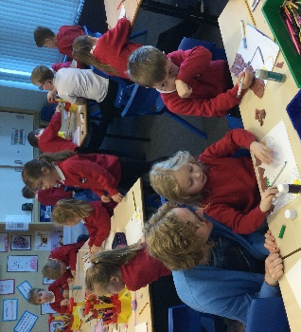
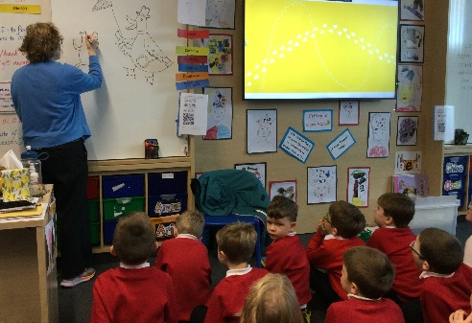
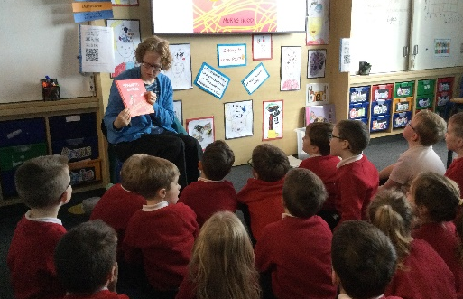
Gaidhlig Story Telling
This week, GM1-4 started a Gaelic intergenerational storytelling project. Members of our local community have agreed to come in every week and tell children stories from their childhoods and our community and work with the children to develop their storytelling skills either from books or their own lives. This week we were joined by Catriona Dunn, Janis Brand and Sarah Mackay. We look forward to meeting the rest of our community storytellers, Seonag McKinnon and Katie Macdonald, next week. (UNCRC Article 20)

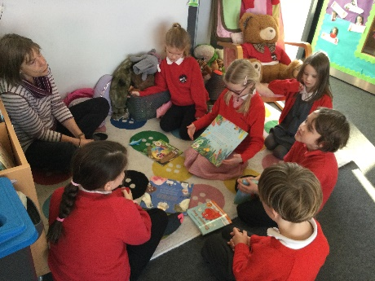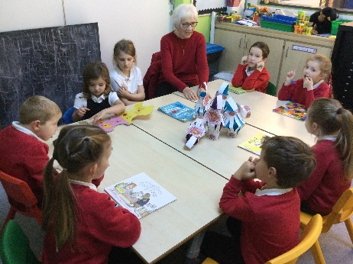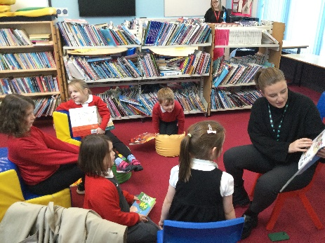

Cross-country
The sun shone last Saturday for the first race of the cross-country season. Well done to all the pupils who took part in the first race of the cross-country event, there were 17 pupils from Sgoil and Rubha who entered. A big shout out to Alex Mackay, who was determined to improve his personal best and came first in the U11 boys category. Well done! (UNCRC Article 24)
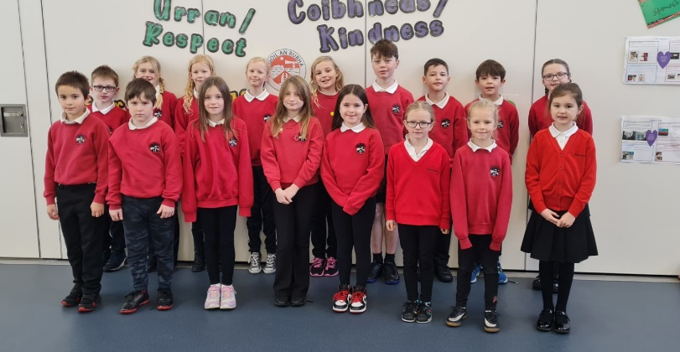

Uni-hoc Competition
The uni-hoc festival got underway on Wednesday night, with 3 teams of our teams competing in the first round. Although none of the teams progressed to the final, we are proud of how well they represented the school and they certainly had lots of fun. Our next 3 teams will play on 23rd November. (UNCRC Article 24)
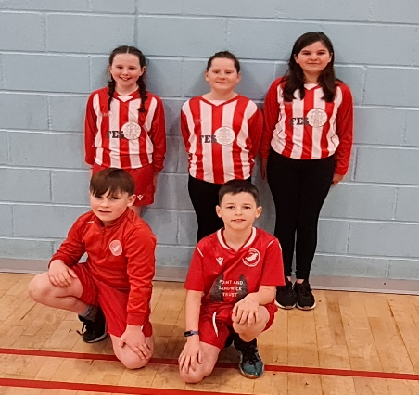
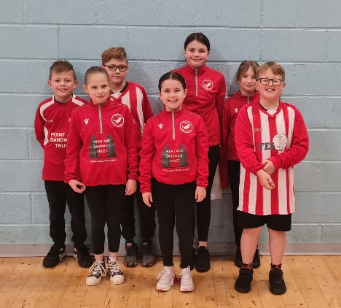

Anti-bullying Week
National anti-bullying week will take place between 13th and 17th November. We will kick off the week with odd socks day on Monday 13th November, where all staff and pupils will be invited to wear odd socks to celebrate what makes us unique and to mark the start of anti-bullying week. Throughout the week there wil be activities focusing on the theme of ‘Make a Noise about Bullying’. The week will end with our Children in Need activities, which the pupil council are busy organising. (UNCRC Articles 2 & 29)


Parents’ Evenings
Parents’ evenings will take place on Tuesday 14th and Wednesday 15th November. On Wednesday evening some of our partners including the school nursing team, active schools, safe families and family support services will be available in the assembly hall to chat to parents about how they support the school community and families.
Appointments have been issued to all pupils, if you wish to change your appointment, please do not hesitate to get in touch with the school office.

Open Afternoon
On the afternoon of Wednesday 22nd November between 1:45pm-3pm, parents and family members are invited to come into the school to hear from the children all about the work they’ve been doing relating to ‘Our Sustainable World’. See below for the timetable of class presentations/activities. If you are free between presentations, there will be a variety of interesting ‘hands on’ activities, led by pupils, in the main hall for you to participate in. (UNCRC Articles 28 & 29, SDGs)
1:45 – 2:05 | 2:10 – 2:30 | 2:35 – 2:55
P1/2 | P2/3 | P6/7
P4/5 | GM1-4 | P5/6
GM5-7


Christmas Performance
Our Christmas performance will take place on Thursday 14th December at 6:30pm. Information regarding tickets will be shared in due course.
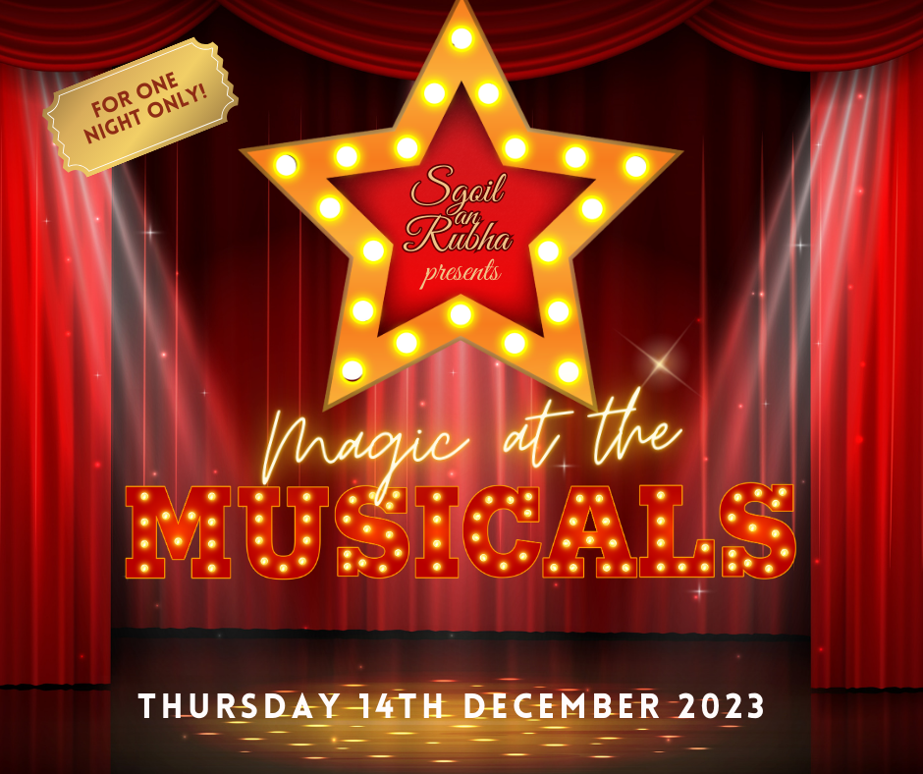

House Captain Update
On Friday 3rd November, house points were counted up and it was the Herons who were the winning house, earning themselves an early break time. Well done Herons!
The pupils below were recognised for their behaviour and adhering to the school values.

Eagles – Kyle Peck
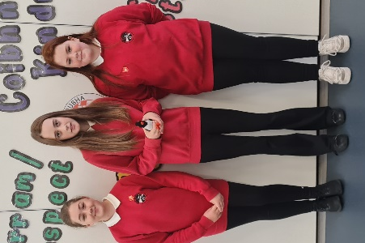
Herons – Jessica Campbell
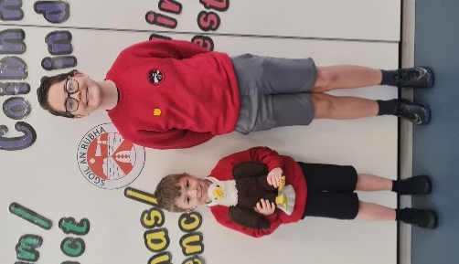
Oyster Catchers – Celia Langhorne
Puffins – Elliza Vinalay

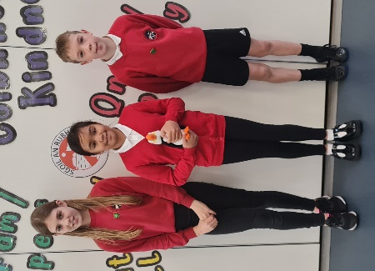
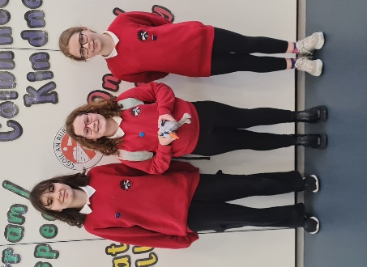

Term 2 - Calendar of Events
14th & 15th November | Parents’ Evenings
15th November | School partners available in main hall
14th November | P1 Health Checks
Friday 17th November | Children in Need – details to be issued from Pupil Council
Wednesday 22nd November 1:45pm | Sharing the Learning Open Afternoon
Thursday 7th December | Christmas Jumper Day
Thursday 14th December 6:30pm | Christmas Performance
Monday 18th December | Christmas Parties – more details to follow
Tuesday 19th December | Canteen Christmas Dinner (pupils may wear Christmas jumpers)
Thursday 21st December 3:10pm | School closes for Christmas break

