Sgoil an Rubha - Parental Update
Thursday 12th October 2023
October Break
We would like to wish all our pupils and families a restful October break and thank you for your continued support. We look forward to welcoming back all pupils on Thursday 26th October.

P7 Trip Funding
We are delighted to have been awarded funding from Point and Sandwick Trust to cover the entire cost the P7 trip again this session. This funding will ensure that our P7 pupils access a range of resources and activities which are not available locally, without there being any financial burden to our families.
All P7 pupils will take part in the trip to Fairburn, in May. P7 parents will receive updates regarding the trip directly from Mrs Macphail, who is organising the trip.

Chaplaincy Team
It was lovely to welcome Canon William Maclean into the school. He delivered a whole school assembly connected to our values. Canon Maclean will join Reverend Iain Thomson on our Chaplaincy team.
(UNCRC Article 14)
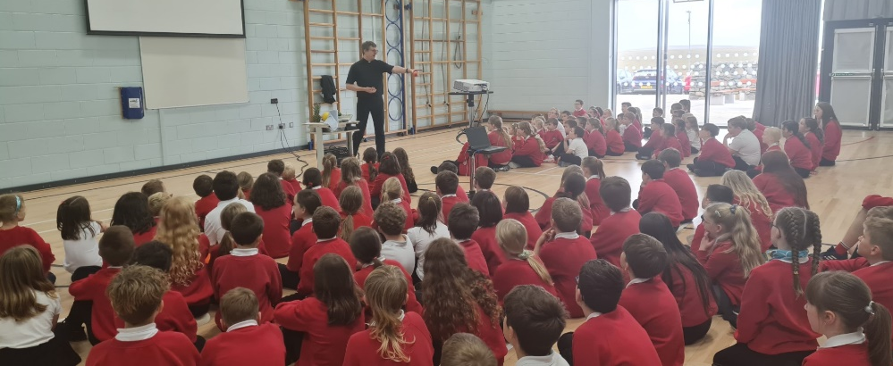

Celebration Assembly
During today’s assembly all classes had an opportunity to share their learning in relation to the 4 capacities: successful learners, responsible citizens, effective contributors and confident individuals. It was fantastic to hear about all the wonderful work that is happening across the school and for pupils to talk so enthusiastically about how much they are enjoying their learning.
Achiever of the term and Gaelic speaker of the term certificates were also awarded.
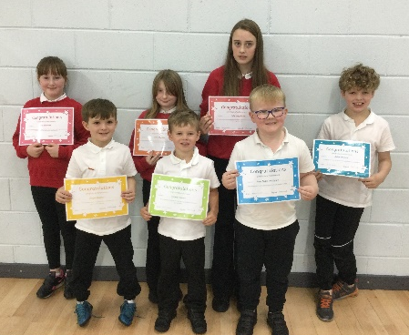
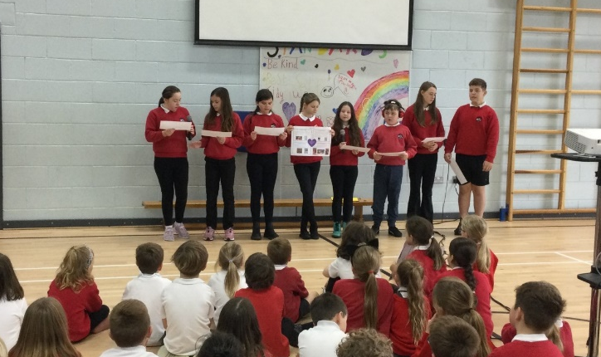

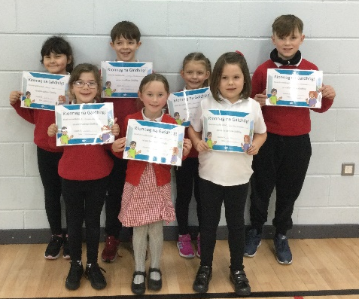

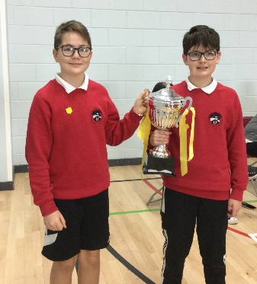
House Captain Update
On Wednesday the 11th October all pupils took part in a House Challenge led by the Sports Council and the House Captains. It was a great event and well done to our fabulous Sports Committee and House Captains for using their initiative and making it a fun challenge for all.
We calculated the house points for the whole term and our winners were the Eagles. They spent this afternoon enjoying ice creams for their treat.
Well done Eagles!

The House Captains and Vice Captains were given the difficult task of deciding who should receive the House Mascots. The pupils selected were recognised for their behaviour and adhering to the school values. (UNCRC Article 12)
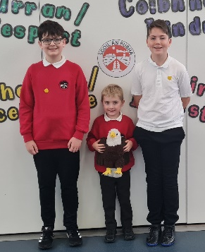
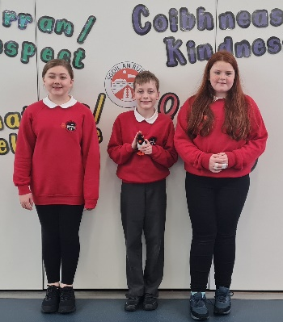
Eagles – Fraser Sim
Herons – Bethany Mackay
Oyster Catchers – Aaron Macmillan
Puffins – Aaryanna Nicolson

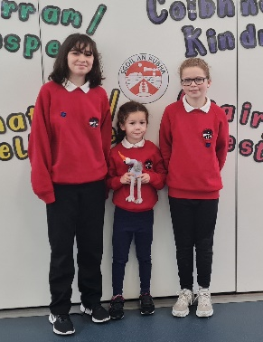
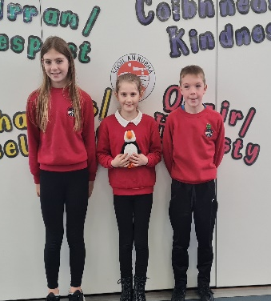

School Uniform
A polite reminder that football strips are not to worn in school, even for P.E. or on Feel Good Fridays.
Thank you for your co-operation.

