Sgoil an Rubha - Parental Update
Friday 15th September 2023

Happy Birthday
Many happy returns to Mrs Morgan, our fantastic school secretary, who celebrated her 60th birthday yesterday.
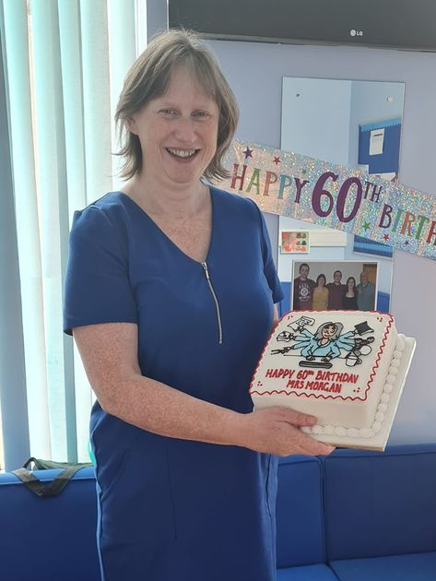

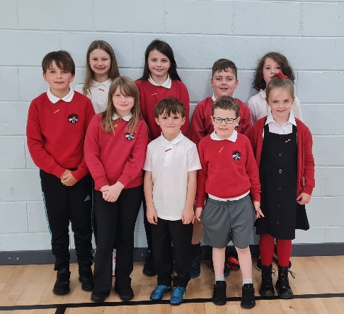

Pupil Council
New class representatives have been elected to form our Pupil Council for 2023-2024. They will play an integral role in gathering pupils’ opinions and in improving the school. Well done to the pupils who were elected. (UNCRC Article 12 &15)

House Captain Update
On Friday 8th September house points were counted up and it was the Oystercatchers who were the first house to be rewarded with an early break time. Well done Oystercatchers!
The new House Captains and Vice Captains were given the difficult task of deciding who should receive the House Mascot. The pupils selected were recognised for their behaviour and adhering to the school values.

Eagles – Ava Grace Carty
Herons – Isla Marshall
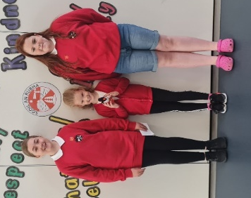
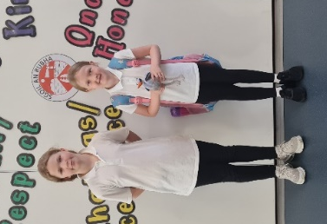
Oyster Catchers – Isla Mackay
Puffins – Iain James Morrison

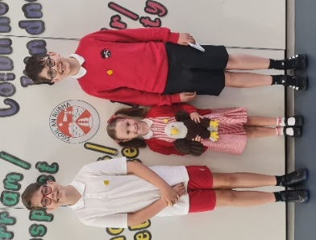
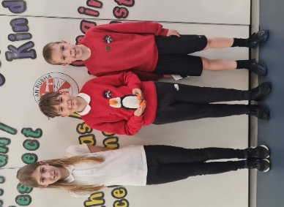



Seasons for Growth® Programme - Learning to live with change and loss
Change and loss are issues that affect all of us at some stage in our lives. It is important to recognise that when changes occur in families through bereavement, separation, divorce and other change-related circumstances, children may benefit from learning how to manage these changes effectively.
Seasons for Growth is a recognised educational programme which is focused on helping children to cope with difficulties they may be experiencing in their lives. The programme is facilitated in small groups and is based on research which highlights the importance of social support and the need the practise new skills to cope effectively with change and loss. It focuses on issues such as self-esteem, managing feelings, problem-solving, decision-making, effective communication and developing support networks.
Families will receive information in the near future with more details about the Seasons for Growth programme. We will also be delivering an information session to all pupils at our whole school assembly in the coming weeks. Additionally, if you think your child would benefit from Seasons for Growth we would encourage you to talk to them about participating in the programme. All participation is subject to parental consent.
Sgoil an Rubha is pleased to be able to offer this important programme and we are confident that it will be a valuable learning experience for those who wish to be involved. If you require further information please contact Mrs Donna Mackay, our ASN Teacher, via the school office. (UNCRC Article 24, SDG 3)

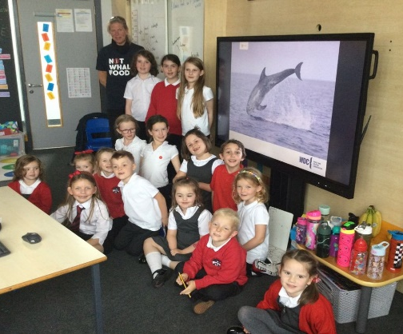
GM1-4
GM1-4 pupils were delighted to receive a visit from Nicola Hodgins, who works for the Whale and Dolphin Conservation. The children had lots of interesting questions about the sea life around the Western Isles and really enjoyed having a visitor in their class. (UNCRC Article 29, SDG 14)

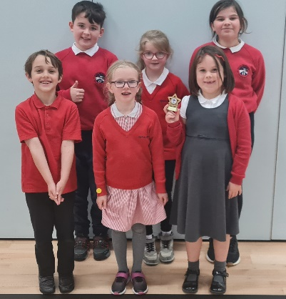
Best Sandcastle Trophy
Well done to all our pupils who took part in the Western Isles District Scout Camp 2023. All showed really good scouting skills by working well in a team, being adventurous and doing their best. Our Cubs and Beavers were awarded a trophy for the best sandcastle; their achievement was celebrated at this morning’s assembly. (UNCRC Article 15)

P1 After-School Club
We are delighted that we have a group of parent volunteers, who are willing to run some more afterschool clubs. P1 pupils will be the first year group to benefit from this provision. It will be an active club, which will run from Thursday 14th September between 3:10pm-4pm, until the October break. (UNCRC Article 15, 31)

Blythswood Shoebox Appeal
On Friday 8th September, we had a visit from Elma Mackay and Charlie Nicolson, who spoke to the children about the Blythswood Shoebox Appeal. It was wonderful pictures and videos of people who had received shoeboxes last Christmas and for our pupils to see how much the recipients appreciate the boxes. Leaflets have been issued to all families. (UNCRC Article 26)

School Improvement Plans
Based on quality assurance activities, including gathering the views of parents, pupils and staff, our improvement projects for this session will be:
- Learning about sustainability through STEM (Science, Technologies, Engineering, Maths)
- Increasing the prominence of Gaelic throughout the school
- Developing pupil profiling
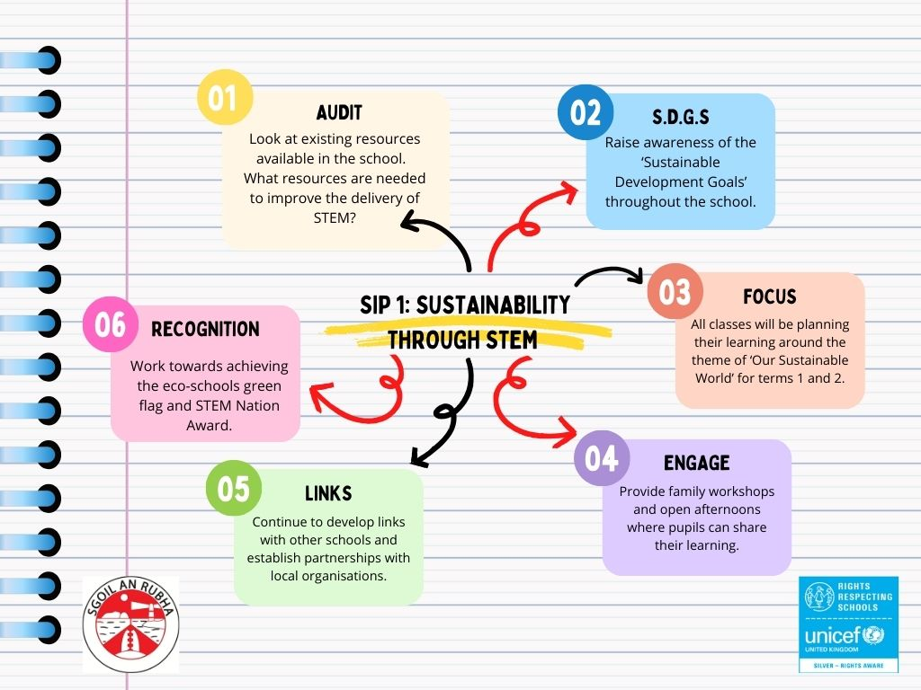
Please see below for posters which detail the main actions within each project. Our full standards and quality report and improvement plan (SQIP) is available from the school office and will be posted on the school website.
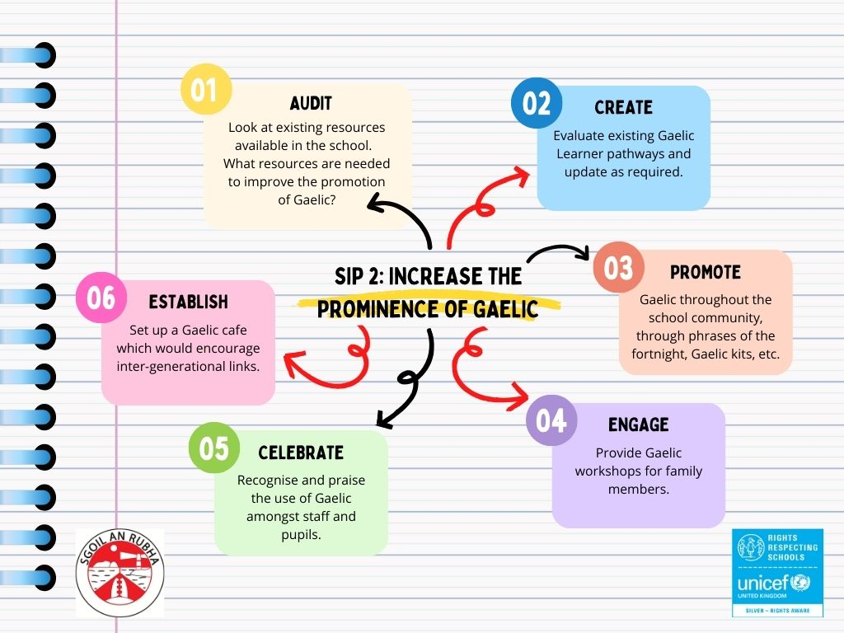

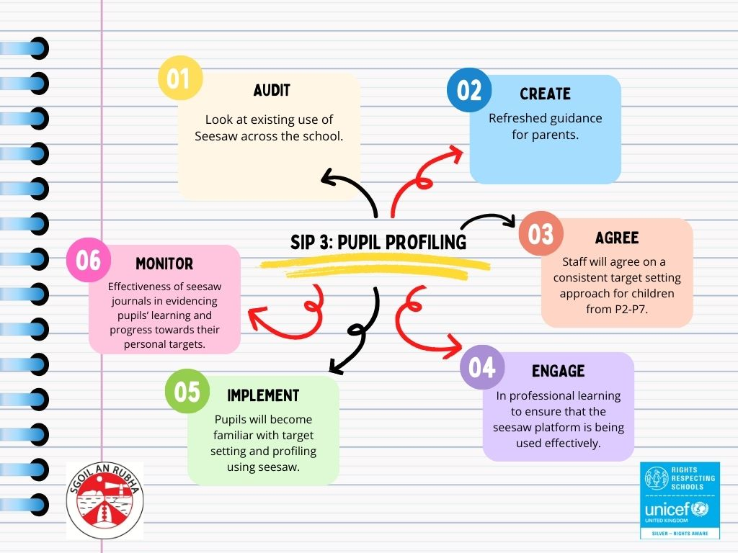

Support from ‘The Shed’
The Shed Project have been given funding to support families who may be struggling during the cost of living crisis. They can provide assistance in the form of Tesco vouchers, electric key card top-ups, etc. depending on your circumstances. There is no referral form required and all enquires will be completely confidential. Please contact Fiona Douglas for further information.
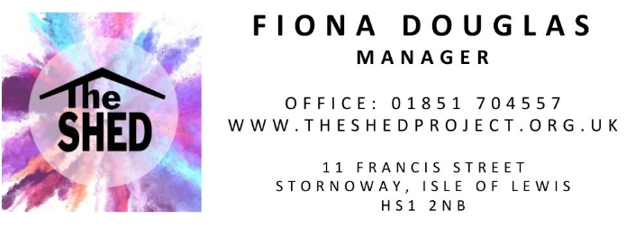

Macmillan Coffee Morning
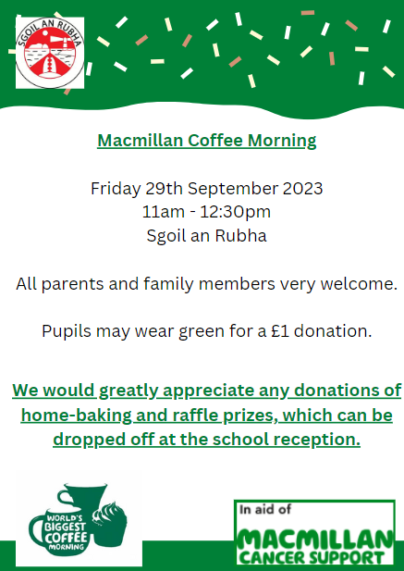

Afterschool clubs
Mondays  Monday until Oct Break | CNAG after-school club (3:10-4:45pm)  Georgia’s P5 Sports (3:10-4:30pm)
Tuesdays | CNAG after-school club (3:10-4:45pm)
Wednesdays until 20th Sept. | Georgia’s P3 Sports club (3:10-4:30pm)
Thursdays until Dec Break  Thursdays until Oct Break | Gaelic Homework Support (3:10-4:30pm)  P1 Sports club (3:10pm-4pm)

Dates for your diary
Tuesday 19th September | Flu Immunisations
Thursday 28th September | P5 Trip to Bridge Centre
Friday 29th September | Feel Good Friday
Friday 29th September 11:30am | Macmillan Coffee Morning – all welcome
Thursday 12th October 3:10pm | School closes for October Break

