Sgoil an Rubha - Parental Update
Friday 1st September 2023

New Entrants
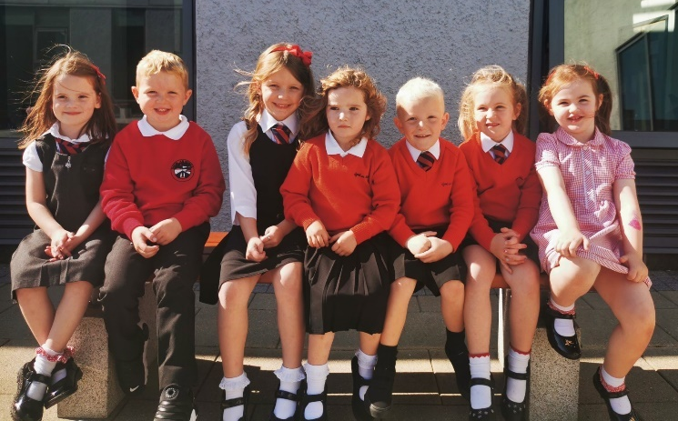
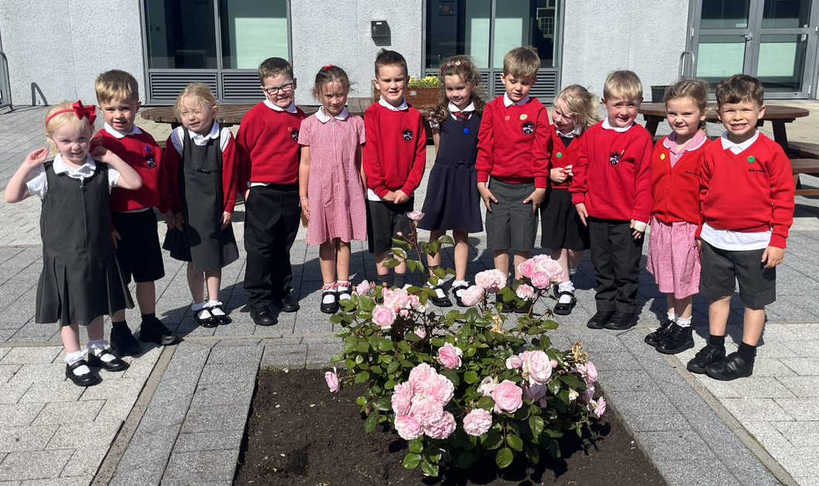
We were delighted to welcome 19 new P1 pupils to the school at the beginning of the session. They have settled in extremely well and are growing in confidence each day. Welcome also to our 3 new pupils who have joined us from other schools.

House Captains
Our new P7 pupils are encouraged to take on as many leadership roles as possible, one of the most coveted roles being that of house captain and vice-captain. Several P7 pupils put themselves forward for these roles and the standard of their presentations was excellent, so well done to everyone who nominated themselves. (UNCRC Article 12)
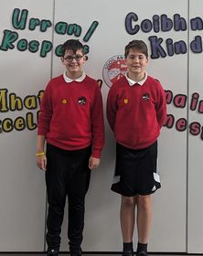
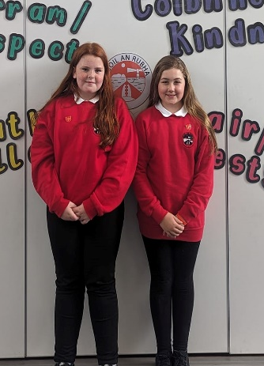
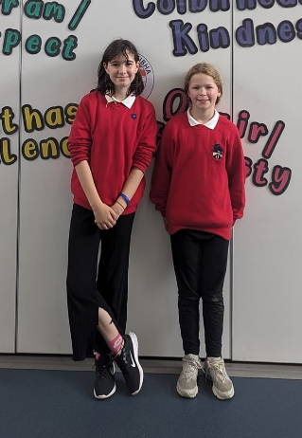
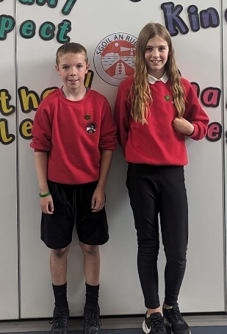
Our new Captains and Vice Captains are pictured below.

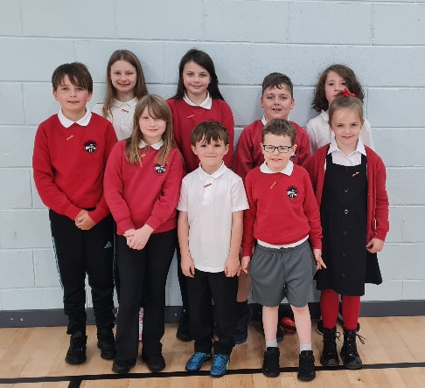
Pupil Council
This week, new class representatives were elected to form our Pupil Council for 2023-2024. They will play an integral role in gathering pupils’ opinions and in improving the school. Well done to the pupils who were elected. (UNCRC Article 12 &15)

Kodaly Development Day
There was much excitement last week when a double-decker bus appeared to transport all our P5 pupils to the Bridge centre to take part in a ‘Kodaly development day’. The session was delivered by our itinerant music tutors and was intended to give the children an introduction to a range of musical concepts, prior to them making their instrumental choices. The children had a fantastic day out and are looking forward to the next session which is planned for 28th September. (UNCRC Article 29)
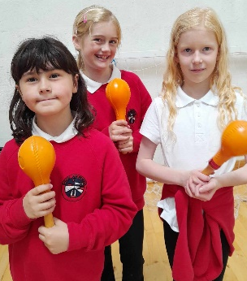
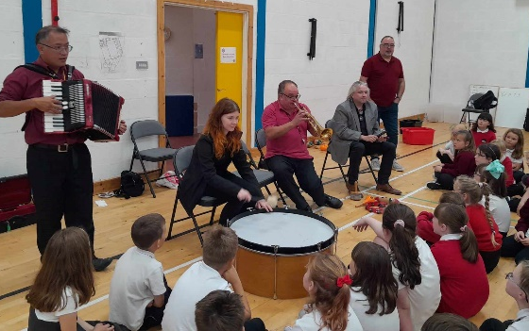
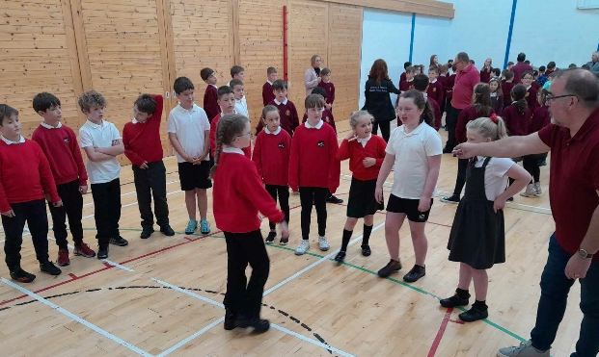

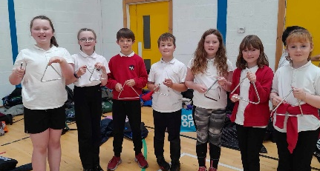
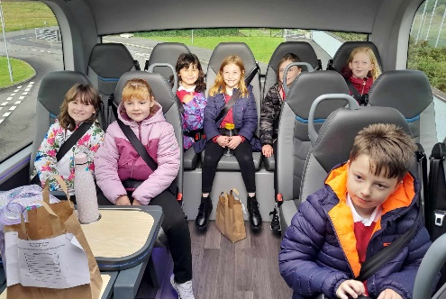

Wider Achievements
At our first house meetings of the session, pupils’ wider achievements were celebrated and will be added to their house display board. Well done to Alexander Macaulay and Ava Mae Campbell who were presented with prizes for their artwork by Jill Thomson from Open Studio Hebrides. Their winning artwork can be viewed in Museum nan Eilean.

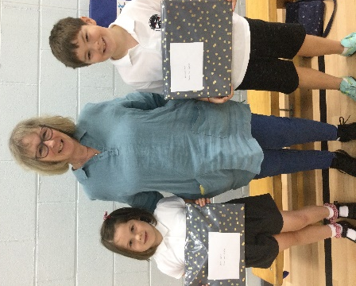

We love to hear about and celebrate the wider achievements of all our pupils, so if your child has been involved in any competitions or interesting activities out-with school please email the school office to let us know. (UNCRC Article 29)

Photographic Permissions
All pupils will be issued with updated photographic permission forms next week, it is important that all parents complete these to indicate their preferences. (UNCRC Article 17)

CNAG After-School Provision
CNAG after school club will resume on Monday 4th September and will run every Monday and Tuesday between 3:10pm-4:45pm. The club is open to all pupils who are willing to try to communicate in Gaelic. (UNCRC Article 30)
Gaelic Homework Support
Maia Pickering, our Gaelic Language Acquisition Practitioner (GLAP), will run a Gaelic homework support club every Thursday between 3:10pm-4:30pm, starting on 14th September. Details on how to sign up will be issued directly from class teachers. (UNCRC Article 30)

Dates for your diary
Friday 29th September | Feel Good Friday
Friday 29th September 11:30am | Macmillan Coffee Morning – all welcome
Wednesday 6th September | School Photographer
Wednesday 13th September | Childsmile
Tuesday 19th September | Flu Immunisations
Thursday 28th September | P5 Trip to Bridge Centre
Thursday 12th October 3:10pm | School closes for October Break

