Sgoil an Rubha

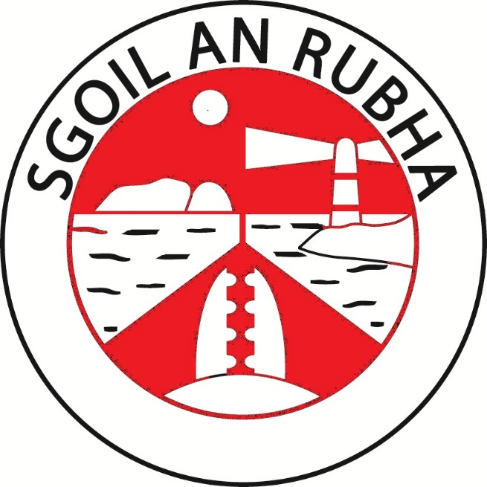

Promoting Positive Relationships and Behaviour Policy

February 2024

INTRODUCTION

This policy and procedure is based on Comhairle nan Eilean policy and procedure, considering the views of staff, parents and pupils within our learning community.
The values we have are reflected in the relationships we have, are demonstrated in our interactions with others and influence the way we consider and behave towards each other.

Adults in a learning community play an important role in modelling positive, respectful relationships for learners. Relationship building is part of the ‘Responsibility of All’.**link

We know that positive relationships and behaviour are at the core of effective learning and teaching and the development of the wellbeing of the whole child. Strong, reciprocal relationships, those with high expectations and clear and consistent boundaries, matter most in terms of pupils’ achievements and self-belief. This policy and procedure should help to establish and maintain positive relationships and mutual respect resulting in a positive learning community and a supportive and restorative ethos.

The relationships that benefit children and young people most of all are those which recognise that all behaviour is communication. The guiding principles of nurture help us to take a holistic approach to the child or young person which consolidates the approach to wellbeing in Getting it Right for Every Child.

CnES Promoting Positive Relationships and Behaviour Policy: Consultation Document 2024

GUIDING PRINCIPLES

Wellbeing | It is essential that the whole school community has a shared understanding of wellbeing and the dignity and worth of every individual. This promotes a culture and ethos of positive relationships.
Inclusion | Inclusion is everyone’s responsibility. Inclusion happens when educational settings create environments that meet the diverse needs of all learners, through personalised learning and support that takes account of individual needs, choices, and circumstances.  An inclusive and positive ethos which is embedded across the whole school community enables positive relationships to thrive. Inclusion entails children and young people being present, participating, achieving, and being supported.
Equality and Equity | Education settings that promote equality treat individuals fairly, value and celebrate diversity and challenge all forms of discrimination. Equity in education ensures that each child and young person is given the right support, at the right time, in the right place to achieve their full potential.
Children’s Rights | Promoting positive relationships and behaviour is underpinned by a rights-based approach. Getting it Right for Every Child and the Children and Young People (Scotland) Act 2014 requires every practitioner to familiarise themselves with and take account of the UNCRC, which has been incorporated into Scots Law (2024), in their day-to-day practice.

Relationship based approaches when thoroughly understood and implemented lead to:

- Improved behaviour
- Improved attendance
- Greater academic attainment
- Reduced exclusions
- Improved attachment to staff, school, and community
- Improved resilience
- Improved long term outcomes

Whilst evidence demonstrates that this approach is of benefit to all children, it is especially beneficial to those who have experienced adversity and trauma in their lives.

Research into Adverse Childhood Experiences indicates that a relationship with a trusted adult can mitigate the detrimental impact of these experiences. We must ensure that all children are included, engaged and involved in creating opportunities and building skills to develop positive relationships.

- RELATIONAL APPROACHES – KEY CONCEPTS

Trauma Informed Practice | Trauma informed practice recognizes the prevalence of trauma, including childhood trauma, and takes account of its impact on emotional, psychological and social wellbeing.  All staff have engaged with trauma informed practice training modules and understand the importance of positive relationships in relation to trauma recovery.
Nurturing Approaches | A nurturing approach values everyone across the whole school community. Positive and attuned relationships are central to a nurturing approach. They form the foundation for effective teaching and learning, and the development of wellbeing.  A nurturing approach is based on 6 principles:  - Children’s learning is understood developmentally  - The environment offers a safe base  - The importance of nurture for the development of wellbeing  - Language is a vital means of communication  - All behavior is communication  - Transitions are important in children’s lives  All staff have engaged in nurture training and are fully committed to providing a nurturing approach.
Restorative Approaches | Restorative approaches promote accountability and seek to repair any harm caused in a situation. Children require the opportunity to hear about and face up to the harm and distress that they may have caused others. This will help them to become responsible citizens.  Restorative approaches have been found to be a more effective response than a traditional disciplinary approach. These approaches can change the emotional atmosphere in a school and lead to more positive relationships between pupils and between pupils and staff.  All staff have engaged in training on restorative approaches and use this consistently across the school.
Staff Wellbeing | Staff wellbeing is key factor in ensuring a nurturing, positive school environment. To be effective role models for the children in their care, staff require good health, strength and resilience to carry out their role successfully.  Appropriate strategies and approaches are in place to ensure that wellbeing is fostered and protected.  Opportunities are provided for collegiality and professional dialogue which allows staff to reflect on their practice and seek support when required.
Career Long Professional Learning | Ongoing professional learning is essential in ensuring that relational approaches are understood and applied consistently. This will include attending courses, self-directed study, reflective practice, practitioner enquiry, coaching and mentoring.

IMPLEMENTATION

Whole School Approach
Good organisation, lesson planning and preparation will help to create the right learning environment. Flexibility, choice and appropriate differentiation will also help to support individual needs and promote positive relationships and behaviour.

We understand that everyone learns best when they feel good about themselves. Positive approaches to support behaviour focusses on relationships, skills building, restoration and when appropriate, consequences appropriate to the child.

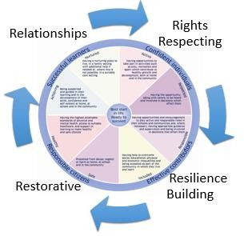
To achieve this positive ethos all staff are committed to;
- Relationships -Developing positive relationships and being positive role models
- Rights Respecting - Respecting and protecting the rights of all children
- Resilience Building - Through identifying strengths and developing skills
- Restorative - Acting restoratively to prevent difficulties and repair relationships when difficulties do arise.

Clear Expectations
We expect positive behavior from the whole school community. Pupils who demonstrate positive behavior and who follow the school’s shared values of respect, kindness, excellence, honesty and fairness are recognized and rewarded. Our values form the basis of all our conversations in relation to behavioural expectations.

Class Charters
At the start of the year each class will create their own Class Charter, this is an opportunity for the pupils and staff to agree shared expectations, based on UNCRC, for the year ahead. Shared ownership and regular reference to the class charter is important in ensuring positive relationship are maintained and that everyone knows what is expected of them.

House System
Our house system is also a powerful tool in reinforcing expectations and an effective way of recognizing and rewarding positive behavior. Every pupil belongs to one of the four school houses, Herons, Oystercatchers, Puffins and Eagles. House points are awarded to pupils who follow their Class Charter rules, who demonstrate the school values, who are polite, tolerant, courteous, and show respect for others and their property. Every pupil can collect house points on a daily basis. Our House Captains and Vice Captains have an important role within school. They promote and encourage good behaviour across all aspects of school. House rewards are given out fortnightly and termly.

Positive Reinforcement
All staff focus on positive relationships by looking for opportunities to encourage learner skills, recognise effort and build on strengths. This includes:
  - Pupils of the fortnight based on school values
  - House points for positive behaviour choices and certificates awarded at assembly to pupils
  - Positive communication with home through Seesaw
  - Sharing achievements with peers at Celebration Assemblies
  - Celebrating wider achievements through house meetings, the school newsletter and social media.
  - Class certificates
  - Stickers and stamps
  - Positive comments in jotters/classwork

Building Skills for Relationships
The school uses lessons and activities that contribute to positive relationships and behaviour and support children to build the skills they need to develop positive relationships, resilience, be rights respecting and act restoratively. This includes:
  - UNCRC Rights of the Child
  - Growth Mindset Lessons
  - Nurture Groups
  - Decider Skills
  - Seasons for Growth

Consequences
However, even with a clear focus on positive reinforcement, some children will present with behaviour that challenges or is difficult to interpret. The school uses approaches and strategies which are designed to help prevent and de-escalate difficult situations, and which are tailored to individuals based on our knowledge of them.
All learners are held responsible for their behavior. Every member of staff will deal with behavior and use the stepped actions below for dealing with poor conduct.
Steps:
- Redirection
- Reminder
- Warning
- Time out
- Restorative conversation
- Phone call home
- Formal meeting

Steps | Actions
Redirection | Gentle encouragement
Reminder | Reminder delivered privately wherever possible, de-escalate the situation. Reference to class charter/school values. Pupil is encouraged to self-manage their behavior.
Warning | A clear verbal warning delivered privately, wherever possible. Make the pupil aware of their behavior and clearly outline the consequences if they continue – stepped actions below. *Time out offered to give the pupil a chance to reflect away from others. It may also diffuse any anger or other big emotions.
*Time out examples may include – moving a pupil from one seat/table where incident happened to another one, moving a pupils away from classmates to a quieter area of the classroom, leaving the playground area, restriction of the current activity.
Restorative Conversation | Give the pupil a chance to reflect away from others. Speak to the learner privately and give them a an opportunity to engage in a restorative conversation, where it is necessary for them to reflect on the impact of their behavior. Complete reflection sheet (appendix 1), which is sent home for parents to comment upon and sign.  If the behavior is significant or repeated behavior, refer the pupil to Head of School for restorative conversation.
Phone Call home | When an incident has been serious and/or violent the Parents of children involved should be phoned. A record of this phone call should be kept. If no answer when phoning an email should be sent. Seesaw should not be used for communicating behaviour incidents.
Formal Meeting | When inappropriate behavior is persistent and the pupil is not responding to any of the above steps, a formal meeting with the pupil, parents, class teacher and SfL teacher should be convened. Specific targets should be agreed, monitored and reviewed over a period of time.

For incidents of bullying please refer to our school’s anti-bullying policy.

Responding to Distressed Behaviour
The school recognises that supporting children and young people with their behaviour requires:

    - acknowledgement that all behaviour is communication
    - understanding how a child’s needs and setting might impact on behaviour
    - identifying any known 'triggers' and early warning signs
    - considering the environment, body language and speech in this process
    - intervening early if warning signs are detected to prevent a situation from escalating

Through restorative conversations, we explore and establish “what’s happened” with children. To do this we listen to their response, whether that is given verbally or expressed non-verbally and act appropriately. Once the reason and purpose for the child’s behaviour is known we explore how we can develop appropriate support or adaptations to address the issue by promoting well-being, offering coping strategies and agreeing constructive solutions. Teaching of restorative language, which will equip pupils to meaningfully engage in restorative conversations, should be taught as part of Health and Wellbeing lessons.

Other strategies
  - Home/school behaviour communication books for individual pupils, where necessary. Staff use these with individual pupils, and in partnership with the parent.
  - Individual chronologies updated with details of serious incidents.
  - Communication with home via phonecall.
  - Individual risk assessments
  - Mediation with peers
  - Alternative playtime
  - Multi-agency support

Additional Support Needs
We provide support that meets children’s needs and identifies additional support needs through the CnES Staged Assessment and Intervention process. The majority of children and young people’s additional needs will be best met through differentiated support provided alongside their classmates; however, a minority might require a more targeted approach.

    - A safe space for pupils to access
    - Key workers or trusted adults: a named person for specific children
    - PEF Senior Development Officer to support pupils and families.
    - Staff being available at critical times e.g. transitions, break times
    - Nurture Groups where appropriate
    - Emotions Talks Framework

Targeted approaches
Through ongoing assessment and intervention, it will be identified that some children and young people will need support that is additional to, or different from, the support provided for their peers. These children may need specific targeted support to develop their ability to regulate and engage in the social behaviours that build positive relationships and cohesive communities. Children may need to be taught specific skills for example, emotional regulation, turn taking, understanding of social expectations, and acceptance of social boundaries.

ROLES AND RESPONSIBILITIES

The Head of School has overall responsibility for ensuring the effective implementation of this policy.

All staff are responsible for ensuring that the policy and procedures are followed. All staff encourage positive relationships and act as role models within our learning community.

Parents and families are regarded by the school as key partners who are asked to work in partnership with the school. Parents are expected to assist in maintaining positive relationships and support restorative approaches and high expectations for positive behaviour. Parents are invited to raise with the school any issues arising from the operation of the policy.
Learners participate in supporting this procedure and contribute to our positive school ethos. All learners know our school values. Learners are supported to ensure that incidents of disruption, violence, bullying and any form of harassment are reported. The implementation of this procedure allows learners to understand the cause and effect of their behaviour.

SELF EVALUATION AND REVIEW

Our policy is displayed on our school website and is reviewed annually by staff.

RELATED DOCUMENTS

Scottish Government
- Standards in Scotland’s Schools etc Act (2000)
- Included, Enagaged, Involved 2 (2017)
- Guidance on the Presumption to Provide Education in a Mainstream Setting (2019)
- Developing a Positive Whole School Ethos and Culture: relationships, learning and behaviour (2018)
- Additional Support for Learning Act (2004) - amended 2009
- Parental Involvement Act 2006
- The Equality Act 2010
- UN Convention of the Rights of the Child
- Children and Young People Act 2014

Local Authority
- CnES Promoting Positive Relationships and Behaviour Policy: Consultation Document 2024

Appendix 1

Sgoil an Rubha Behaviour Reflection Form

