Sgoil an Rubha
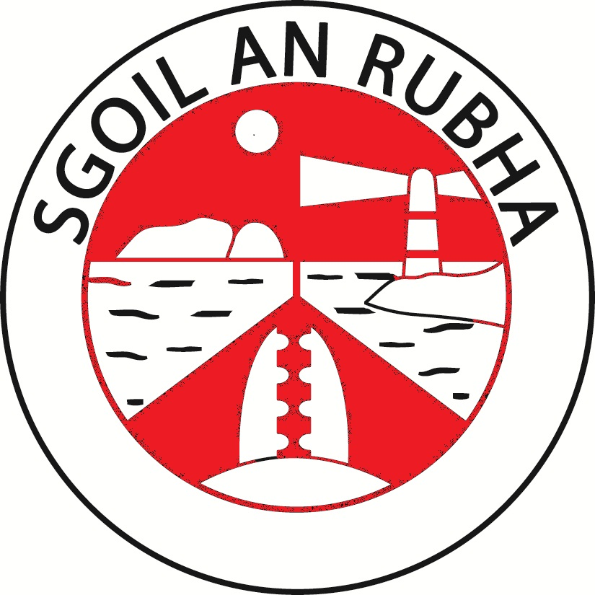
Writing Policy

November 2022

Rationale
The purpose of this policy is to establish a clear and consistent approach throughout Sgoil an Rubha and to ensure that continuity and progression are embedded in our practice.
Literacy skills empower pupils to realise their potential as independent lifelong learners. They have a significant impact on self-esteem, motivation and aspirations for the future.
“Children and young people will demonstrate their progress in writing through the degree of independence they show, the organisation and quality of their ideas, their skills in spelling, punctuation and grammar, the match of their writing to audience and the effectiveness of their use of language.”
Curriculum for Excellence
At Sgoil an Rubha we strive to provide exciting, challenging opportunities for pupils to engage in the writing process as we recognise that writing skills are essential for children to achieve in the future and enter the world of work confidently.
Achieving equity and excellence for all learners in Sgoil an Rubha is a whole school priority. This policy provides a clear framework to enable all staff to raise attainment in writing and close the attainment gap between the most and least disadvantaged children by supporting class teachers to ensure that appropriate teaching and learning writing experiences are in place at all stages. It provides a clear rationale and expectation for the development of writing skills as a responsibility of all staff and that these core skills for learning and life should be progressively developed across a range of meaningful and motivating contexts from early to second level.
Aims
At Sgoil an Rubha we aim to:
- Have a positive writing ethos throughout the school so that pupils develop confidence and pleasure in writing
- Raise standards in writing by providing high quality learning experiences
- Ensure progression, continuity and consistency at all stages and across areas of transition
- Provide pupils with effective feedback, identifying next steps in learning to raise attainment
- Provide appropriate levels of challenged and support for all learners
Planning Learning and Teaching
Writing is major part of the literacy curriculum and along with reading, listening and talking, makes a significant contribution to the development of children as thinkers and learners.
Class teachers will plan a balance of all genres over the course of a school session. Writing is planned using a genre approach, where pupils are able to extend their writing of a specific genre in a specific time frame. Teachers will select appropriate genres according to pupil choice, stage, IDL, need, etc.
Literacy and English, Literacy and Gaidhlig experiences and outcomes and the benchmarks underpin the planning process at Sgoil an Rubha. Staff aim to provide writing that is real and relevant to pupils, allowing them to make connections in their learning and transfer what they have learned in writing to other curricular areas.
Planning:
- Whole school Literacy and English and Literacy and Gaidhlig progression pathways are in place for all stages from early to second level.
- Each pathway contains the experiences and outcomes for the level alongside the key skills to be developed from each experience and outcome.
- The associated national benchmarks are incorporated into each pathway to support with class teacher planning and assessment.
- Children’s prior learning and next steps will play a key role in specific skills to be developed.
- Class teachers plan termly for the specific skills to be developed for each group and groups/individual pupils will progress through the planners at an appropriate pace.
- Class teachers will record termly the following information on each planner:
- Identify the overarching experiences and outcomes to be developed and the related skills and highlight the appropriate phase on the pathway.
- Plan the key learning experiences to be delivered to effectively develop these skills and detail in daily diary.
- Plan for the appropriate resources and teacher approaches required to effectively develop these skills and detail in daily diary.
- Identify appropriate benchmarks for assessment of these skills and highlight on the pathway.
- Plan and record on at the bottom of the pathway the appropriate assessment activities which will allow evidence of progress to be gathered in relation to the specific skills.

Approach to teaching writing:
Extended writing lessons will take place at least once a week and where possible will relate to the class topic. Additionally, skills for writing, which will be applied during the main extended writing session, will be developed through regular language lessons. Class teachers embed a variety of writing skills by using a range of resources and strategies such as Big Writing and Alan Peat Sentences.

In order to raise attainment in literacy and writing it is important that in every class children experience stories on a regular basis. This is done through a class novel or short stories. Children are exposed to a variety of texts throughout their school career in order to widen their vocabulary and raise their awareness of different story structures and themes. Choices on class novel are at teacher and class discretion however variety is key.
Staff should plan learning activities which utilise a wide range of texts including spoken, written and digital texts and encourage the use of creative approaches which harness the imagination.
All classrooms will display examples of good work. Staff will ensure that all pupils are given recognition for their writing achievement at some point during the session.
All writing lessons in Sgoil an Rubha will follow the ‘Steps to Success’, which are displayed in all classrooms and are discussed with learners.
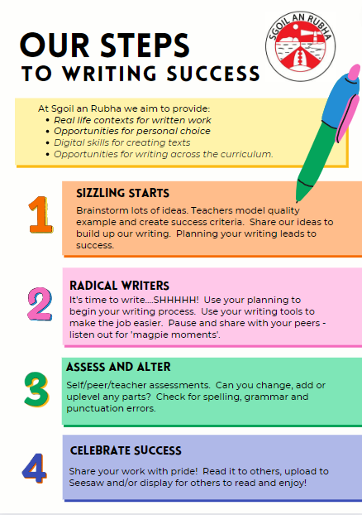
Feedback:
At Sgoil an Rubha we believe that a variety of feedback, which is directly linked to the Learning Intention and Success Criteria, is essential in improving writing.
- Peer assessment - children pair up working together on reviewing a person’s piece of work. Work is marked by the child whose book is being looked at but the feedback given is decided on as a pair. The pairs can work on traffic lighting success criteria.
- Self assessment - children are asked to check their work, against the Success Criteria, independently and highlight a part of work they would like some feedback on. This might be because they think this is a really good part or a part they wish to develop. The teacher will give feedback by writing a small note in the child’s jotter or verbally.
- Teacher assessment - teachers will sit with individuals going through their work. After this pupil and teacher will decide the child’s next steps, considering their success criteria for the piece. Pupils should then write at the bottom of the piece of writing what their next steps are.
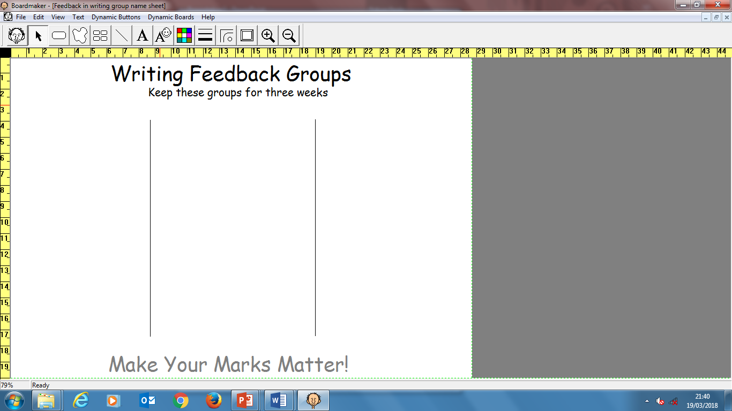
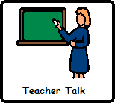
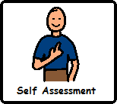
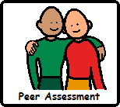
Regular oral feedback is also given to individuals throughout the writing and editing process, this is key to raising standards and to help learners to recognise the importance of checking and editing work.
‘Magpie Moments’ where the whole class stop, share and give feedback on each other’s writing is an effective way for children to hear what others are writing, to reconsider the success criteria and to apply further strategies to their pieces.

Assessment, Monitoring and Tracking
Assessment is an integral part of the learning and teaching process. A balance between formative and summative assessment will be used to:
- Provide pupils with clear and regular feedback
- Assist teachers and pupils to plan their next steps
- Evaluate the effectiveness of teaching

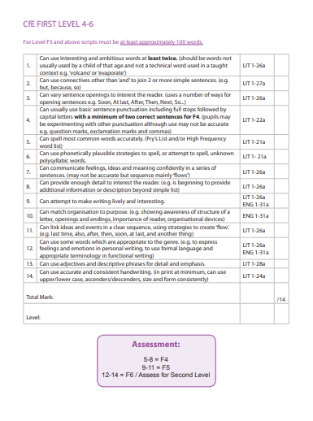
At the beginning of term 1 children will complete a base line assessment. This assessment should be a piece of unassisted writing. This assessment will be marked using the Scottish Criterion Scale. Results will be recorded in the school’s tracking system.
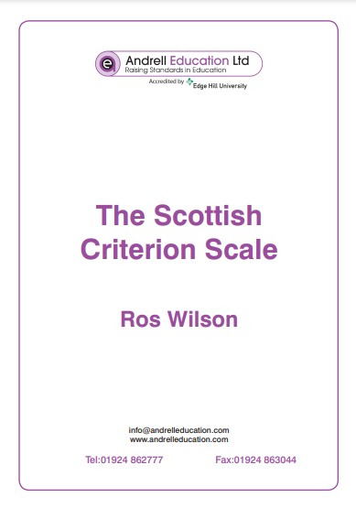

During the school session 3 further formal assessments of pupil’s writing should be carried out.
Baseline
June – from previous teacher
Interim Progress
October, January and March
Final Progress
June

It is expected that pupils will move steadily through the levels of the scale moving at least 1 increment between each interim and final assessment.
Monitoring and tracking will be carried out by class teachers and SMT who will track progress through forward plans, a variety of assessments and through teacher judgement/observations.

Roles and responsibilities
The role of the SMT will be to:
- Create an ethos of achievement in literacy
- Provide a clear policy for skills development in writing
- Ensure rigorous assessment and monitoring takes place
- Promote literacy across the curriculum
- Ensure staff access appropriate training opportunities
- Lead self-evaluation activities to review the school’s progress against National standards
The role of teaching staff will be to:
- Take account of prior learning and assessment data when planning next steps
- Employ a range of teaching strategies to take account of different learning styles
- Create a literacy rich learning environment
- Share learning intentions and success criteria at the start and throughout all writing lessons
- Set a pace of learning and level of differentiation which ensures appropriate challenge and support
- Show children quality examples of writing
- Have high expectations and celebrate success
- Be an effective role model in promoting writing and literacy (demonstrate a love for writing, the editing process and celebrate mistakes)
- Use a variety of resources including ICT to support learning
- Discuss next steps with learners and encourage independent learning
- Participate in regular moderation activities

Parents are asked to support the work of the school through encouraging children in homework tasks, which should enhance and compliment literacy work being completed in school. Regular reading and spelling practice with children are key to developing writing skills.
Pupils are expected to participate fully in all classroom and homework activities. Children will set themselves targets and have high expectations of the work they can produce.
Pupils with additional support needs will be supported in line with CNES’s Additional Support for Learning Policy. These pupils may be supported by Support for Learning Assistants (SFLAs) or given further explanation and/or be supported individually by the class teacher.
Practical Expectations:
- There should be high expectations of presentation (handwriting, date, title, line space left between title and rest of script)
- Learning Intention and Success Criteria should be clear in every piece of writing
- There should be evidence of feedback
- Correction code should be used in all classes

Children’s Rights
Consistent application of this policy will ensure that the following rights are being met:
- Article 12 – Respect for the views of the child
- Article 13 – Freedom of Expression
- Article 17 – Access to information from the media
- Article 28 – Right to Education
- Article 29 – Goals of Education

