 | 
Roinn an Fhoghlaim is Seirbheisean Chloinne
Department of Education & Children’s Services

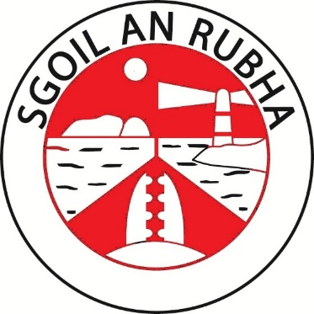

Sgoil an Rubha

Aithisg Ìre de Mhathas 2022-23
Plana Leasachaidh na Sgoile 2023-24
__________

Standards & Quality Report 2022-23
School Improvement Plan 2023-24

A’ Coileanadh Sàr-Mhaitheas Còmhla – Achieving Excellence Together

Standards & Quality Report for 2022-23
and School Improvement Plan 2023-24
(SQIP)

Contents

Section One - The Context of the School 3

  - The School and its Community
  - Our Vision, Values, Aims and Curriculum Rationale
  - Collaboration & Consultation

Section Two - Standards & Quality Report for 2022-23 6
2.1 The Year in Review
2.2 Successes & Achievements
2.3 Self-Evaluation & Quality Assurance Processes
2.4 Progress Towards Delivery of NIF Priorities
2.5 Review of School & ELC Improvement Projects 2022-23
2.6 Summary of PEF Action & Impact
2.7 Evaluation of Progress – HGIOS QIs
2.8 Progress Towards Achieving Stretch Aims
2.9 Key Improvement Priorities for 2023-24

Section Three - School Improvement Plan for 2023-24 21

3.1 Creating the Plan
3.2 SIP Planning Context & Influencing Priorities
3.3 Planning for Pupil Equity Fund Delivery
3.4 School Improvement Plan Projects for 2023-24
3.5 School Improvement Plan Delivery Timeline
3.6 Long Term Planning

The Language of Evaluation

All | 100%
Almost All | 90% - 99.9%
Most | 75% - 89.9%
Majority | 50% - 74.9%
Less than half | 15% - 49.9%
Few | > 15%

Section One - The Context of the School

1.1 The School and its Community
Sgoil an Rubha is a non-denominational local authority school in the village of New Garrabost, Point, on the Isle of Lewis. The school opened in August 2011 and offers Primary and Nursery education through Gaelic and English Medium.

The school has a roll of 127 primary pupils and 39 pre-school pupils supported by 32 teaching and non-teaching staff. The Head of School is responsible for the day to day management of the school and works closely with the Executive Head Teacher to strategically plan and implement the improvement agenda for the school.

We are the only school in the area of Point and are well supported by members of the local community and community organisations.

1.2 Our Vision, Values, Aims and Curriculum Rationale

Our Vision:
Soirbheachaidh sinn còmhla! – Together we can do more!

Our vision is to provide a happy, safe, nurturing community in which children value their culture and heritage and are motivated to learn and achieve their full potential. Our children should have the

skills, confidence and resilience that equip them for this rapidly changing world.

Our Values:
Onair / Honesty
Urram / Respect
Coibhneas / Kindness
Cothromachd / Fairness
Sàr-Mhathas / Excellence

Our Aims:
- Promote high quality learning and teaching to meet the needs of all pupils.
- Raise the standards in attainment and achievement by having high, realistic expectations of pupils to realise their full potential.
- Provide all pupils with opportunities for personal achievement and support learners to develop the skills needed for learning, life and work.
- Get it right for all children – ensuring they are active, respected, responsible, included, safe, healthy, achieving and nurtured.
- Improve the educational outcomes of children affected by poverty and/or adverse childhood experiences.
- Give opportunities to celebrate success and achievement.

Children’s Aims:
- To have more opportunities for outdoor learning and active learning, in school and in the local community.
- Learn more about the world of work and be able to make links between our work and the world of work.
- To be more involved in the decision making about our learning.

Our Curriculum Rationale:
We are currently in the process of refreshing our curriculum rationale and are consulting with all stakeholders to identify key priorities for our school.

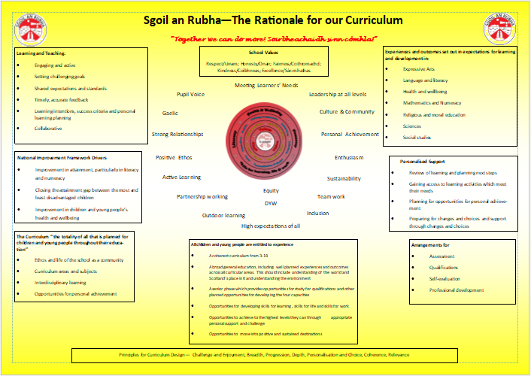

1.3 Collaboration and Consultation
In completing the Standards & Quality Report for the current year and the School Improvement Plan for the year ahead, a critical process in the gathering of evidence is to collaborate with key stakeholders and to consult to establish views about the service and opinions about how it should improve.
Who? | When? | How? | What did we find out? | Informed
 |  |  |  | SQR | SIP
Staff | Ongoing | Self-Evaluation sessions  Self-Evaluation questionnaires | Quality Indicator (QI) 2.4 (Personalised Support) – rated overall good  QI 2.2 (Curriculum) – rated overall good  Next steps:  More professional development (CPD) pertaining to Additional Support Needs (ASN) required.  Consistent practice in the use of interventions.  Improvement in support from outside agencies.  More focus on Developing the Young Workforce (DYW)/ partnerships required.  Need to identify what makes our school unique when refreshing rationale.  More emphasis required on 4 contexts and 4 capacities when planning the curriculum.
Children and young people | Sept 2022  Jan 2023  Mar 2023 | Use of Learner Friendly ‘How Good Is Our School’ (HGIOS) themes with different groups of pupils.  Questionnaires based around QI 3.1 (Improving wellbeing, equality and inclusion) | Next steps identified by pupils:  More outdoor learning and equipment.  Learning to be linked to the world of work.  Opportunities to run and be part of clubs.  More time to talk to teachers and set targets in their learning.
Parents and Carer | Oct 2022  Mar 2023  May 2023 | Open Afternoon  School Improvement Planning Session  Parental Questionnaires | Parents noted improvements in the communication and family involvement in the nursery.  Parents were pleased that mental health resources and the Nurture Principles were being promoted, and noted that pupils felt well supported by ‘excellent teachers.  100% of parents who completed the questionnaire were happy with the school and there were several comments about our hard-working, caring staff.  Parents indicated that they wanted more regular feedback on learning, including information about next steps in learning.
Community and other stakeholders | Mar 2023 | School Improvement Planning Session | Partners noted that there was a strong pupil voice and that pupils were confident in representing their school. They stated that they were pleased to see the United Nations Convention on the Rights of the Child (UNCRC) being embedded across the school.

Aithisg Ìre de Mhathas 2022-23

__________

Standards & Quality Report 2022-23

Section Two – Standards & Quality Report 2022-23

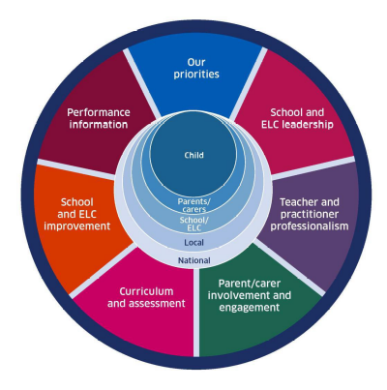
The Standards & Quality Report documents the progress the school has made during 2022-23 in the delivery of a range of improvement priorities and key performance measures. This includes:

- The National Improvement Framework priorities
- School Improvement Plan projects
- National and Local Stretch Aims

2.1 The Year in Review / 2.2 Successes and Achievements
The end of last session marked the anniversary of the school being open for 10 years. Parents and members of the community were invited into the school to celebrate. All classes created wonderful displays which documented Sgoil an Rubha across the decade and attendees were entertained by our talented pupils.

To date, the 2022-2023 session has been extremely busy and very productive. Term 1 started with a review of planning and new formats and approaches were agreed. Our Healthy World was the theme for all classes in the first term. This was very successful and culminated with a health week involving several health professionals and parents.
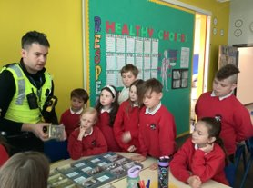
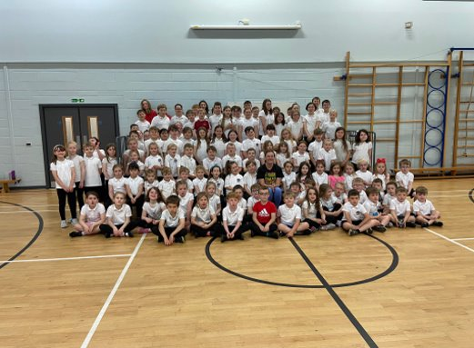

On 7th September 2022, we were delighted to be awarded the Rights Respecting Schools Award (RRSA) Silver Accreditation. Staff and pupils have worked well together to ensure that UNCRC is a feature of everything that is happening in the school.

During term 2, all classes experienced learning around the theme of Our Creative World. It was wonderful to see what confident individuals we have in Sgoil an Rubha as all pupils participated in a whole school Christmas Performance to a packed hall of parents and family members.

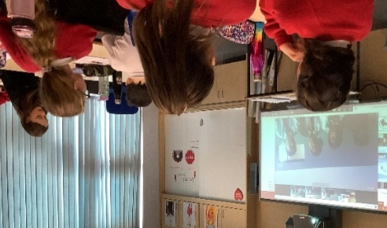
In January 2023, we established a link with Smarika School, in Nepal. Pupils involved in the project will investigate various aspects of climate change in our local community, and compare their findings with pupils in Nepal.

Most recently we were awarded the Silver Sports Scotland Award and will now start working towards achieving the gold award.

We believe that Sgoil an Rubha should be at the heart of the Point community and endeavour to provide regular events involving parents and members from the local community. Earlier this session, a successful funding application was made to Point and Sandwick Trust which meant that the entire costs of P7 school trip would be covered. This is an example of how working with community organisations has directly benefitted some of our pupils

2.3 Self-Evaluation, Quality Assurance and Evidence Gathering Processes
Self-evaluation is ongoing and is included as part of the staff collegiate calendar. To ensure that all quality indicators are being addressed regularly there is a self-evaluation cycle which we follow.
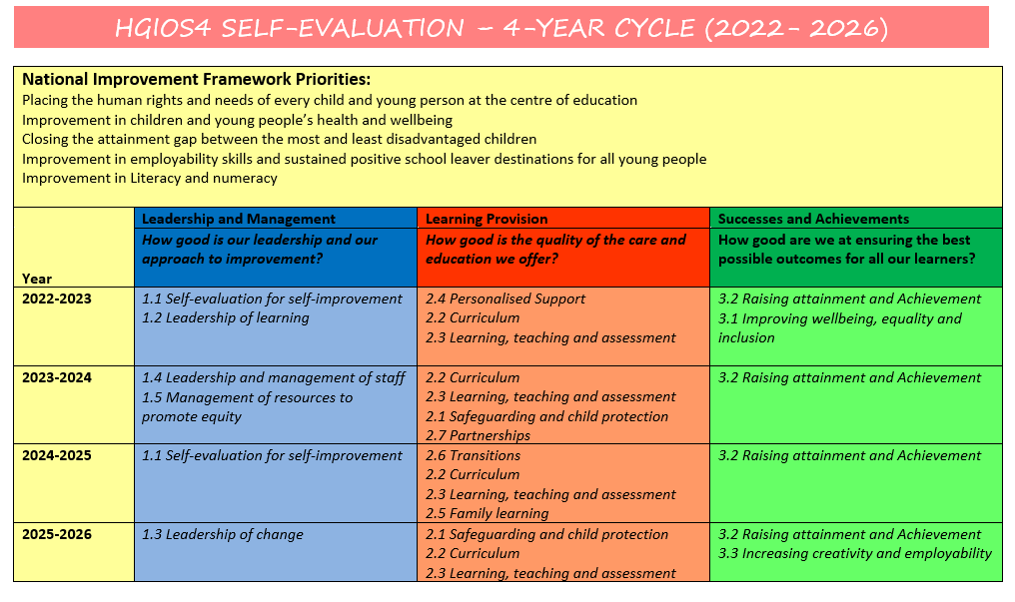

In addition to the quality indicators (Q.I.s) required for this document, so far this session, we have evaluated quality indicators 2.4 (Personalised Support) and 2.2 (Curriculum)
Strengths identified through this work:
- School values unpin the relationships throughout the school and this contributes to an ethos where pupils feel valued and heard
- Attainment meetings which clearly identify support needs and detail specific targeted approaches
- Children are encouraged to have more ownership of planning processes and to take responsibility for their learning
- Additionality and support are implemented in-line with tracking information
- Staged Intervention processes are being used effectively and consistently
- Communication with Senior Management Team (SMT) regarding developments relating to pupil progress/concerns
- Staff know the children/families very well and are cognisant of hardship and other issues which may affect pupils’ learning
- Support provided for Pupil Equity Fund (PEF) pupils – more detail in section 2.4
- Use of Gaelic Language Acquisition Practitioner (GLAP) to support in GM1-4 class
- Pupil chronologies are used to store important information
- Class teachers use a variety of learning approaches
- Co-ordinated planning, including relevant training specific to the needs of ASN children
- Regular meetings with support for learning staff
- Focus weeks involving partners and the school community
- Thematic approach to Inter-disciplinary Learning (IDL)
- Planning and evaluation documents have been updated to give more emphasis on the 4 contexts and 4 capacities
- Curriculum overviews ensure adequate coverage across levels
- Teachers are skilled in providing motivating lessons which develop key literacy and numeracy skills
In August, the Quality Assurance (QA) calendar was also discussed and agreed with staff. The Executive Head Teacher participates in QA activities throughout the session to ensure that practices in Sgoil an Rubha are consistent with practices across the cluster.
Strengths identified from this work:
- Across the classes, almost all pupils are able to explain their learning and are settled, well behaved and ready to learn
- Across all classes learning experiences are relevant and purposeful
- Learning is appropriately challenging in some classes
- Where appropriate, a range of differentiation is evident, and in some instances, differentiation is very good.
- Pupils are articulate, confident and can respond to questions appropriately.
- Pupils can explain their targets
- All pupils believe that there are positive relationships across the school and can give examples. All pupils feel included and a sense of belonging
- Pupils are able to explain how feedback supported their learning and can explain how they could access support if required
- All lessons observed were of a good/very good standard
- The ethos and culture of the classes reflect children’s rights.
- Play pedagogy is effective and tasks are skillfully planned to ensure they are matched to the needs and abilities of all pupils
- The teaching and explanations are very good, clear and concise
- Questioning is good and encourages pupils to think
- Assessment is used to inform teaching
Next steps:
- Further work is required to promote Gaelic across the school.
- Continue to challenge more able learners
- Continue to reinforce the language of learning
- Use of targets across the school. This could be linked with profiling learning on Seesaw.

A programme of moderation, including which experiences and outcomes are to be focussed upon, is also agreed at the start of the session.

On 13th July 2022, the Care Inspectorate visited our nursery setting. Their findings were very positive, key messages and evaluation are below:
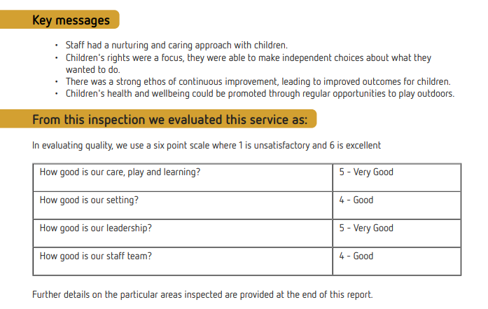

2.4 Progress Towards Delivery of the National Improvement Plan Priorities

Priority | Actions | Impact on Learners | Next Steps
Placing the human rights and needs of every child and young person at the centre of education. | - UNCRC articles are clearly referenced in all planning documents  - Children’s rights are referenced in recently updated policies  - Pupil led assemblies are focused around UNCRC articles | - All pupils know a range of UNCRC articles and can talk about how they enjoy their rights and how they link to their learning  - Pupil voice is becoming stronger across the school, this was noted at a recent parent/partner consultation | - Continue working to ensure that UNCRC permeates all learning and teaching  - Continue to update school policies to reference UNCRC  - Embed UNCRC in the nursery
Improvement in children and young people’s health and wellbeing (HWB) | - Implementation of The Decider Skills Programme across all classes  - Involvement of a range of partners, CAMHS, School Nursing Team, Educational Psychologist, to support individual pupils  - Specific interventions based on HWB questionnaire data  - Investment in new resources to support mental health  - Promotion of ‘kooth’ amongst older pupils  - Engagement with Action for Children to support some of our pupils  - Information about new RSHP resource has been shared with all staff  - Staff CPD in play pedagogy | - Most pupils are able to reflect on their progress meaningfully using the wellbeing indicators. This information is part of our tracking which ensures interventions are put in place to support pupils’ health and wellbeing needs.  - Parents are well informed of the approach and resources which will be used to deliver RSHP, through sharing of the authority blog. Pupils will receive their full entitlement to the RSHP element of the curriculum.  - Pupils at Early Level will have greater opportunities to learn through play. | - Continue to develop HWB measures, which can be used to positively impact pupils  - Implement newly developed RSHP resource across the school and nursery  - Undertake play pedagogy evaluation and identify next steps
Closing the attainment gap between the most and least disadvantaged children and young people | - Regular review of Pupil Equity Funding (PEF) list, using local knowledge  - Targeted use of Education Attainment Apprentice (EAA)  - Guidance and advice from Attainment Advisor  - Promotion of Free School Meals (FSM), clothing grants and bridging payments  - More detailed tracking of FSM/PEF pupils and comparison to non-FSM/PEF  - Easy access to pre-loved uniform  - Provision of food parcels through EAA  - Use of Strategic Equity Fund (SEF) to help support children on the PEF list  - Free afterschool homework club  - Breakfast club  - Reduction in the number of donations/fund raising activities  - Information regarding holiday clubs and meal provision is shared with eligible families  - Attendance monitoring and analysis | - More consistent identification of pupils who are experiencing a poverty-related attainment gap  - Parents are aware of and encouraged to apply for financial support  - Analysis of main factors contributing to any attainment gaps and identification of means to address these  - Uniform swap shop is well used as it is very accessible and discreet  - Breakfast club is very well attended, pupils enjoy attending and are readier to learn  - All children are included in all activities  - SEF funding has enabled more pupils access after school provision and has enhanced the HWB resources/approaches | - Continue to regularly review PEF list to take account of changing circumstances within families  - Involve EAA more fully in termly attainment meetings  - EAA to record, monitor and report on specific interventions for PEF pupils  - Continue to promote uptake of FSM  - Continue to monitor attendance and create more innovative ways to engage some families
Improvement in skills and sustained, positive school-leaver destinations for all young people | - Introduction of ‘pupil choice’ groups  - Thematic approach for IDL, with DYW being the theme for term 4  - 4 contexts planners make links to DYW explicit  - Participation in Developing Young Workforce (DYW)/Science Technologies Engineering Maths (STEM) events/visits  - Health Week involving partners from various organisations | - Pupils are involved in the planning process and can see how their skills are being developed across the 4 contexts of learning  - Levels of engagement and feedback suggests that all pupils enjoy participating in DYW/STEM events and having partners visit the school | - Increase the number of DYW/partner events  - Create a database of employers and partners that can be utilised by the school
Improvement in attainment, particularly in literacy and numeracy. | - Termly attainment meetings  - Regular moderation/Quality Assurance activities  - Use of ‘additionality’ to target attainment in writing  - Refresh of writing policy  - Review and refresh of writing assessment tools  - Use of National Standardised Assessment (NSA) data to inform planning  - School Improvement Plan 1 focused on raising attainment in numeracy and writing. Further information in section 2.5 | - Regular moderation activities have resulted in a more consistent understanding of achievement of a level  - Interventions are closely monitored and reviewed as required to ensure they are having the desired impact  - Tracking data indicates improvements in attainment of targeted pupils | - Continue to use data from tracking meetings and moderation/QA activities to target individuals and groups of pupils  - Review moderation and assessment activities

2.5 Review of School & ELC Improvement Plan Projects 2022-23

Project Title & Objectives | Actions Undertaken | Impact on Learners | Next Steps/Future Development
Raise attainment in Numeracy and Writing  By June 2023:  - At least, 90% of all children in P1, 81% of all pupils in Primary 4 and 85% of all pupils in Primary 7 will achieve their expected levels in numeracy and writing.  - Pupils on the pupil equity fund list will have increased attainment by 5% in numeracy and writing | - Identification of targeted intervention groups (including PEF)  - Clear timetable of interventions  - Framework for a high-quality writing lesson agreed and displayed in all classes  - Opportunities for Early Years staff to improve their understanding of play pedagogy, evaluate current practice and implement at least one new play approach  - Whole school focus on writing, increased amount of time spent on writing each week  - Purchase of new resources to support the delivery of writing/maths  - Robust tracking meetings, focusing on interventions for pupils who are not on track  - Refresh of the writing policy  - Use of ‘additionality’ to target areas where pupils are not achieving  - Sharing of good practice  - Use of NSA data to target areas of maths and writing | - All staff are clear about which pupils require more intensive input and are accountable for reporting on impact during attainment meetings  - Data is used effectively so that interventions are more focused and successfully target problem areas  - Tracking indicates that there has been a positive impact on attainment for some pupils (84% of P7 pupils will achieve milestone numeracy and 89% in writing)  - All pupils are experiencing a similar approach in writing lessons, they are clear about what is expected of them and how to achieve success  - Writing is given a higher profile in the school and pupils have more opportunities to apply their writing skills in a variety of contexts  - Numeracy resources purchased have contributed to an increase in attainment/confidence in maths  - QA activities evidence that pupils are experiencing high quality learning and teaching and can articulate the purpose of their learning  - There are increased opportunities to learn through play and there is a clear direction for the further development of play pedagogy  - Evidence from QA activities indicates that interventions detailed in planning/tracking information is happening in classrooms  - Sharing good practice sessions have led to changes in approaches to writing and maths | - Continue to use a variety of data to target individuals/groups of children  - Become involved in CYPIC project  - Update writing assessment criteria to align it more closely to benchmarks  - Implement Talk for Writing approach in early level classes/playrooms  - Provide training for support staff in new numeracy resources
Improve wellbeing and relationships across the school  By June 2023, there will be:  - A 10% increase in the number of pupils who feel they are respected  - There will be a 50% decrease in the number of incidents reported to SMT  - A 10% increase in CfE attainment in Health and Wellbeing, across the school | - Whole school nurture evaluation  - Consultation with Nurture teacher from Glasgow City Council  - Promotion of Nurture Principles amongst staff and pupils, pupil friendly posters displayed throughout the school  - Review of HWB measurement approaches  - Use of HWB data to plan interventions  - Creation and implementation of RRSA Gold action plan  - Increased opportunities for pupil leadership and pupil voice  - Staged implementation of The Decider Skills Programme  - Review and update of anti-bullying policy  - Provision of nurture, attachment and trauma training for staff  - Implementation of restorative approaches  - Health and Wellbeing focus week held in October 2022  - Purchase of ‘Tree of’ resource  - Staff wellbeing session  - Creation of a nurture group  - Use of SEF funding to establish a ‘nurture room’ within the school  - Provision of a free homework club, open to all but targeted at PEF pupils  - Introduction of ‘playground buddies’.  - Review of behaviour reflection sheets  - Training in Boxall Profiling | - Results of nurture evaluation have been shared with all staff and working groups have been established to develop specific nurture principles  - HWB snapshots have been adapted to gather more meaningful data from younger pupils  - Data from HWB snapshots are used to plan interventions where required  - Information obtained during focus groups indicate that pupils feel they are being effectively supported to overcome difficulties  - Pupils are able to articulate a range of emotions and can describe which of the decider skills could help them when they are experiencing negative emotions  - Feedback from the whole school health week was very positive  - Involvement in the nurture group has had a significant impact on the HWB and attainment of the pupils involved  - The nurture room provides a safe space for individual pupils and groups and is used by other agencies to work with some pupils  - Playground buddies provide activities for their peers and ensure everyone feels includes at playtimes  - Pupils are becoming more responsible for their actions and are being taught the necessary vocabulary to engage in restorative conversations  - Our anti-bullying policy includes the views of staff, pupils and parents and references our school values and UNCRC, all stakeholders are clear on how incidents of bullying will be addressed | - Publish and share final version of anti-bullying policy  - Continue to embed nurture principles  - Implement Boxall profiling across the school  - Implement Tree of Knowledge resource in all classes and as part of staff collegiate time
Nursery  - One Parent/Community engagement activity will be held by the Nursery at least once a term in session 2022/2023 | - Self-evaluation of family learning/engagement completed with next steps.  - A list compiled of possible Parent/Community engagement events with Parental contribution/feedback  - Consultation with children about their learning and who they would like to invite in to nursery, and where they would like to explore in the community.  - Schedule of events compiled for the upcoming year. | Learners have had the experience of a wide range of visitors in the Nursery, including:  - Parents/Grandparents reading stories  - People who help us in our community came to visit the children. Children had the opportunity to learn about different jobs and how they help us.  - Local Football team in to visit and held a mini training session sharing their skills and knowledge with the children.  - Visit to Pupil’s house to see and learn about livestock.  This has started to form Intergenerational links with the community, extend the children’s learning and knowledge of who and what is about in our community. | - Nursery to provide more opportunities for the children to have access to their wider community, planning and organising outings/visits to different parts of our island.
Nursery  - 80% of staff partaking in trial groups, will be trained and confident in implementing Planning in the Moment by June 2023  - 80% of staff will be able to document and share children’s learning in response to informed observations of children’s play by June2023  - 80% of practitioners will demonstrate effective interactions to support and progress children’s learning by June 2023 | - All staff attended In The Moment Planning training at August Inservice 2022  - Parents advised of the planned change and the Planning in the Moment approach on SWAY  - Staff reflected on their own practice, measuring current practice and not documentation of learning recorded by time/pressure rating scale.  - Reviewed and developed spaces indoors and outdoors  - Staff scheduled and undertook peer evaluation of each other using the Leuven scale/Teaching is tool  - Staff moderation of observations at October Inservice | - Children were able to freely choose and plan own learning  - Staff got to know more about the children in regards to their interests. The learning was more engaging as it was based around the learner’s individual interests.  - Some staff improved their recording of observations which has led to higher quality assessments of their learning and more specific next steps. | - Use self-evaluation to explore other methods of planning to suit the needs of all learners.

2.6 Summary of Pupil Equity Fund Action and Impact

Details of actions taken to support learners in receipt of Pupil Equity Fund and the evidence and evaluation of impact of this work.

Measure | Actions Undertaken | Impact on Learners | Next Steps/Future Development
Attainment  - ACEL  - Baselines and Gap  - Achievement over Time  - Local Measures | - School Improvement Project 1  - Development of attainment over time data specifically for PEF/FSM pupils  - Baseline and termly formative assessments are recorded in our data packs and used for analysis of performance between PEF and non-PEF pupils | - See impact of SIP 1 in section 2.5  - Specific pupils can be tracked and any dips in attainment can be investigated  - Tracking can be compared to assessment data to ensure all PEF pupils are performing to their potential | - Continue to develop tracking which enables attainment of PEF pupils to be compared more easily to non-PEF pupils
Attendance  - Attendance Change  - Male/Female etc.  - Patterns/Reasons  - Exclusions | - Monthly monitoring and analysis of PEF pupil attendance  - Support offered to PEF pupils whose attendance is of concern | - Where parents/carers have been made aware of problems with attendance and offered support, attendance has improved | - Continue to monitor attendance of PEF pupils and create more innovative ways to engage some families
Inclusion  - Ethos and Culture  - Reducing Exclusions  - Meeting ASN  - Social/Emotional Support  - Equity/COSD | - Promotion of diversity and neurodiversity events  - Effective ASN procedures  - Introduction of playground buddies  - School Improvement Project 2 | - Evidence from HWB snapshots and focus groups indicates that almost all pupils feel included  - Children can describe differences and can discuss how these should be celebrated and respected  - Pupil interactions evidence the inclusive ethos of the school | - Continue to develop approaches and resources which could be used to support PEF pupils who may be experiencing social/emotional difficulties
Participation  - Measures of Participation  - Change over Time  - Participatory Activity  - 7 Golden Rules | - Introduction of pupil choice groups  - Pupils encouraged to develop clubs/groups of their own  - Promotion of the 7 Golden Rules of Participation  - Promotion, amongst PEF families, of activities out-with school and holiday clubs | - Pupils are engaged and participate well in activities where they are given choices, and opportunities to lead  - Pupils have a clearer understanding of how they can be effective participants in the school community  - PEF pupils have access to a wide range of activities out-with school | - Review skills groups to allow for more personalisation  - Investigate meaningful methods for tracking and recording PEF pupil participation
Engagement  - Targeted Measurement  - Emotional/Cognitive  - Change over Time  - Parents and Carers  - Equity/Removing Barriers | - PEF pupil engagement is continuously monitored by class teachers and support staff  - A variety of strategies are deployed to address any PEF pupils who are not engaging with their learning  - EAA works with PEF pupils who may be experiencing barriers to their learning  - Nursery project promoted more regular opportunities for parents to visit the setting | - QA evidences that almost all our PEF pupils are motivated and engaged in their learning  - Nurture group and EAA interventions have had a significant impact on the engagement of individual PEF pupils  - Parental engagement in the nursery setting has increased | - Investigate meaningful methods for tracking and recording PEF pupil engagement  - Focus on increasing parental and community engagement

2.7 Evaluation of Progress - HGIOS4 Quality Indicators

Quality Indicator | Evaluative Judgements | Grading | Sources of Evidence
1.3 Leadership of Change | All staff and pupils are very familiar with the school’s values and they feature strongly in the learning and teaching and approaches to behaviour management. It has been some time since the school’s vision and aims were refreshed and there is scope for further collaboration within the school community to update these. All staff have a very clear understanding of social justice and have a caring and nurturing approach towards all children. Time is protected for professional dialogue, collegiate learning and self-evaluation which leads to a shared understanding of existing good practice and next steps for improvement. The curriculum rationale has been refreshed and staff views are sought and acted upon as to what the school priorities are and how we can be unique within our context. Practitioner enquiry is encouraged throughout the school, staff skills and abilities are recognised and celebrated and staff are encouraged to take lead on projects where they have a particular interest. UNCRC is an integral part all learners’ experiences, this is driven forward effectively by SMT and steering groups. | Good | Self-evaluation questionnaires and QA work evidence commitment to ensuring the best standards for all learners.  Dialogue during PRD meetings evidences staff commitment to professional development and the impact this has on their learners.
2.3 Learning, Teaching & Assessment | SIP 2 has been successful in further enhancing a positive and nurturing environment in the school. House meetings are used to recognise and celebrate successes and achievements, in and out of school, these are displayed throughout the school and contribute to a positive and motivating ethos. Monitoring of planning and classroom observations evidence that learning and teaching is planned effectively to meet the needs and interests of learners. Almost all pupils are engaged as a result of active and creative learning approaches adopted by teachers. Assessment is for Learning approaches are evident in all classes and pupils are clear about how they can improve. All learners are encouraged to play an active role in the school, with several pupil committees in operation and opportunities to lead learning. A collaborative approach between class teachers, support for learning staff, parents and EAA ensures that interventions are reviewed and updated appropriately to ensure that they are having the desired impact. Pupils know that their views are sought and receive feedback on how they have been acted upon. | Good | Records of house meetings, house display boards and seesaw profiles highlight pupil achievements.  Feedback on Learning Walks, Observations, planning documents and records of Pupil Focus Groups highlight the quality of teaching and learning.  Records of attainment meetings, data packs and ASN paperwork evidence that interventions are reviewed and updated appropriately.
3.1 Ensuring Wellbeing, Equity & Inclusion | A collaborative approach to identifying and addressing any barriers to learning ensures that effective interventions are implemented as early and consistently as possible. Effective partnerships with a range of outside agencies help staff to support specific learning and HWB needs. All staff are proactive in promoting positive relationships across the school environment, resulting in a climate of mutual respect based upon shared values and expectations. All staff have a very good understanding of the principles of GIRFEC and the wellbeing indicators and have a clear appreciation of how these impact on learning and teaching. The continued development of a nurturing approach has resulted in positive outcomes for some of our pupils. Regular training ensures all staff understand and apply statutory requirements and codes of practice in relation to child protection. All staff use shared pupil chronologies to record any concerns, this provides an overview of the child’s progress. | Very Good | Data packs and ASN paperwork evidence interventions that are in place.  Observations and feedback from nurture interventions indicate that the approach is having a positive impact.  Evidence from pupil focus groups, QA activities and the general ethos and atmosphere in the school is clear evidence of the positive and caring relationships which exist within it.  All staff use pupil chronologies effectively.
3.2 Raising Attainment & Achievement | Most teachers are confident in using a range of assessments and the Benchmarks to inform judgements of achievement of a level. They have a shared understanding of the progress made from prior levels of attainment.  Almost all children are making good progress in literacy and numeracy, with some learners attaining beyond their expected milestones. Attainment is closely monitored and reviewed to ensure that pupils are making appropriate progress. Attainment over time is tracked to ensure that each cohort is making progress and to address any dips in attainment. In addition to teacher professional judgement, ongoing assessments, NSA information and standardised assessments at P5, are considered to ensure projections are in line with cognitive abilities. Pupils are fully engaged in their learning and have many opportunities to participate in decision making about their learning, and to lead learning. Both SfL and EAA staff work to support our most vulnerable pupils and help them raise their attainment. Outdoor learning is a key approach to ensuring our pupils are making progress and have the opportunity for wider achievement. All pupils are encouraged to participate in the Local Mod and tuition is provided for all pupils taking part. School staff are able to evidence how they plan learning within the four contexts of learning and across the four capacities. We provide a range of opportunities for achievement through learning and through out-of-class activities, these achievements are shared through wall displays, assemblies, house meetings and seesaw. | Good | Professional dialogue during attainment meetings demonstrates understanding of benchmarks and assessment.  Assessment data and evidence from work sampling evidences pupil progress.  QA on planning clearly evidences that tracking, assessment and planning all correlate, and that there is a strong pupil voice.  Updated planning formats evidence a breadth of learning and that pupils are being given many opportunities for wider achievements.

2.8 Progress Towards Achievement of National and Local Stretch Aims
Summary data in relation to achievement of stretch aims to close the poverty-related attainment gap. Please reference the Comhairle’s Stretch Aims Report 2022-23 when completing this section.

1a | Increase the attainment in literacy of learners registered for FSM in P1, P4 & P7
Stretch Aim: Reduce the attainment gap between FSM and not FSM by 3.2%
- Tracking information indicates that the attainment gap for learners who are registered for Free School Meals reduced in English Listening and Talking and English Reading.
- The tracking data in Reading and Listening and Talking shows that pupils who are registered for Free School Meals achieved their expected milestones.

1b | Increase the attainment in numeracy of learners registered for FSM in P1, P4 & P7
Stretch Aim: Reduce the attainment gap between FSM and not FSM by 3.0%
- Tracking information indicates that the attainment gap for learners who are registered for Free School Meals reduced in Numeracy at P7.
- Attainment data evidences that there was no attainment gap, in Numeracy, at P1 and P4.

6 | Reduce the combined attainment gap in writing at P1, 4 & 7 for learners registered for FSM
Stretch Aim: Reduce the attainment gap between FSM and not FSM by 2.5%
- Tracking information indicates that there was no attainment gap in writing at P1 and P4.
- The attainment gap at P7 in writing did not change.

2.9 Identification of Key Improvement Priorities for 2023-24 and Beyond

Considering all of the information set out in section two of the report as well as local priorities and the National Improvement Framework and Improvement Plan (NIF) which sets out the vision and priorities for Scottish education, Sgoil an Rubha has identified the following areas for improvement in 2023-24.

- Learning about Sustainability through STEM
- Raising the prominence of Gaelic
- Pupil Profiling

Plana Leasachaidh na Sgoile 2023-24

__________

School Improvement Plan 2023-24

Section Three – School Improvement Plan 2023-24

This section uses the evaluative evidence from the Standards and Quality Report to develop improvement plan projects for the coming school session.

The School Improvement Plan takes into account collegiate working time agreements and avoid unnecessary bureaucracy. Professional learning within the school and authority will focus on the successful delivery of improvement priorities.

3.1 Creating the Plan
The setting of priorities for the School Improvement Plan is individual to each school and must, importantly, reflect the specific development and improvement needs of that setting. The priorities are informed by and are collectively drawn from a number of different sources.

School
- Standards & Quality Report
- How Good is Our School Framework
- Self-evaluation programme
- Views of learners, staff and parents
- Outcome of external reviews such as school inspections

Local Authority
- CNES Corporate Strategy & Business Plan
- Education Skills & Children’s Services Improvement Plan
- Northern Alliance Improvement Plan
- Local Authority Stretch Aims

National
- National Improvement Framework
- Scottish Attainment Challenge
- National Policy Focus Areas

3.2 School Improvement Planning Context and Influencing Priorities

In the development of the School Improvement Plan, the following table provides information about influencing priorities and local, regional and national level.

CNES ES&CS Department Priorities | CNES ES&CS Improvement Themes
DP1 Deliver high-quality learning and teaching in all educational settings, recognising the rights and needs of all children and young people.  DP2 Ensure effective and accountable leadership for all.  DP3 Improve the use of data to secure excellent outcomes for all learners in the Outer Hebrides.  DP4 Improve curriculum, learning and wellbeing transition planning at all key stages for children and young people. | IT1 Raising Attainment  For All, for PEF, for CECYP – Curriculum Design  IT2 Gaelic Language, Culture & Heritage  Strategy, GME, GLE, progression  IT3 Learning for Sustainability  Citizenship, RRSA, Outdoor Learning, Play  IT4 Health & Wellbeing  Mental Health, Physical Health, Participation & Engagement
NIF Priorities | NIF Drivers
NP1 Placing the human rights and needs of every child and young person at the centre of education.  NP2 Improvement in children and young people’s health and wellbeing.  NP3 Closing the attainment gap between the most and least disadvantaged children and young people.  NP4 Improvement in skills and sustained, positive school-leaver destinations for all young people.  NP5 Improvement in attainment, particularly in literacy and numeracy. | ND1 School and ELC Leadership  ND2 Teacher and Practitioner Professionalism  ND3 Parent/Carer Involvement & Engagement  ND4 Curriculum & Assessment  ND5 School & ELC Improvement  ND6 Performance Information
CNES Corporate Business Plan Links | Northern Alliance Phase 4 Plan
BP1 Strengthen the Local Economy  Increased level of skills across our community & workforce (1.1.4).  BP2 Support for Children, Families & Young People  Attainment, Early Intervention, Lifelong Learning, Health, Childcare (2.1.1 – 2.1.5)  BP3 Supporting Resilient Communities & Quality of Life  Gaelic language, safe communities, reducing poverty & inequality. (3.1.1, 3.1.4, 3.1.5)  BP4 Be a Sustainable & Inclusive Council  Environment, reduction in carbon footprint, Net Zero, Equity of opportunities (4.1.2, 4.1.3) | NA1 Wellbeing and Learning  Feeling well and learning well.  NA2 Social Intelligence  How we work and learn together.  NA3 Equality Investments  How we break down barriers to wellbeing and learning.  NA4 Systemness  Working together to improve our system.

3.3 Planning for Pupil Equity Fund Delivery
Headline planning objectives for the closing of the poverty-related attainment gap for learners in receipt of Pupil Equity Fund.

Attainment Gap  English Literacy |  |  | Attainment Gap  Gàidhlig Literacy |  | Attainment Gap  Maths/Numeracy
Based on % combined P1,4,7 that achieved all aspects of literacy 2022, there was a 23% attainment gap. |  |  | Based on % combined P1,4,7 that achieved all aspects of literacy 2022, there was no evidence of an attainment gap. |  | Based on % combined P1,4,7 that achieved Maths/numeracy 2022, there was a 27% attainment gap.
Planning Objectives | Cohort | Improvement Actions |  | Resources |  | Monitoring
Early identification of pupils who are at risk of experiencing a poverty related attainment gap. | All pupils | - Regular review of PEF list, using local knowledge to include pupils from ‘Just About Managing’ (JAM) families. |  | - Staff knowledge  - Pupil chronologies |  | All support staff will be clear about which pupils should be prioritised. PEF pupils will be clearly identified in tracking sheets.
Reduce the poverty related attainment gap, in English Literacy and Maths. | PEF pupils | - Timetable of specific interventions for pupils identified as being on the PEF list, and not on track  - EAA involvement in attainment meetings and time to consult with class teachers  - More training on effective interventions for EAA |  | - EAA  - SFLAs |  | Interventions will be recorded and regularly reviewed to ensure impact. Impact will be evidenced through RAFA methodology and tracking information.
Address HWB issues which may be affecting attainment. | PEF Pupils | - Use of HWB data to identify pupils who may require additional support  - Continuation of nurture groups and whole school nurturing approach  - Implementation of Boxall profiling  - Further involvement from out-side agencies to support HWB and equity for pupils |  | - Nurture room  - Boxall Platform |  | HWB data will be gathered termly and analysed. Gathering of evidence using PEF 5 measures.
Improve school attendance for specific pupils. | PEF Pupils | - Monitor attendance of PEF pupils and create more innovative ways to engage some families |  | - Attendance tracking system |  | Monthly attendance monitoring of PEF cohort will be tracked along with information regarding any interventions.
Ensuring that there is equity for all | PEF Pupils | - Promotion of pre-loved school uniform, swap shop  - Access to after school clubs and holiday clubs  - Free events – all pupils can participate in fundraising events whether they contribute or not |  | - SEF  - PEF |  | All events will be equitable ensuring that there are no boundaries to participation.  Records will indicate that PEF pupils are participating well in clubs and events.

3.4 School Improvement Plan Projects

1 | Project Title: | Learning about Sustainability through STEM | Baseline Data: | Learning for Sustainability Evaluation/STEM Nation Award Evaluation/curriculum overviews
1 | Objectives: | By June 2024, all pupils will increase their understanding of sustainability through high-quality STEM experiences. | Target Data: | To have moved up 2 increments in each section of the LfS evaluation.  Overviews and tracking will show a greater focus on STEM.
1 | Links to Local/National Priorities or Stretch Aims: | DP1, NP1, NP4, BP4  IT3, ND1, ND2, ND3, ND4, ND5, NA1, NA2 | Lead Responsibility: | Head of School

Improvement Actions | Target Cohort | Completion Date | Measuring Impact
1.1 Audit current STEM resources and purchase new resources to support the delivery of STEM. | All pupils | September 2023 | Teachers will feel more confident and better equipped to teach STEM lessons. Pupils will report that lessons are more engaging.
1.2 Raise awareness of ‘Sustainable Development Goals’ (SDGs), appropriate to stage, throughout the school. Staged programme of which goals are to be taught at each stage. | All pupils | October 2023 | All pupils will be aware of the SDG. Most pupils will be able to describe at least 2 of the SDGs.
1.3 Whole school focus for terms 1 and 2. | All pupils | December 2023 | Opportunities for pupils to engage in STEM/sustainability will increase, this will be evidenced in planning documents.
1.4 Provide interactive workshops/challenges for pupils and parents. Increase Parental engagement. | All pupils | December 2023 | Parents will gain a clearer understanding of how STEM is delivered in school and how it can be reinforced at home. Pupils will share their learning with each other and with their families.
1.5 Continue to develop partnerships (Nepal, College, Engineers) | P4-7 pupils | June 2024 | The importance of STEM/sustainability in the wider world will be emphasised to pupils.
1.6 Provide high quality CPD sessions for staff, in collaboration with PSO. | All pupils | June 2024 | Staff will be able to apply new skills/ideas in the classroom, leading to enhanced pupil experiences.
1.7 Seek accreditation through Eco-schools and STEM Nation. | All pupils | June 2024 | Pupils will have validation that the work they are doing is meaningful and deserves recognition from out-with the school.

2 | Project Title: | Increasing the prominence of Gaelic | Baseline Data: | Assessment from Go Gaelic
2 | Objectives: | By June 2024, pupils throughout the school will be more confident using Gaelic phrases in and out of the classroom. | Target Data:
2 | Links to Local/National Priorities or Stretch Aims: | IT2 BP3 ND3 | Lead Responsibility: | Anne Macphail (PT)

Improvement Actions | Target Cohort | Completion Date | Measuring Impact
2.1 Conduct an Audit throughout the school – what current resources are we using? Are EM classes using Go Gaelic resources and if so are they being used regularly? | All English Medium Classes | October 2023 | SIP Group will have a better understanding of what is available for teachers and will know what resources to get to support teachers in the delivery of Gaelic.
2.2 Revisit the Progression Pathways in Go Gaelic and update to suit our setting. | All pupils | October 2023 | All staff will have confidence in how they are to promote Gaelic and deliver lessons effectively.  High quality, innovative learning experiences will ensure pupils are developing skills in reading, writing, listening and talking in Gaelic
2.3 Provide Gaelic workshops for parents involving outside agencies.  Have involvement with outside agencies for Latha na Gaidhig and SNG day. | All pupils | December 2023 | Parents will be more confident supporting their child using the Gaelic phrases at home that are used in school.
2.4 Provide each class with essential Gaelic kits for display purposes – with routines such as date, weather etc. | All pupils | October 2023 | Teachers will be more confident and better equipped to teach Gaelic using these resources.  Pupils reporting that Gaelic is embedded in their daily routine.
2.5 Improve the prominence of Gaelic throughout the school. Ensure signage is adhering to the Gaelic First policy.  Ensure Phrase of the Fortnight is being used in all classes. | All pupils | June 2024 | Pupils are confidently using conversational Gaelic throughout the school.  More opportunities are provided across the school to engage in Gaelic activities
2.6 Set up a Gaelic Café with Gaelic Medium pupils leading English Medium Classes to be involved. This would also involve intergenerational activities with community supporting this venture. | All GM classes and Upper EM classes. | May 2024 | EM and GM classes working together thus creating a working together approach and ethos of bilingualism will be developed within the school setting.

3 | Project Title: | Developing Pupil Profiling | Baseline Data: | Information from seesaw audit
3 | Objectives: | By June 2024, all pupils will be confident in using seesaw as a learning profile and to set learning targets. | Target Data: | Pupils’ journals will evidence progression in learning.
3 | Links to Local/National Priorities or Stretch Aims: | DP2, DP3, DP4, NP5  IT4, ND3, ND4, ND5 | Lead Responsibility: | Head of School

Improvement Actions | Target Cohort | Completion Date | Measuring Impact
3.1 Audit of how Seesaw is currently being used across the school | All pupils | September 2023 | Audit information to be used as a baseline to compare to an audit in June 2024.
3.2 Staff CPD on target setting using seesaw | All staff | October 2023 | Sessions will give staff more confidence in using all the functions of seesaw effectively.
3.3 Collegiate development of appropriate target setting methods | All teaching staff  Nursery play leaders | October 2023 | Clear understanding of how targets will be set by pupils and shared with parents at each level.
3.4 Updated guidance for parents on the use of seesaw | All parents | October 2023 | Parents will have a clear understanding of how seesaw is to be used.  June seesaw audit will evidence that seesaw is being used solely for profiling of learning.
3.4 Series of lessons to for pupils to familiarize themselves with using seesaw for target setting | All pupils | March 2024 | Pupils will demonstrate that they are able to independently set, share and review targets using seesaw. Conduct focus groups to gauge opinion.

Nursery Improvement Plans
1 | Project Title: | Developing Pupil Profiling | Baseline Data: | Seesaw audit
1 | Objectives: | By June 2024, all staff will be using seesaw to track learning and parental will increase | Target Data: | Children’s journals will evidence progression in learning
1 | Links to Local/National Priorities or Stretch Aims: | DP2, DP3, DP4, NP5  IT4, ND3, ND4, ND5 | Lead Responsibility: | Nursery Manager

Improvement Actions | Target Cohort | Completion Date | Measuring Impact
1.1 Staff CPD on seesaw. | All nursery staff | October 2023 | Sessions will give staff more confidence in using all the functions of seesaw effectively and independently.
1.2 Work with Early level school staff to develop appropriate target setting methods | Play Leaders | October 2023 – Feb Inservice | Consistency of target setting across early level which will improve information sharing at transition from nursery to P1.
1.3 Implement seesaw as a target setting and profiling tool | All nursery staff | December 2023 | All pre-school children’s learning is tracked consistently to evidence progress.
1.4 Updated guidance for parents on the use of seesaw | All parents  Nursery Manager | June 2024 | Parents will have a clear understanding of how seesaw is to be used.  June seesaw audit will evidence that seesaw is being used mainly for profiling of learning.

2 | Project Title: | STEM | Baseline Data: | Most recent floor-books – audit of STEM based activities
2 | Objectives: | By June 2024, all children will have regular opportunities to engage in a range of STEM learning experiences. | Target Data: | Planning documents, seesaw profiles
2 | Links to Local/National Priorities or Stretch Aims: | DP1, NP1, NP4, BP4  IT3, ND1, ND2, ND3, ND4, ND5, NA1, NA2 | Lead Responsibility: | Nursery Manager

Improvement Actions | Target Cohort | Completion Date | Measuring Impact
1.1 Staff to complete STEM training | All nursery staff | Ongoing | Staff will be able to apply new skills/ideas in the playroom, leading to enhanced experiences.
1.2 Improve STEM resources and utilize resources gained through e-sgoil STEM training | All nursery staff | September 2023 | Improved teaching and learning
1.3 Run play and stay STEM sessions for parents | All parents | Termly | Increased parental engagement
1.4 Review planning of STEM experiences and outcomes and implement progressive programme of STEM activities | All nursery staff | June 2024 | Planning documents and children’s profiles will evidence a breadth of STEM based learning.

3.5 School Improvement Plan Delivery Timeline
Indicative timeline for delivery of the School Improvement Plan projects during the 2023-24 academic session.
SIP Project Title | Aug to Oct 2022  (Term One) | Oct to Dec 2022  (Term Two) | Jan to Mar 2023  (Term Three) | Apr to Jun 2023  (Term Four)
SIP 1
Learning about Sustainability through STEM
SIP 2
Increasing the prominence of Gaelic
SIP 3
Developing Pupil Profiling
Nursery Plan 1
Nursery Plan 2
Planning for Pupil Equity Fund Delivery

SIP 1 – We hope to achieve most of the identified actions within the first two terms by having a large focus on sustainability and STEM through IDL, however as the session progresses, we will continue to embed sustainability into the curriculum and will continue to work towards the STEM Nation Award.
SIP 3 – We will use the October Inservice session to provide staff CPD, and work across terms 2 and 3 to launch across all the classes. It is hoped that by the end of term 4 all pupils will be confidently and consistently using seesaw as a profiling tool.

3.6 Long-Term Planning
As well as this plan setting out in detail the school’s improvement plans for the year ahead, the school operates a strategic high-level plan for its improvement priorities for the next three years. This is an indicative plan and may be subject to change if other local or national priorities are identified ahead of plan implementation.

Year/Session | Self-Evaluation Priorities | Pupil Equity Fund Priorities | School Improvement Planning Priorities
2024-25 | - 1.1 Self-evaluation for self-improvement  - 2.6 Transitions  - 2.2 Curriculum  - 2.3 Learning, teaching and assessment  - 2.5 Family learning  - 3.2 Raising attainment and achievement | - Reducing the attainment gap  - Engaging all PEF pupils and families | - Assessment and moderation  - Reading  - Family Engagement
2025-26 | - 1.3 Leadership of change  - 2.1 Safeguarding and child protection  - 2.2 Curriculum  - 2.3 Learning, teaching and assessment  - 3.3 Increasing creativity and employability | - Reducing the attainment gap  - Ensuring high levels of participation | - DYW  - Technologies  - Maths
2026-27 | - 1.2 Leadership of learning  - 2.4 Personalised support  - 2.2 Curriculum  - 2.3 Learning, teaching and assessment  - 3.1 Improving wellbeing, equality and inclusion  - 3.2 Raising attainment and achievement | - Reducing the attainment gap  - Attainment and attendance | - Attainment  - Pupil Leadership

